Checkup • Chapter 12
1 Technical objects (pp. 368–369)
1. Which of the following are technical objects?

a lake • a dog • a statue • an apple

a coin • a pair of pants

2 Materials (pp. 369–383)
2. Name the constraint placed on each of the following bones:
a) the femur (the thigh bone) when standing up without moving
b) the spine when the back is curved
c) the phalanges when one finger is pulled
3. Wood is often used as flooring.
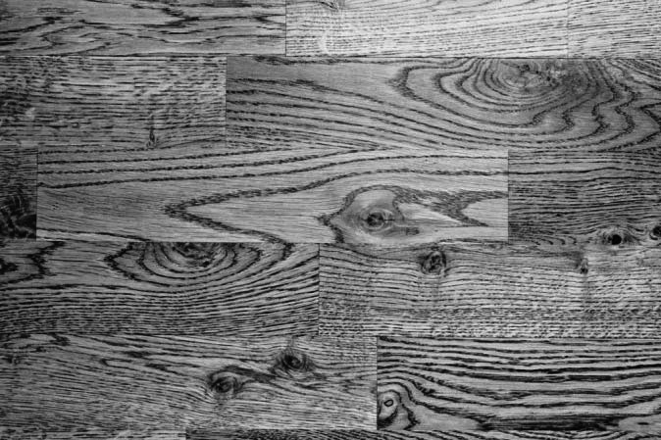
a) Why are wood floorings seldom made of spruce
or pine?
b) What mechanical property makes wood flooring resistant to impact?

c) Name at least three species of wood that are good to use as flooring.
4. Plywood is widely used in construction.
a) What type of material is it?
b) How are the sheets processed in the making of plywood?
c) Name three other types of materials similar to plywood.
•
•
•
5. Name the mechanical property associated with each of the following statements.
a) It is easy to flatten zinc without damaging it.
b) Steel is very resistant to tension.
6. Name two mechanical properties that make it possible to use metal in electrical wires.
•
•
7. Which mechanical property makes it possible to manufacture coils? Explain your answer.

8. Today stepstools and ladders are made of aluminum. Years ago they were made
of wood.
a) Identify two benefits of using aluminum ladders instead of wooden ladders.
•
•
b) What property does aluminum possess that explains why it is dangerous to use objects made of aluminum near electrical wires?
9. Explain the difference between a ferrous alloy and a non-ferrous alloy. Provide two examples for each type of alloy.

Type of alloy |  | Definition |  | Examples
Ferrous alloy
Non-ferrous alloy

AST question only
10. Plastics can be divided into two categories.
a) Name the two categories.
•
•

b) Which category contains plastic that cannot be remoulded after being heated?

AST question only
11. The following statements are related to the properties of thermoplastics. Indicate whether they are true or false. Correct the statements that are false.

True |  | False
 |  |  | a) Polystyrene is a good electrical conductor.
 |  |  | b) A sealer must be applied to polyethylene surfaces because
 |  |  | they rust easily.
 |  |  | c) Polyvinyl chloride is durable.

AST question only
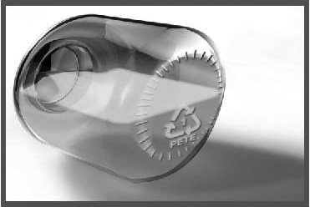
12. Look at the jar of honey in the illustration at right. What type
of plastic was used to make the jar?

3 Basic mechanical functions (pp. 383–388)
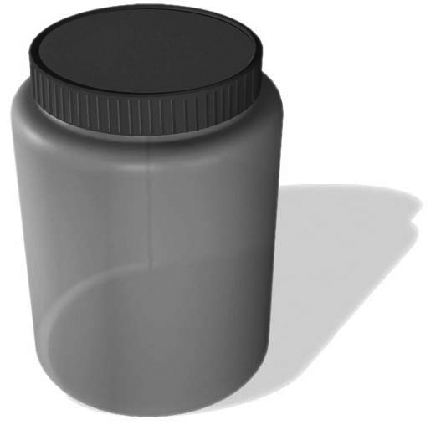
13. Look at this jar and its cover.
a) Is it a technical object? Explain your answer.
b) How many components does this object contain?
c) Name the four link characteristics that describe the jar and its cover. Explain each of these characteristics.

 | Link characteristic |  |  | Explanation

d) Name the type of link.

14. Look at the bicycle in the picture below.
a) In a bicycle, part of the handlebars is inserted into the steer tube. The handlebar perform a rotational motion but not a translational one. What is the steer tube’s basic mechanical function?
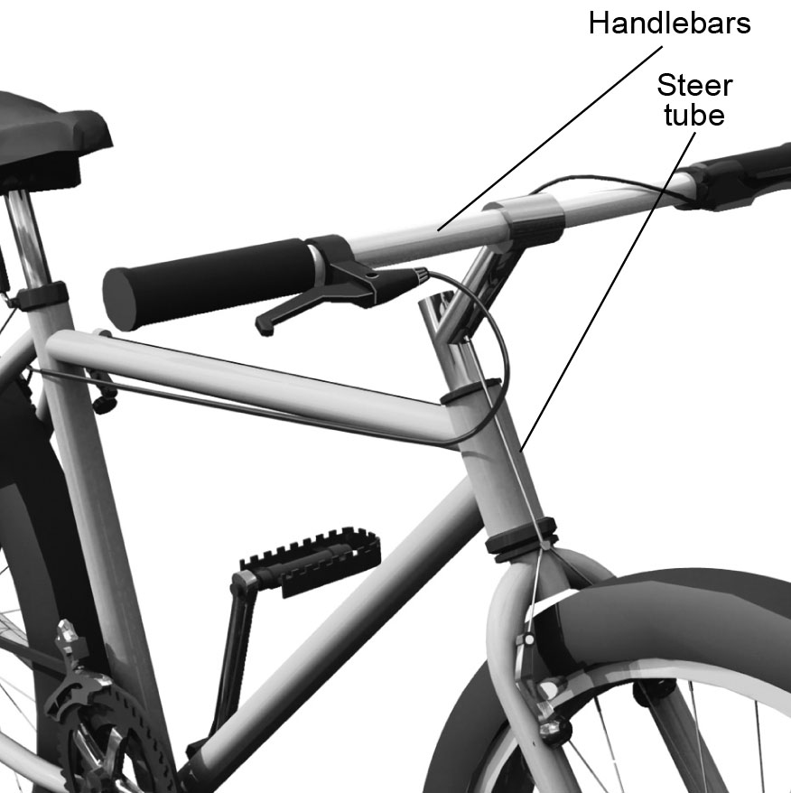
b) What type of link does this system have?
4 Complex mechanical functions (pp. 389–398)
15. Name the two types of complex mechanical functions. Provide four examples of each type.

Type of complex  mechanical function |  | Examples of mechanisms

Type of complex  mechanical function |  | Examples of mechanisms

16. Automobile engines contain a slider-crank system among others. Why is it important to maintain the required oil levels? Answer by identifying the function of oil in car engines.
17. To activate the manual hand drill, the crank must
be turned, which makes the mandrel turn as well.
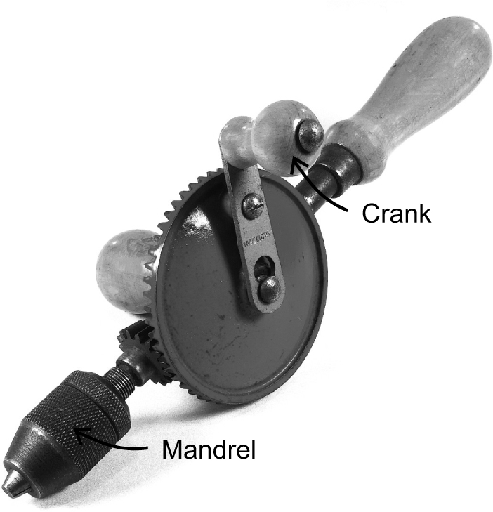
a) Does this object contain a motion transmission
system or a motion transformation system?
Explain your answer.

b) Name this object’s system and draw a diagram of it.

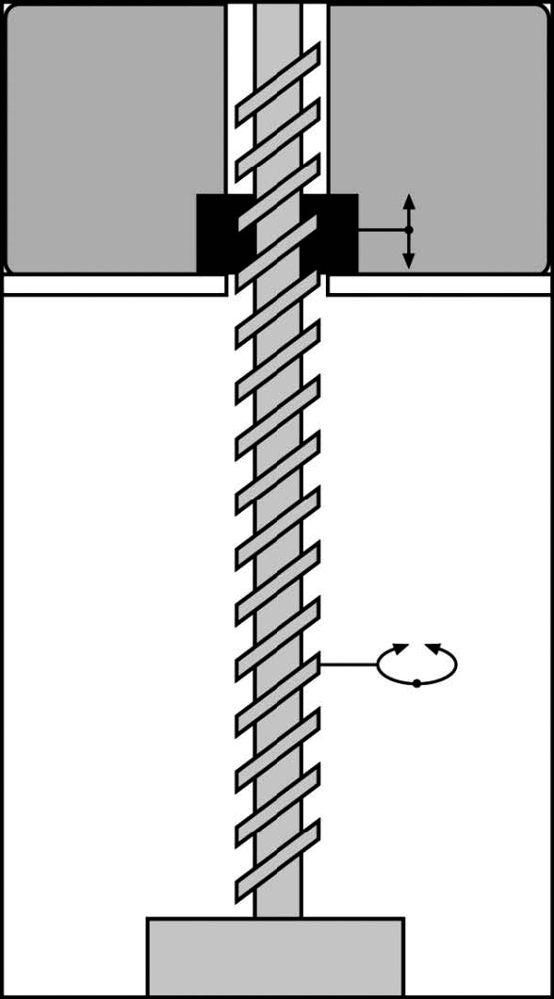
18. Antiperspirant applicators contain a system that
makes the antiperspirant stick move up and down.
a) Does this object contain a motion transmission
system or a motion transformation system?
Explain your answer.
b) Name this object’s system.

AST section only
5 Electricity (pp. 399–405)
19. An electric current is required to make many technical objects function.
a) What is an electric current?
b) For each of the photos below, indicate whether the current is alternating or direct.

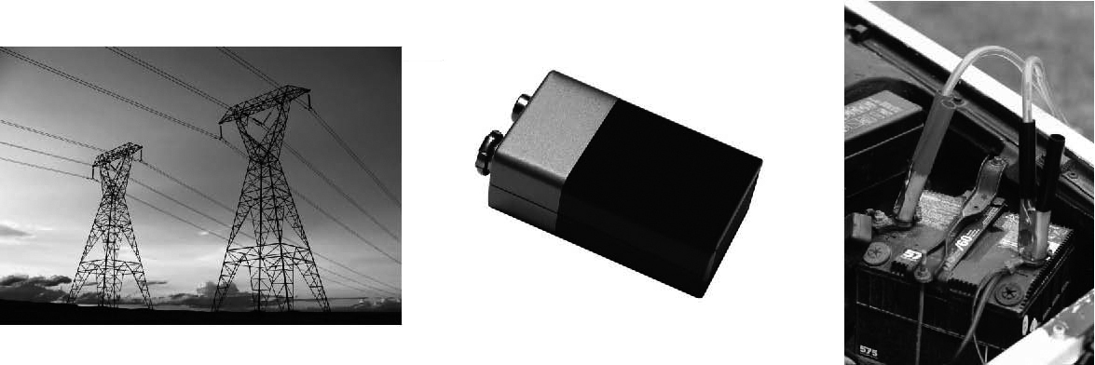

20. The two electrical circuits described in the diagrams below contain an audible alarm device. When the current flows through the device, it emits a sound.

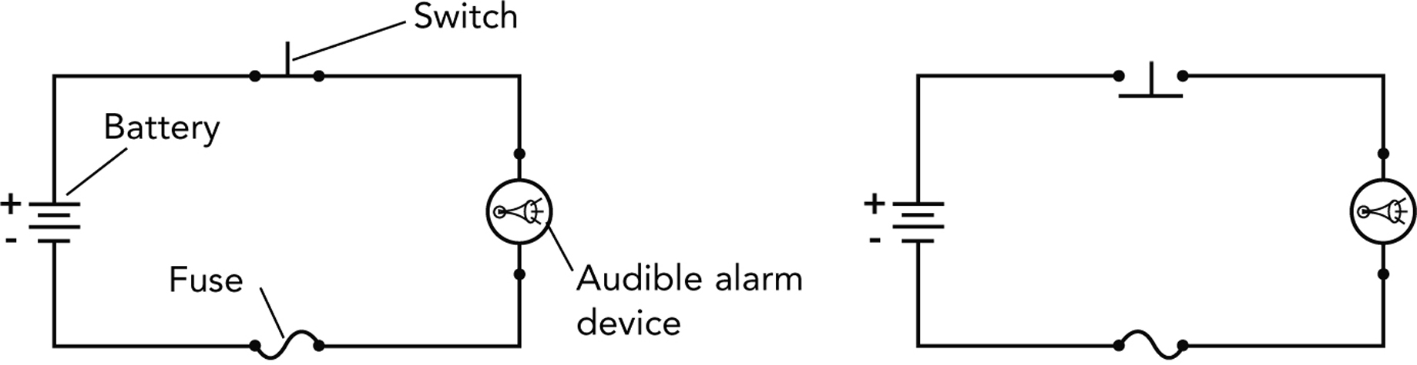
Circuit 1 Circuit 2

a) For each electrical circuit, indicate whether the alarm will ring or not. If the alarm won’t ring, explain why.

Circuit 1:
Circuit 2:
b) Identify the electrical function of each circuit component.

 | Component |  |  | Function

AST section only
6 The manufacturing process (pp. 405–407)
21. Look at the following five photos. For each one, identify the manufacturing process used and the technique being shown.

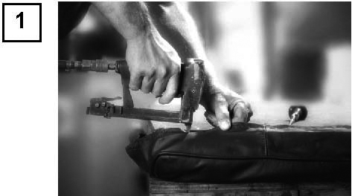 |  | Manufacturing process:
 |  | Technique shown:

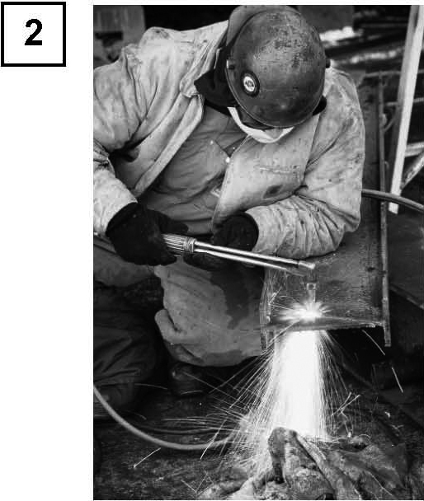 |  | Manufacturing process:
 |  | Technique shown:
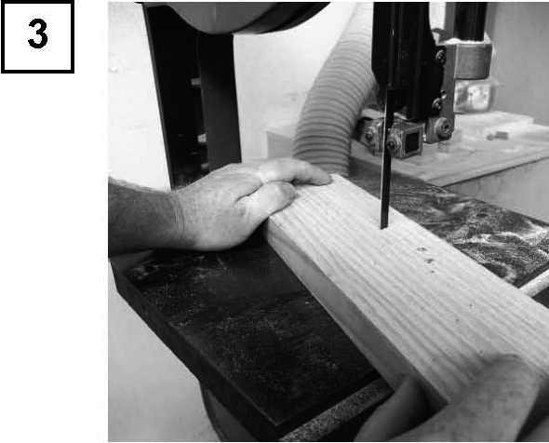 |  | Manufacturing process:
 |  | Technique shown:
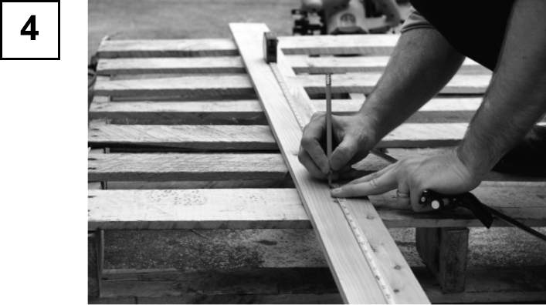 |  | Manufacturing process:
 |  | Technique shown:
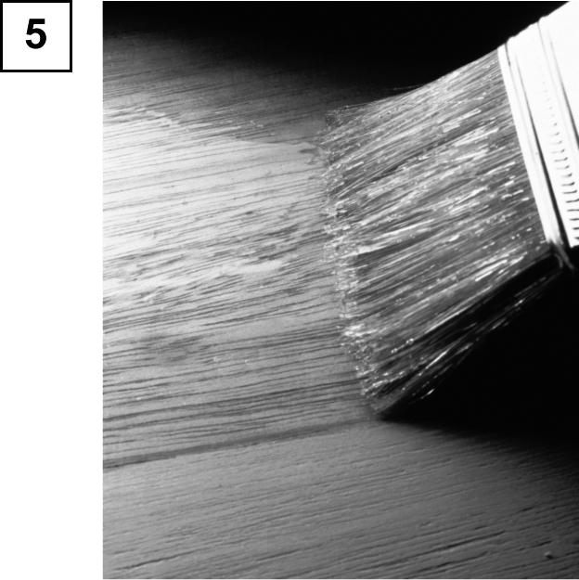 |  | Manufacturing process:
 |  | Technique shown:

