Checkup • Chapter 11
1 Communicating with symbols (pp. 336–337)
1. What are the two types of drawings most commonly used in technology?
2. What is technology?
2 Lines and geometry in technical drawings (pp. 337–342)
3. At right is a cross-sectional view of
a deodorant stick.
In the table on the next page:
a) Give the name of the basic line indicated by each number.
b) Give the function of these basic lines in
the diagram.
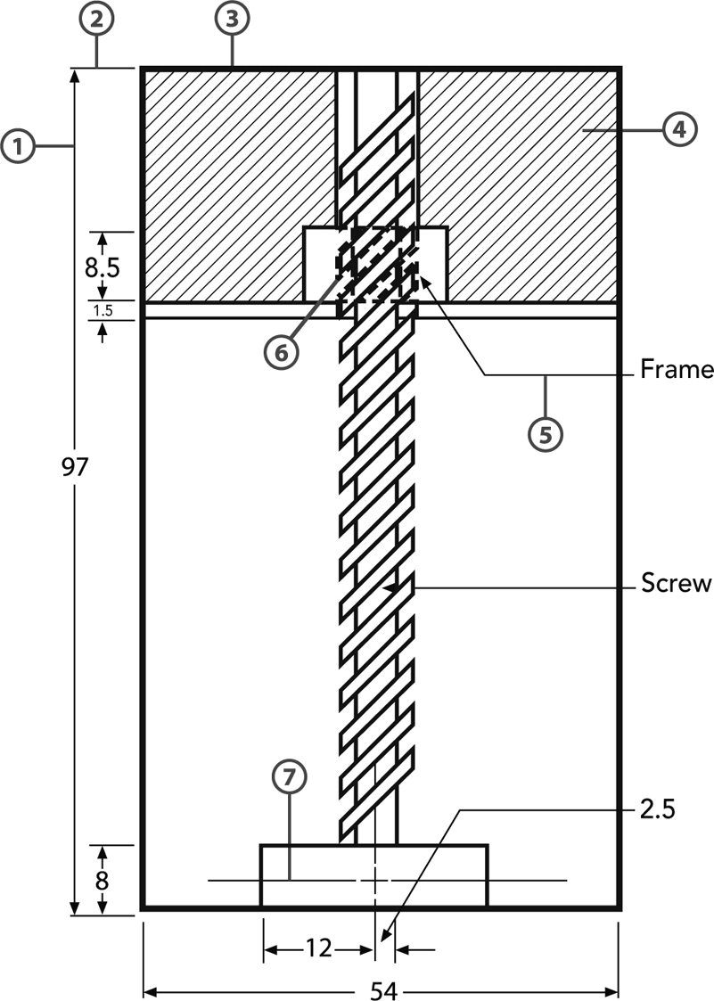

 | Number |  |  | Type of line |  |  | Function
c) Two of the basic lines discussed in Chapter 11 are not in this drawing. Name them and describe their function.
•
•

4. Geometric lines can be made using manual drafting instruments.
a) What are the main instruments for drafting?
b) Three types of straight lines can be made with geometric lines. What are they?
•
•
•
c) Name two drafting instruments that are used to draw circles.
•
•
5. Look at these two representations of a stop sign. Which one is a sketch? Explain your answer.

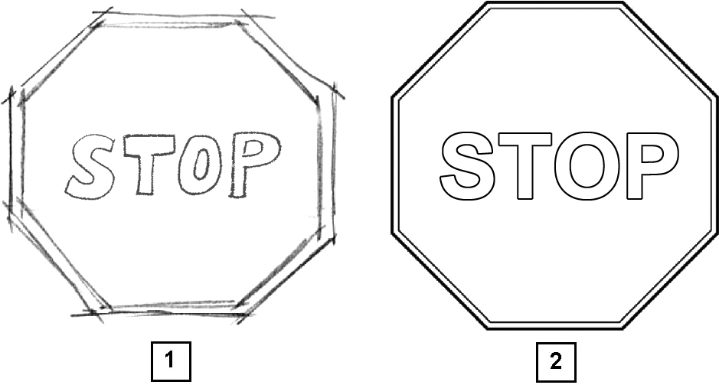

3 Projections and their use in technical drawings (pp. 343–351)
6. Projections are different ways to draw an object on a two-dimensional surface.
a) Name two projections in which the visual rays are perpendicular to the sheet of paper.
•
•
b) What name is given to these two projections?
7. An object can be drawn from six different angles.
a) What are these six views?
b) Which views are conventionally used when drawing a multiview projection of an object?
8. Look at these three drawings of the same object.

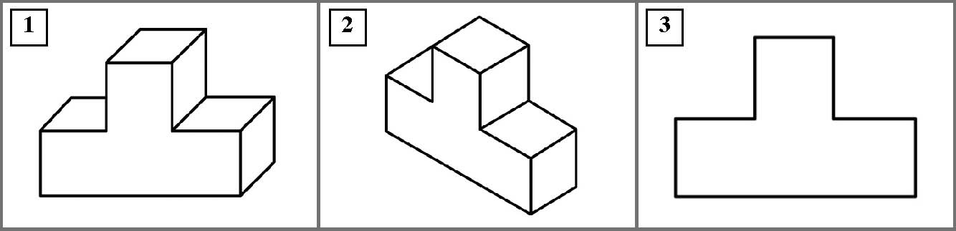
a) Which projection was used for each drawing?
1
2
3

b) Which ones are perspective drawings?
9. Match the isometric projections on the left with their multiview projections on the right.

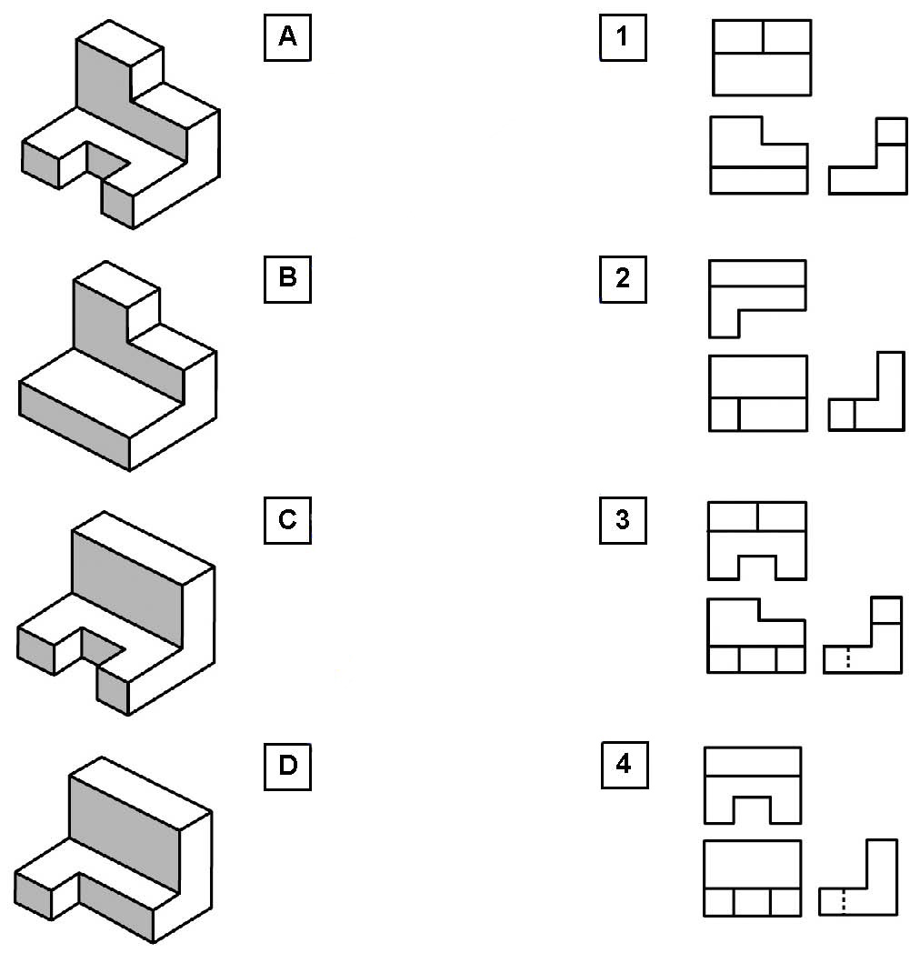
4 What’s in an engineering drawing? (pp. 351–355)
10. Jonathan is building a model car. He is reducing all of the measurements 40 times.
a) What scale is he using?

b) How would you indicate that scale?
c) The car he has chosen measures four metres in length. What will the length of the finished model be? Give your answer in millimetres.
11. The following drawing is a reproduction of a soccer field with a scale of 1:2000. The world Cup soccer finals are played on fields with the same dimensions. Calculate the width and the length of the soccer field using its representation to scale.

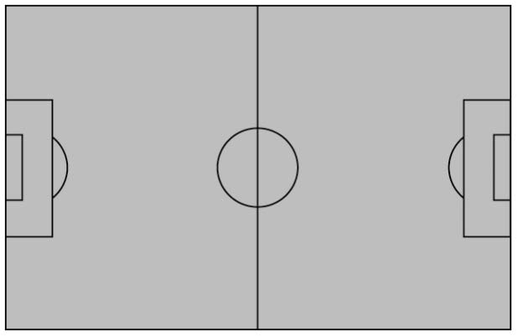

12. Look at the drawing at right. (The measurements given are in mm.)
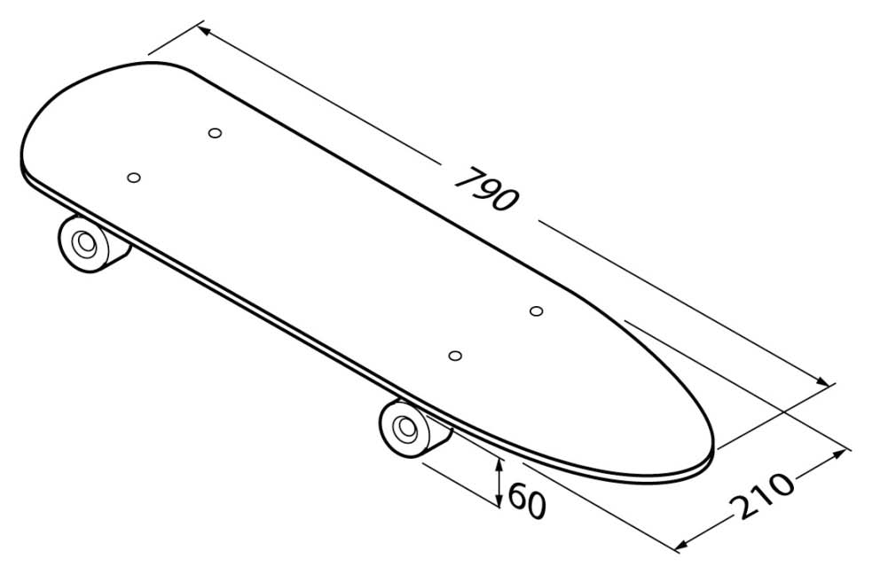
a) What is the length
of the skateboard?
b) What is its width?
c) What is the diameter
of each wheel?

AST question only
13. What is the name of the maximum possible difference between a measurement as specified on a drawing and the real-life measurement?
14. Match each object on the left to its corresponding cross-sectional view on the right.

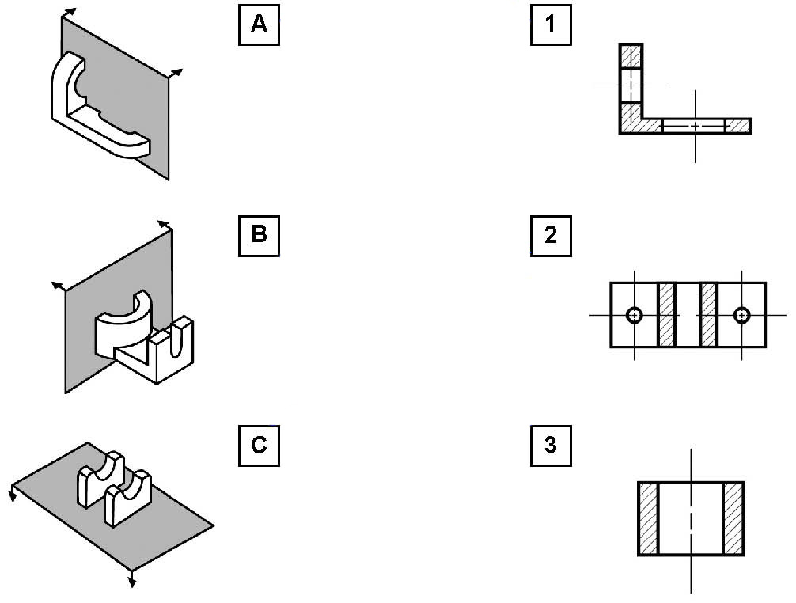

AST question only
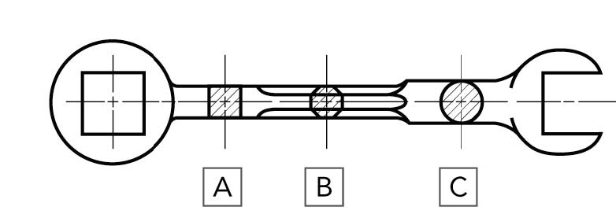
15. Look at the drawing of a wrench at right.
a) Which section shows that the handle of the wrench has an octagonal shape?
b) What is the shape of the handle indicated in section C?

c) Are the sections in the drawing aligned or offset? Explain your answer.
5 Diagrams (pp. 355–359)
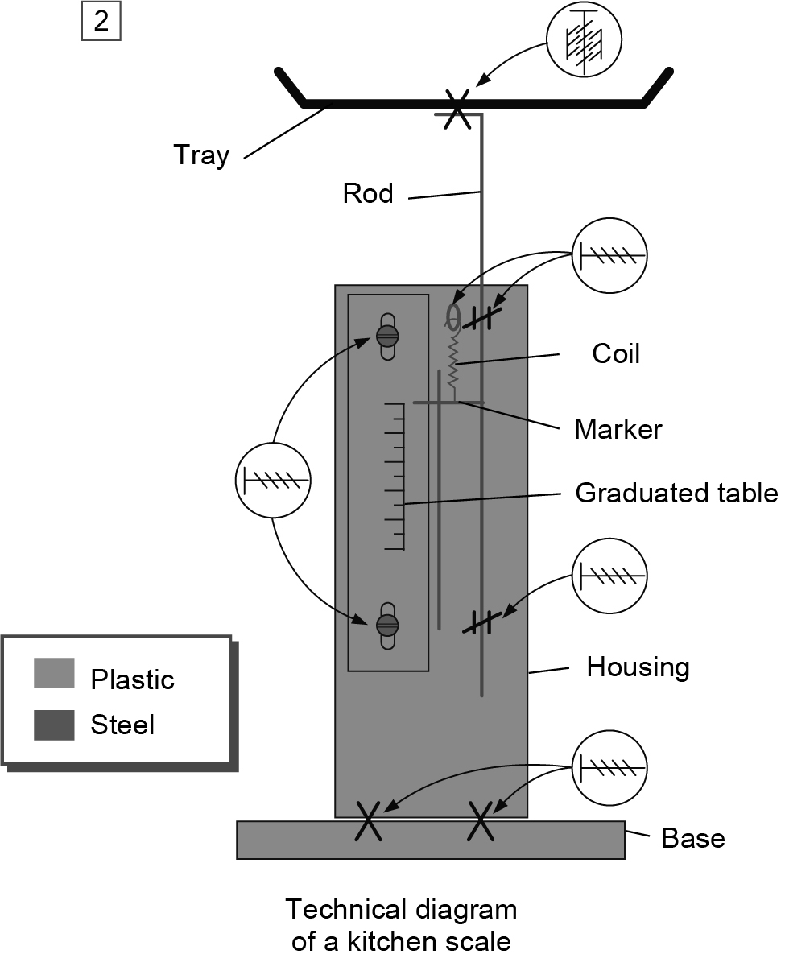
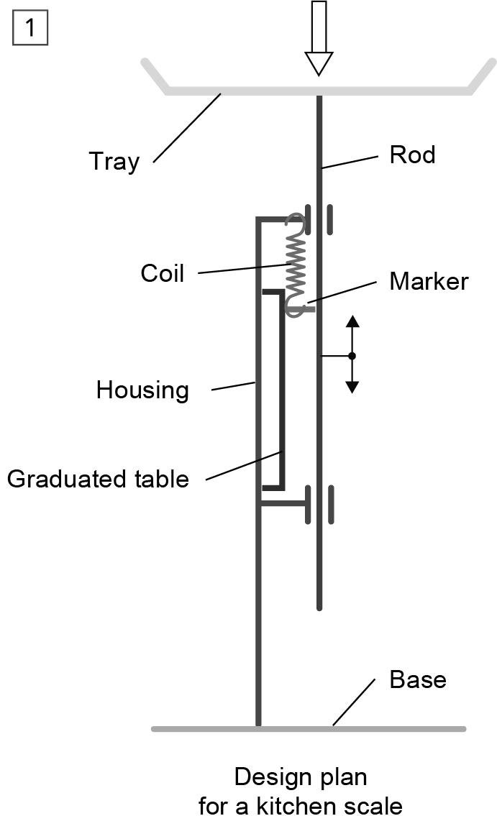
16. Look at the following design plan and technical diagram of a kitchen scale.

a) On which part of the scale is force exerted?
b) In total, how many screws were used to
make this scale?
c) What kind of movement can the rod make?
d) Once force has been removed, what allows the rod to return to its initial position?

