ST chapter only
Checkup • Chapter 10
1 The origin of life (pp. 300–305)
1. Earth took millions of years to form.
a) Where did the matter that formed our planet come from?
b) How long ago did Earth form?
c) How did the Moon form?
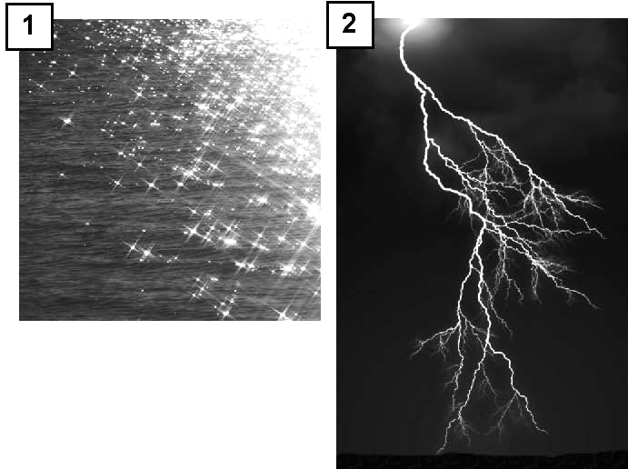
2. Look at the photos at right.
a) What favourable condition for the
emergence of life is illustrated in
photo 1?
b) What favourable condition for the emergence of life is
illustrated in photo 2?
c) What are the other two favourable conditions essential for the emergence of life and that are not illustrated in these photos?
3. a) Complex organic molecules are mainly made up of which chemical elements?
b) Where do scientists believe these organic molecules were when they first organized into living cells?
c) Why did it take so long for the first cells to form?

d) When did life first appear on Earth?
e) What were the first forms of life to appear
on Earth?
2 The history of life on Earth (pp. 305–318)
4. A great number of species have appeared since the beginning of life on Earth.
a) Name the very slow process that brings
about modifications in living beings.
b) Name the natural process that gradually results in the reproduction of living organisms better adapted to their environment.
5. Which of the four geological eras is described in each of the following examples?
a) era in which we live at present
b) era when many dinosaur species lived,
as well as when they all became extinct
c) the longest geological era of the four
d) era during which most species of mammals appeared
e) era that ended with the biggest extinction event ever
6. Here are a few important events in the history of life:
appearance of amphibians and insects
first evidence of life
appearance of vertebrates
appearance of dinosaurs
appearance of our species
extinction of about 90 percent of all marine species
appearance of soft-bodied invertebrates
appearance of fish
extinction of dinosaurs
In the table on the next page:
a) In the first column, write the events in chronological order.
b) In the second column, write the geological era in which each event occurred.
c) In the third column, write the geological period in which each event occurred.
Do not indicate anything for events that occurred during the Precambrian era.

Event |  | Era |  | Period
7. Below is a photo of the fossil of a species of fish that lived 380 million years ago in an area that is now the Gaspé Peninsula.

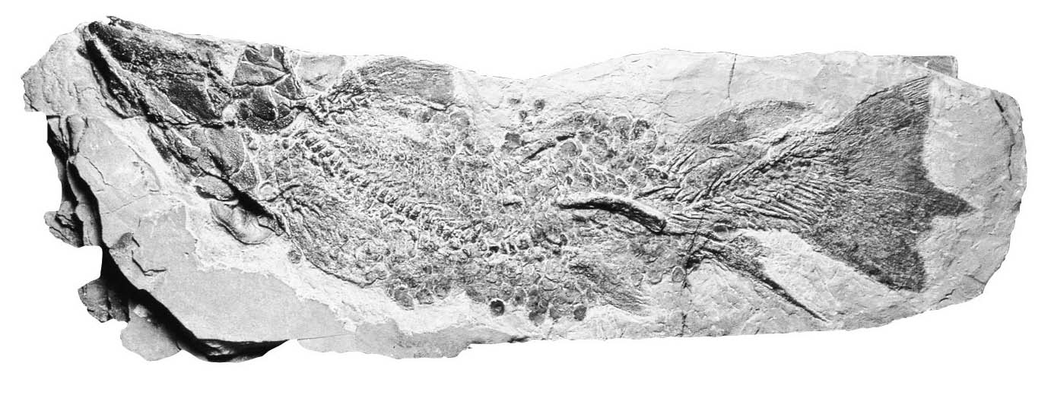

In which era and period on the geological time scale did this fish live?
8. Jurassic Park, the first film of a science fiction trilogy about dinosaurs, was released in theatres in 1993. Why was this an appropriate title for a film about dinosaurs?
9. Apes and humans are animals from the order of Primates.
a) Which ape is our closest cousin?
b) What characteristic do paleontologists rely on to distinguish humans and apes in evolution?
10. The human lineage contains many species, all of which are extinct except our own.
a) What are the three main genera of the human lineage?

b) What is the scientific name of our species?
c) What are the names of the two human species that once lived at the same time as us?
11. Our species has undergone many adaptations since its appearance. Explain one advantage for each of the following adaptations.
a) bipedalism
b) our brain, which is highly developed compared to that of other species
c) our hair, which is finer than that of other mammals
d) our many sweat glands
12. Explain why it is difficult for scientists to establish exactly how the human species evolved.
3 Fossils (pp. 319–325)
13. In what type of rock are fossils most often discovered?
14. Look at the photos below.

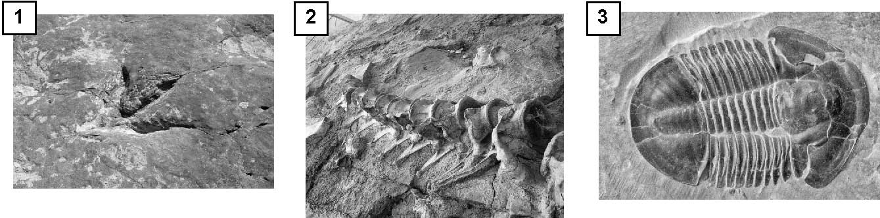

a) Identify the type of fossil illustrated in each one.
b) Briefly describe how each fossil was formed.
Write your answers in the table below.

Fossil |  | Type |  |  | Formation
1
2
3
15. a) What type of fossil is not included in the photos in question 14?
b) Provide two examples of this type of fossil and how each was formed.
•
•

16. True or false? If false, explain your answer.

True |  | False
 |  |  | a) Geologists specialize in the study and research of fossils.
 |  |  | b) A tree trunk can become fossilized.
 |  |  | c) Many fossils are found in Québec, mainly in magmatic rock.
 |  |  | d) All the organisms that die will one day become fossils.

True |  | False
 |  |  | e) On a fossil, parts of an organism can be petrified and
 |  |  | others moulded.
 |  |  | f) Relative dating is more accurate than absolute dating.
 |  |  | g) A fossil that formed 25 million years ago contains more
 |  |  | carbon-14 than one that formed 60 million years ago.
17. In your own words, explain the Laws of Continuity and Superposition of stratigraphic layers.
18. What type of dating is referred to in each of the following examples?
a) One tree is older than another because it is bigger.
b) A tree is 12 years old because it has 12 growth rings.
19. a) On what properties of certain elements is carbon-14 dating based?
b) How can the age of a fossil be determined using this method of absolute dating?
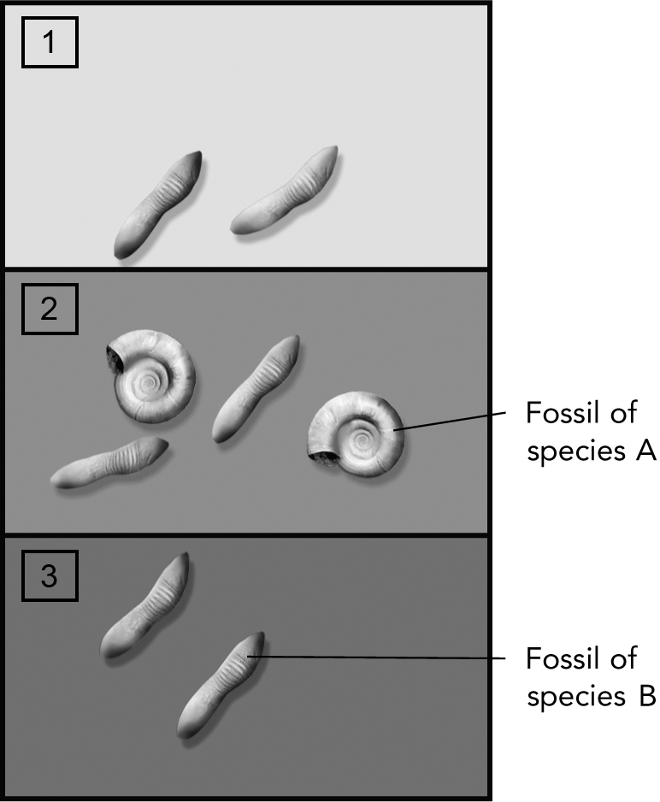
20. Carefully study the illustration at right. It
includes three stratigraphic layers and
the fossils they contain.
a) What colour is the oldest stratigraphic
layer? Explain your answer using
the principle on which it is based.
b) What species appeared first? Explain your answer.
c) What species disappeared last? Explain your answer.
d) Did species B exist at the same time as species A? Explain your answer.
e) What type of dating helps determine
the age of a stratigraphic layer according to its location with regard to other layers?
f) If fossils of species A and species B are estimated to be more than 60 000 years old, what radioactive element could be used
to determine the age of the two fossils?

