ST chapter only
Checkup • Chapter 9
1 Observations of the sky (pp. 274–282)
1. Certain astronomical phenomena can be seen with the naked eye while others must be observed with instruments. Which of the following phenomena can be observed with the naked eye?
a lunar eclipse
the Great Red Spot of Jupiter
a meteor crashing on Mars
the movement of the stars in the sky
Saturn’s rings
day and night on Earth
2. Name three instruments used to observe the night sky.
•
•
•
3. Which five planets were discovered through visual observation?
• |  |  | • |  |  | •
• |  |  | •
4. Which two planets were discovered thanks to either the refracting telescope or the reflecting telescope?
• |  |  | •
5. Define the terms astronomical unit and light year.
Astronomical unit:

Light year:
6. What is the speed of light (km/s)?
7. The kilometre, the astronomical unit and the light year are three units of measurement used to calculate distances. Which would be used to calculate each of the following?
a) the distance between Jupiter and Mercury
b) the distance between the Sun and the
star Rigel
c) the distance between Earth and the Moon
d) the distance between Gaspé and Rouyn-Noranda
e) the distance between the Milky Way and Andromeda
8. On April 3, 2024, Earth and Jupiter will be respectively 1.0 AU and 5.0 AU
from the Sun.
a) How much further will Jupiter be from
the Sun than Earth?
b) Is this data sufficient to calculate the distance between Earth and Jupiter on that date? Use a diagram to explain your answer.

c) On that date, how many kilometres will separate Jupiter from the Sun?
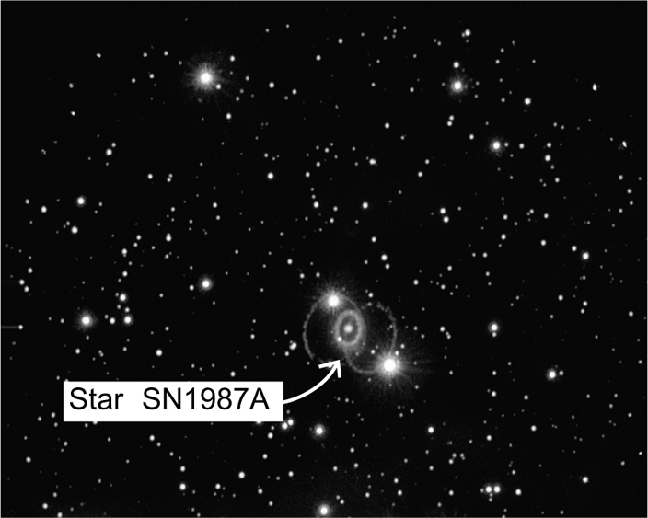
9. In 1987 an explosion of the SN1987A star
was observed. It was located 170 000 ly away
from our planet.
a) How long ago did this explosion occur?
Explain your answer.
b) How many kilometres separated Earth and SN1987A when it exploded?
Show your calculations.

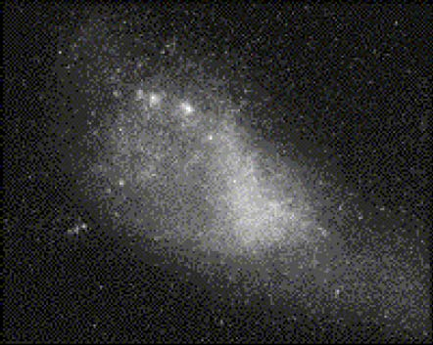
10. The Small Magellanic Cloud is a neighbouring galaxy. It is located about 200 000 ly away. Convert this distance to kilometres.
2 The Earth in the universe (pp. 283–292)
11. The Sun is a heat and light source for Earth and the entire solar system. Is the Sun a star? Explain your answer.
12. For a long time, humans thought all celestial bodies revolved around Earth. We now know that is not the case. There is only one celestial body orbiting Earth.
a) What is it called?
b) What is its average distance from Earth?
13. How much time elapses between two full moons?
14. What phenomenon is at the source of the Sun’s energy?
15. How many times is the Sun’s diameter greater than Earth’s?
16. Which planets in our solar system do not possess any known natural satellites?
17. “My very eager mother just served us noodles” is a sentence used to remember the names and order of the planets. The first letter of each word corresponds to the first letter of each planet.
a) Identify the planets corresponding to the first letter of each word in the sentence.
M |  |  | V |  |  | E
M |  |  | J |  |  | S
U |  |  | N
b) Indicate the average distance of each planet from the Sun.
c) Identify the three dwarf planets and indicate their average distance from the Sun.
18. A planet in our solar system is located at 4 500 000 000 km from the Sun.
a) What is the distance in astronomical units?
b) Identify the planet.
19. Planets with a rocky surface, such as Earth, are also called terrestrial planets.
a) Which planets in our solar system are terrestrial planets?
b) Which dwarf planet also has a rocky surface?
c) What is the surface composition of the other two dwarf planets?
20. It is not likely that spacecraft would be able to land on a planet with an orbit beyond that of Mars. To explore such planets, spacecraft must do flybys.
a) Which planets have an orbit beyond that of Mars?
b) Why are spacecraft not able to land on such planets?
21. Answer the following questions.
a) Why is the average surface temperature of Venus so high?
b) Why does Mars appear red?
c) Why does Neptune appear blue?
22. What is the difference between a comet and an asteroid?
23. The Milky Way is the name of our galaxy.
a) What is a galaxy?

b) How far away are we from the centre of our galaxy?
c) Approximately how many stars are in the Milky Way?
d) What is our closest neighbouring galaxy?
e) How far away is it from our galaxy?
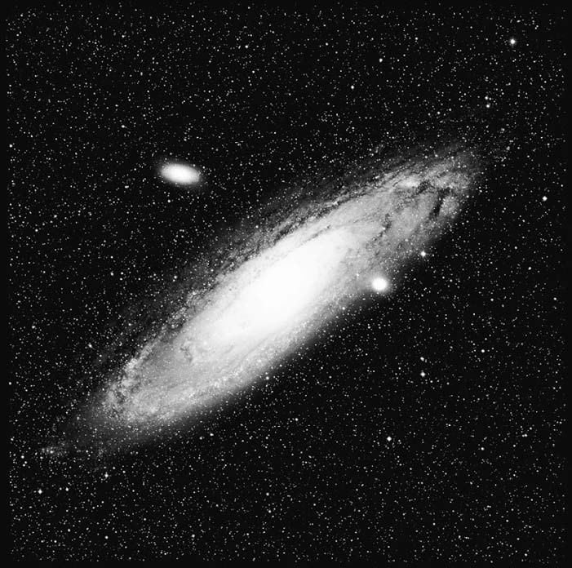
24. The Andromeda galaxy is pictured at right.
a) Is it an elliptical, spiral or irregular galaxy?
b) Is the Milky Way the same type of galaxy
as Andromeda? If not, what type is it?
25. True or false?

True |  | False
 |  |  | a) The Sun is located at the centre of the solar system.
 |  |  | b) The solar system is located at the centre of the Milky Way.
 |  |  | c) The Milky Way is at the centre of the Universe.

