Checkup • Chapter 8
1 What is a biotechnology? (p. 236)
1. What is the difference between technology and biotechnology?
2. What am I?
a) To replicate, I have to get into a cell and use its structures.
b) I help accelerate chemical reactions in the body.
c) I am a unicellular organism without a nucleus.
d) I am a unicellular mould.
e) I am a ring-shaped segment of genetic information.
f) I am a molecule containing an individual’s genetic information.
2 Traditional biotechnologies (pp. 237–239)
3. When did human beings start using biotechnology?

4. How is selective breeding different from natural breeding?
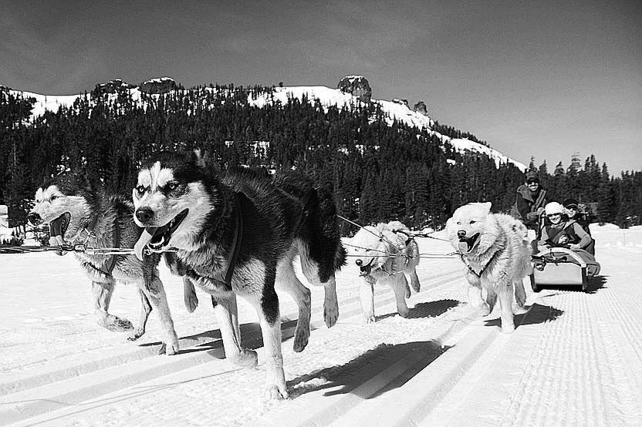
5. Brittany retrievers are great in finding and fetching game because they have been selected for their sense of smell and for their calm and cautious nature. Provide two examples of desired traits used when breeding Malamute huskies.
•
•
•
•
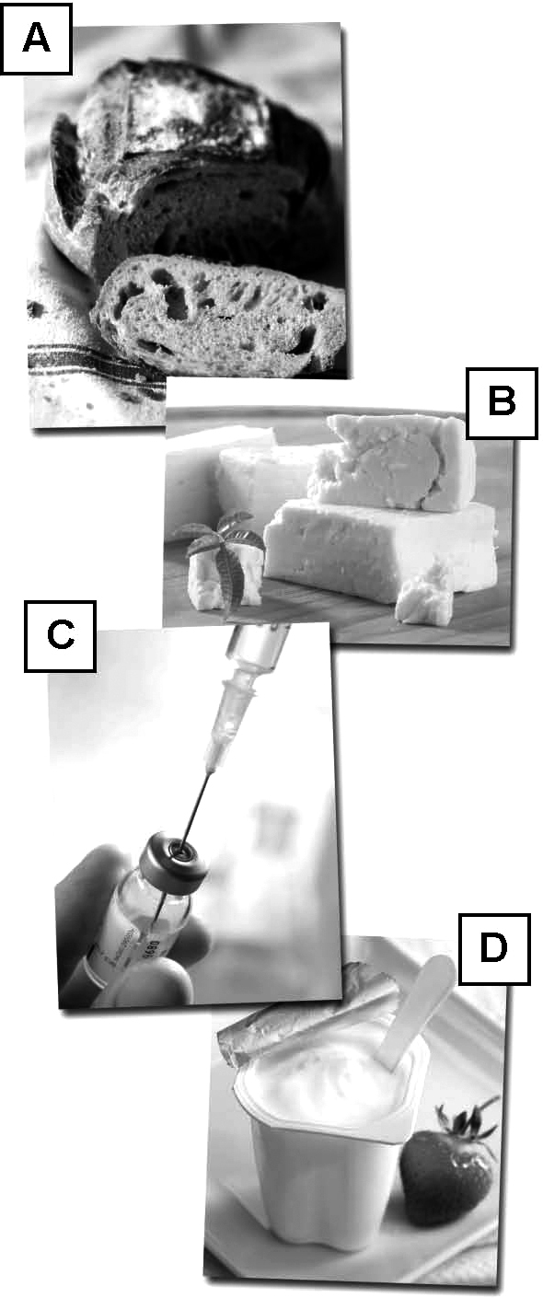
6. Look at the photos at right.
a) Identify the product(s) made using enzymes.
b) Identify the product(s) made using yeast.
3 Modern biotechnologies (pp. 239–248)
7. Give two reasons that explain the development of modern biotechnology.
•
•
8. What is the meaning of the term cell growth in a cell culture?
9. Illustrated below are the steps to follow when culturing unicellular organisms. The steps are not in the correct sequence. Name them and order them correctly.

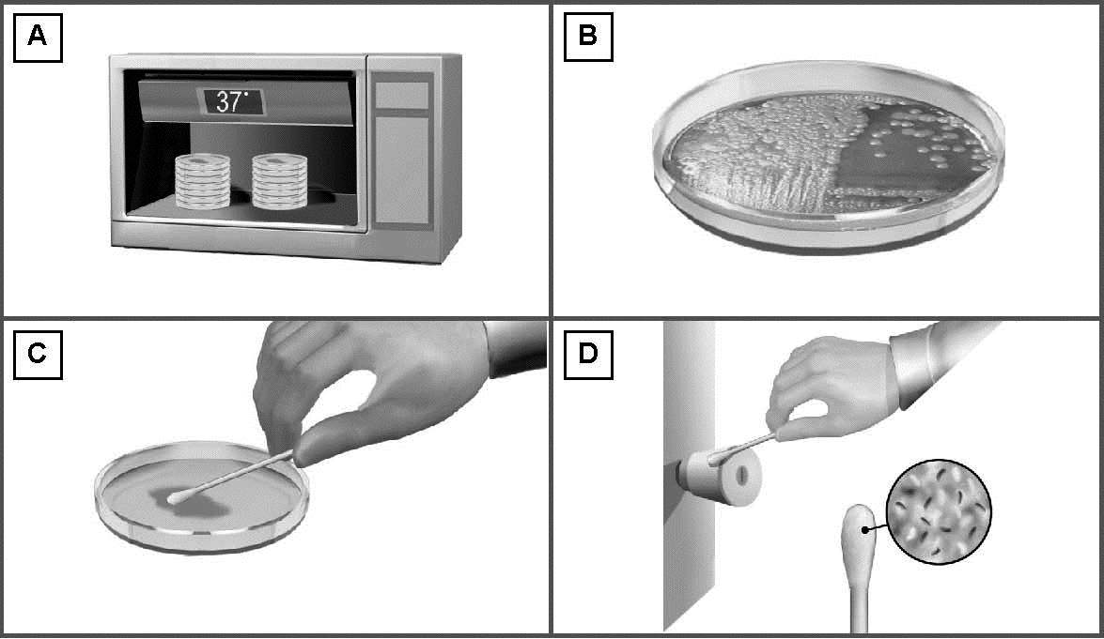

A
B
C
D

10. A culture medium must have all the elements necessary for cell growth.
a) What are the seven main parameters that must be considered when preparing a culture medium?
1.
2.
3.
4.
5.
6.
7.
b) What are the two types of culture media?
• |  |  | •
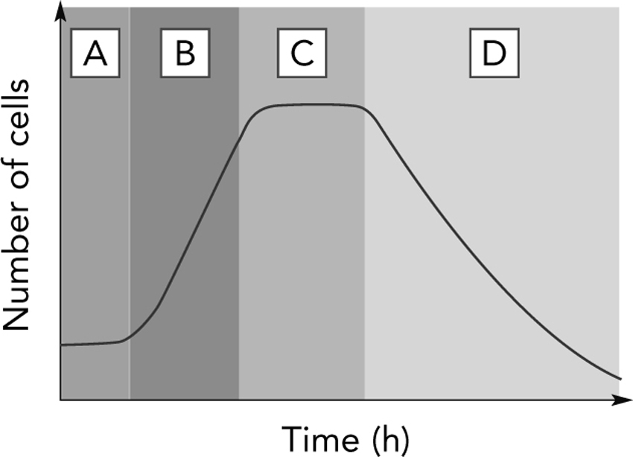
11. The diagram at right illustrates the growth curve of a typical cell culture. Name and describe each of the four phases.
A
B
C
D

12. Why should lab equipment be sterilized before and after use in a cell culture?
13. The following statements describe various methods used to sterilize lab equipment.
Name the methods described in each statement.
a) This method destroys microorganisms using an oven.
b) This method destroys microorganisms using irradiation.
c) This method destroys microorganisms using a flame.
d) This method destroys microorganisms using a liquid solution or a gas.
e) This method destroys microorganisms using pressure and high temperature.
14. GMOs are spoken of and written about frequently these days.
a) What does GMO stand for?
b) What process makes it possible to create GMOs?

c) Describe the six steps needed to obtain a GMO.
1.
2.
3.
4.
5.
6.
15. Cloning is a controversial issue.
a) What is cloning?
b) What is artificial cloning?
c) What is the difference between reproductive cloning and therapeutic cloning?

d) What is Canada’s position on human cloning?
16. Cloning also occurs naturally.
a) Give an example of natural clones in plants.
b) Give an example of natural clones in animals.
17. Why do breeders use artificial insemination rather than natural reproduction methods to increase the size of their herds?
4 Agro-food applications (pp. 249–253)
18. GMOs are a controversial subject.
a) Give three examples to illustrate the benefits of GMOs.
•
•
•
b) Identify three concerns associated with the use of GMOs.
•
•

•
19. Name three traits that have been added to plants to improve crop yield.
•
•
•
20. Why do farmers prefer growing herbicide-resistant genetically modified plants?
21. Name three genetically modified crops that are grown in significant quantities in Québec.
• |  |  | • |  |  | •
22. Why is it easier to genetically modify a plant rather than an animal? Give two reasons.
•
•
23. Pasteurization is a treatment process applied to some foods.
a) What is the purpose of pasteurization?
b) How is pasteurization carried out?
c) Why do we pasteurize some types of food and not others?
5 Medical applications (pp. 253–263)
24. Vaccines strengthen immunity against several infectious agents. What is immunity?
25. Study the following illustrations and name the type of vaccine shown in each case.

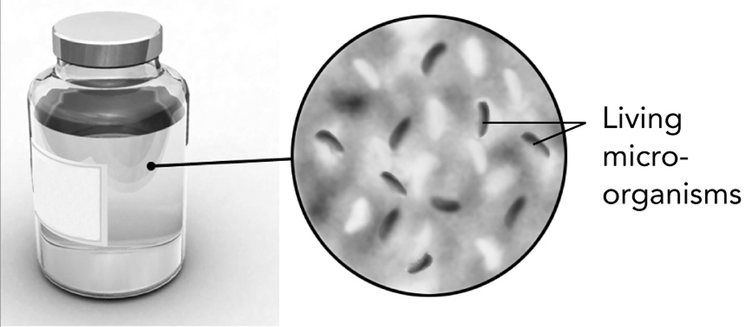

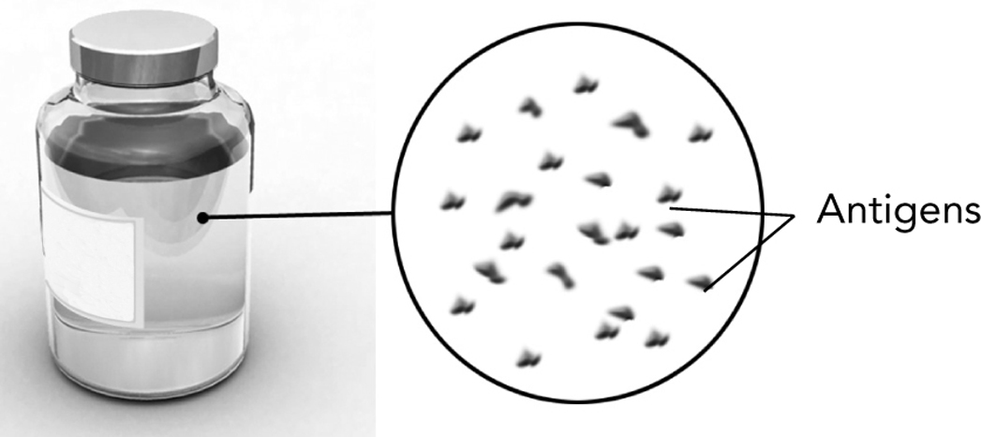
26. According to Québec’s regular vaccination schedule, all children must get
an MMR vaccine.
a) Against what diseases does this vaccine develop protection?
b) How many doses should a child receive and at what age?
27. What is assisted reproduction?
28. Following are illustrations of four techniques used to treat infertility. Name them.

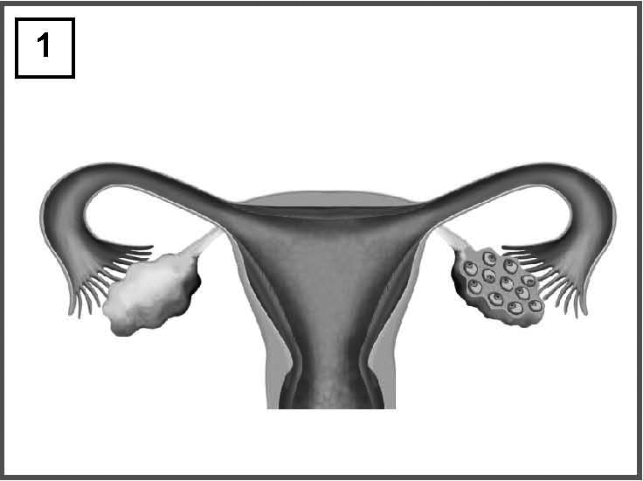 |  | 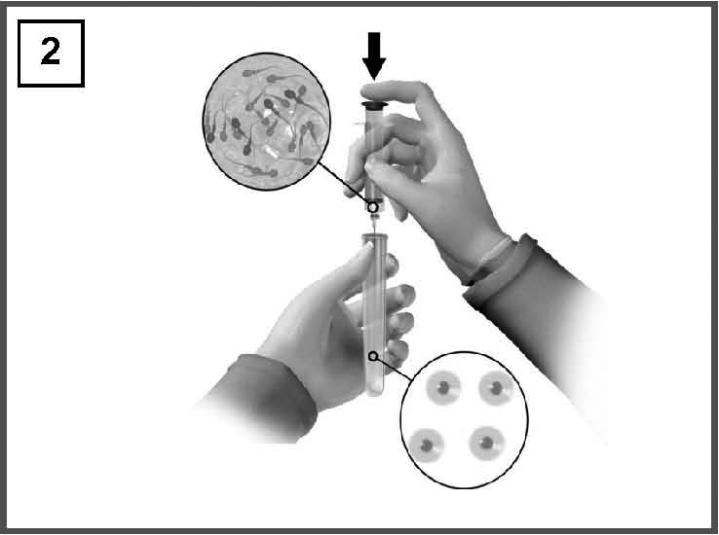

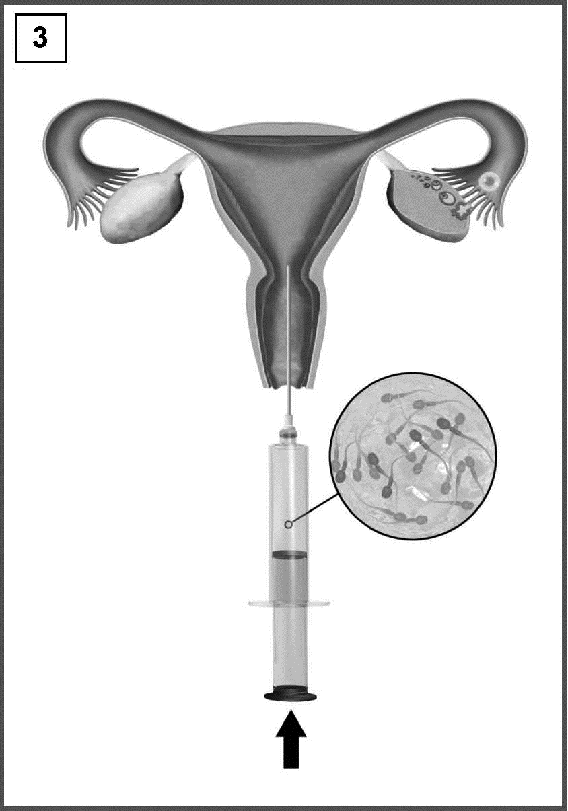 |  | 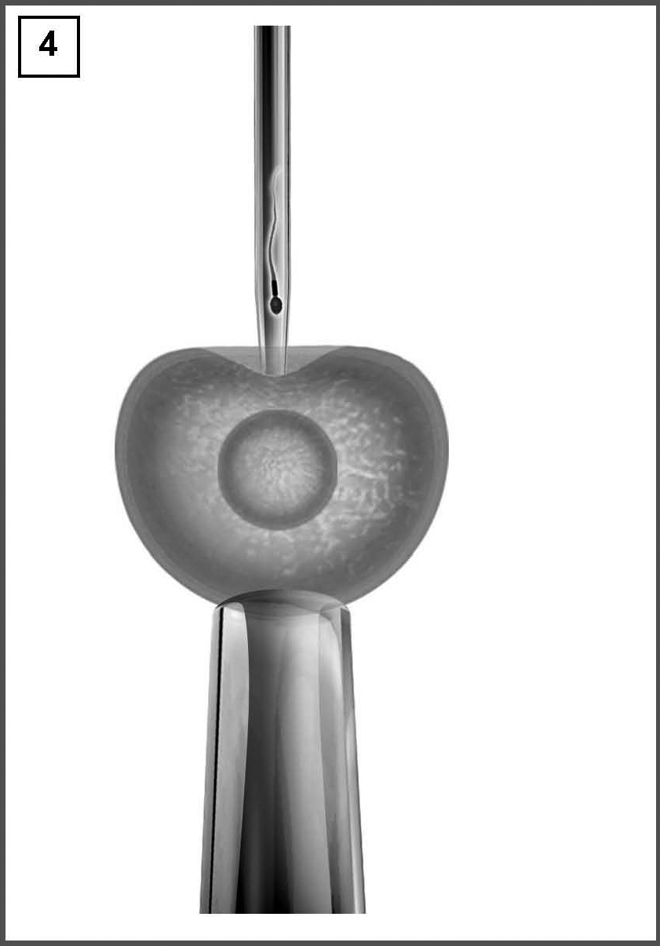
29. The human organism is made up of two types of cells: specialized cells and stem cells.
a) Describe each type of cell.
Specialized cell:
Stem cell:
b) Why is the culturing of stem cells so controversial?

