Checkup • Chapter 7
1 The nervous system (pp. 202–212)
1. The illustration below depicts the human nervous system. Name each of the
structures indicated.

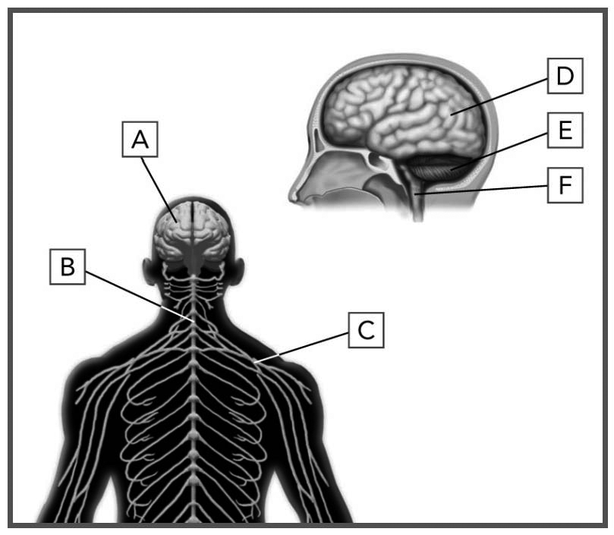

A |  |  | D
B |  |  | E
C |  |  | F
2. Relate each of the following examples to one or more functions of the nervous system,
e.g. receiving, processing, storing or transmitting information.
a) Feeling pain after being stung by an insect
b) Sharing memories from a trip
c) Raising your leg to avoid an obstacle
d) Listening to your favourite music
3. The illustration below depicts two neurons. Name each of the structures indicated.

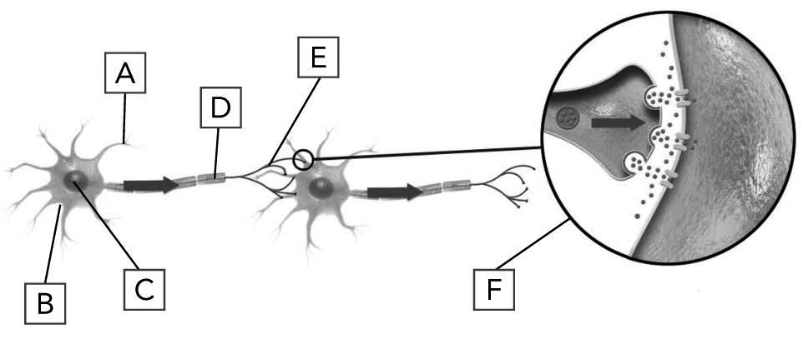

A |  |  | D
B |  |  | E
C |  |  | F

4. Name the chemical substances that help transmit nerve impulses from one neuron to another.
5. The brain communicates with the rest of the body through 12 pairs of nerves. Why are the nerves usually in pairs?
6. Name the region of the brain most likely responsible for each of the following activities:
a) singing a song
b) walking on a tightrope without falling
c) memorizing the script from a play
d) laughing at a funny joke
e) digesting a meal
f) walking to school

7. When the doctor taps your knee with a little hammer, he or she is testing your reflexes.
a) Indicate the path taken by the nerve impulse during this procedure.
b) Name the path taken by the nerve impulse.
8. Indicate whether the following examples refer to sensory nerves or motor nerves:
a) The optic nerve conveys nerve impulses
to the brain.
b) Nerves transmit stimuli coming from
the stomach.
c) Certain nerves transmit nerve impulses
to muscles surrounding the intestine.
d) Certain nerves transmit stimuli coming
from muscles.
2 The sensory organs (pp. 213–220)
9. For each sensory organ:
a) Name the sense associated with it.
b) Name the structure where the related sensory receptors are located.
c) Name the stimulus or stimuli detected by these sensory receptors.
Write your answers in the table below.

 | Organ |  |  | Sense |  |  | Structure where sensory receptors are located |  |  | Stimuli detected by sensory receptors

 | Organ |  |  | Sense |  |  | Structure where sensory receptors are located |  |  | Stimuli detected by sensory receptors
10. The lens accommodates according to the distance of the object observed. For each of the two illustrations below, indicate whether the object is near or far.

a) | 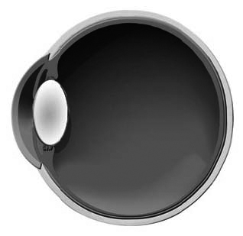 |  | b) | 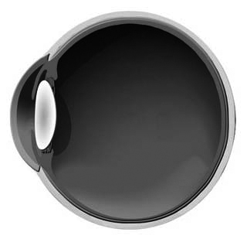
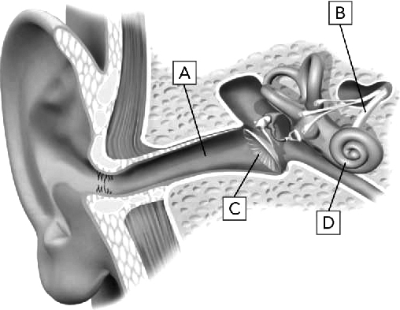
11. Name each structure indicated
in the table on the following page.

 | Structure |  | Function
A
B
C
D
12. Why do we have the feeling that food has no flavour when our nose is congested?
13. To what does each of the following phrases refer?
a) part of the retina where no image can
be formed
b) sensory receptors that detect tastes
c) structures that play a role in balance
d) organ that is responsible for vitamin D production
e) transmitter of nerve impulses from the eye
to the brain

3 The musculoskeletal system (pp. 221–228)
14. Name the type of bone for each of the following:
a) cube-shaped bone, composed mainly
of spongy bone
b) bone that is longer than it is wide, composed mainly of compact bone
c) bone of the spine
d) bone that is flat
15. Describe the function of the bones referred to in each of the following cases:
a) These skull bones surround the brain.
b) Without bones, we would be as soft as a slug.
c) Some patients with leukemia undergo a bone marrow transplant.
d) Minerals are essential to the proper functioning of the organism.
16. What is the difference between a tendon and a ligament?

17. Indicate the joint movements illustrated in each example below.
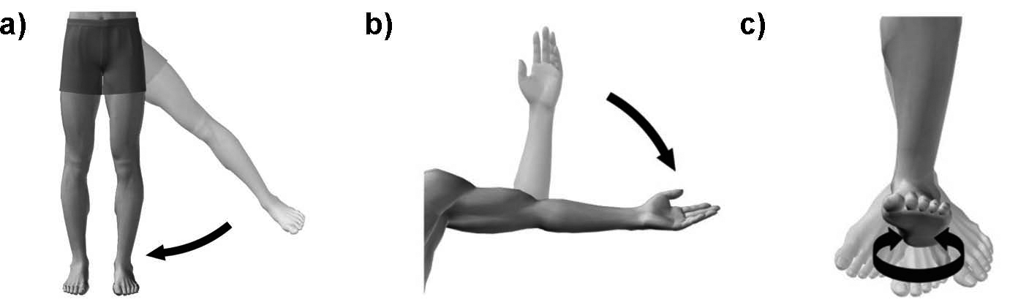
18. What function of muscles is described in each of the following situations?
a) The members of the Royal Guard stand without moving for several hours at a time.
b) The temperature of the body is maintained
at about 37ºC.
c) Food moves into the esophagus.
d) Muscles strengthen the junction
between bones.
19. What type of muscle is involved in each of the following:
a) the muscle that forms the ventricles
of the heart
b) the muscle that makes up the wall
of internal organs
c) the muscle that makes it possible
to perform voluntary movements

