Checkup • Chapter 6
1 Food and its use by the body (pp. 160–172)
1. This is what Veronica ate for supper:

– 1 grilled Atlantic salmon steak
– 1 baked potato
– 5 mL of butter (on the potato)
– 3 boiled broccoli florets
– 2 glasses (500 mL) of 2% milk
– 125 mL of chocolate ice cream
– 60 g of strawberries (on the ice cream)
For each food item eaten by Veronica:
a) Name the food group to which the item belongs.
b) State the amount of energy provided by the item. (See Appendix 2, “The nutritional value of certain foods,” page 424.)

 | Food group |  | Amount of energy  provided by the food
Salmon
Potato
Butter
Broccoli
Milk
Ice cream
Strawberries
2. In a 250-mL glass of 2% milk:
a) How many grams (g) of proteins, carbohydrates and fats does this glass contain?

Proteins |  | Carbohydrates |  | Fats
b) How many micrograms (μg) of vitamin A does it contain?
c) How much energy (kJ) is provided by the glass of milk?
3. At right is the Nutritional Facts label found on a bag of raisin bread.
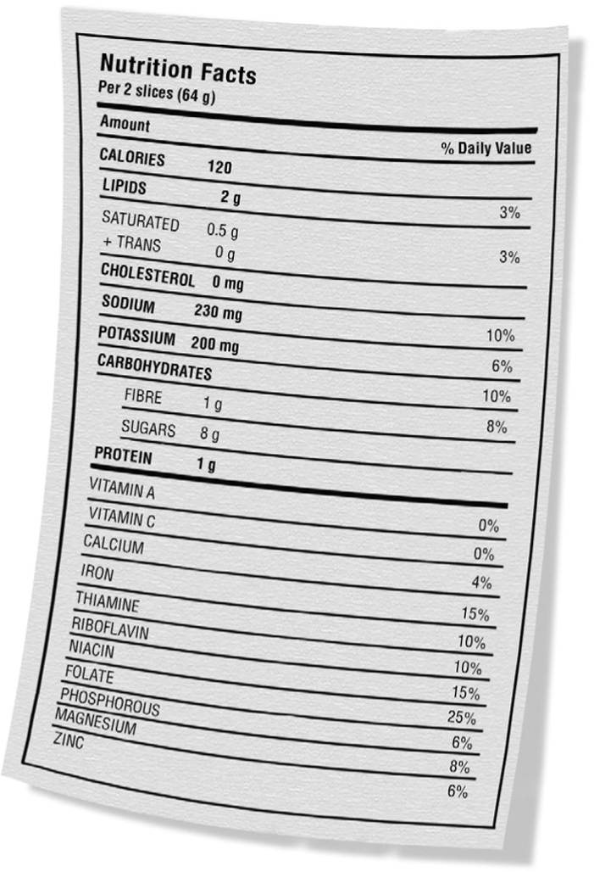
a) If you eat two slices of raisin bread, will you
have eaten most of your recommended daily
fat requirements? Explain your answer.
b) This raisin bread contains niacin (vitamin B3).
What other vitamins does it contain?
c) This raisin bread contains zinc. What other minerals does it contain?

4. For each of the following statements, indicate whether it refers to a chemical transformation or a mechanical transformation.

 | Type of transformation
 | Chemical | Mechanical
a) Teeth grind and cut food.
b) Saliva breaks down starch.
c) The stomach churns the food.
d) Gastric juices break down proteins.
5. For each structure of the digestive tract, indicate:
a) the kind of conversion (mechanical or chemical) that takes place
b) the substances that are secreted for digestion, if applicable
c) the glands that secrete these substances
d) the nutrients that are broken down by these secretions
Write your answers in the table below.

Structure |  | Type of  conversion |  | Substances that  are secreted |  | Glands that secrete  these substances |  | Nutrients that are broken down

Structure |  | Type of  conversion |  | Substances that  are secreted |  | Glands that secrete  these substances |  | Nutrients that are broken down
6. Digestion prepares nutrients so they can be used by the body.
a) What do we call the transport of nutrients from the digestive tract into the blood and lymph?
b) From which part of the digestive tract are most nutrients absorbed into the blood and lymph?
2 Respiration (pp. 172–176)
7. Our respiratory system enables us to extract a gas from the air, which we need in order
to live.
a) Name this gas.
b) What is the general equation that summarizes the role of this gas in the
nutritional process?
8. A student eating in the cafeteria starts to choke. Once he stops coughing, he wonders what made his body react this way. How could you explain it to him?
9. Below are some statements about respiration. For each statement, indicate whether it refers to inhalation or exhalation.

 | Inhalation | Exhalation
a) Intercostal muscles and diaphragm contract.
b) Intercostal muscles and diaphragm relax.
c) Lung volume increases.
d) Lung volume decreases.
e) Air pressure in the lungs decreases.
f) Air pressure in the lungs increases.
g) Air inside the lungs flows outside.
3 Blood and lymph circulation (pp. 177–190)
10. This is a photo of a drop of blood seen through a microscope.

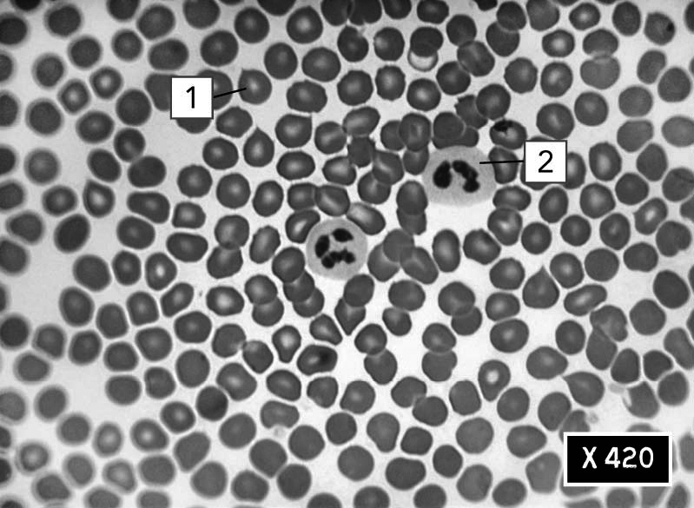
a) Name element 1 and 2 and give their respective functions.

 | Element |  | Function
1
2
b) What other formed element in the blood is not shown in the photo? What is its function?
c) What percentage of blood volume is composed of formed elements?
11. a) What is the name of the liquid that contains the formed elements of the blood?
b) What are the main constituents of this liquid?
12. Here are the blood types of four friends:
• Joseph : AB⁺
• Karla : B⁺
• Maxime : O–
• Samir : A–
a) Draw the red blood cells of these four people while showing the substances found on each type of cell membrane.

Joseph (AB⁺) |  | Karla (B⁺)

Maxime (O–) |  | Samir (A–)
b) Samir is in a serious car accident and loses a lot of blood. He needs a transfusion. Which one of his friends could give him blood? Explain your answer.
c) Which one of these four friends could be considered a universal recipient?
13. Name the type of blood vessel referred to in each of the following statements.
a) This vessel carries blood back to the heart.
b) This vessel is where most of the exchanges
occur between the blood and the cells.
c) In this vessel, blood circulates under
high pressure.
d) In this vessel, blood moves forward with the
help of muscular contractions.
e) In this vessel, red blood cells travel in single file.
f) In this vessel, blood travels from the heart to
the capillaries.
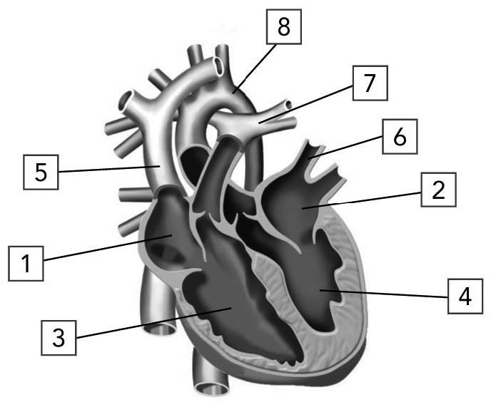
14. The illustration at right shows the heart and the main vessels attached to it.
Name each of the numbered structures and indicate whether it contains oxygen-rich blood or carbon-dioxide—rich blood. Write your answers in the table on the next page.

 | Structure |  | Oxygen-rich blood | Carbon  dioxide-rich blood
1
2
3
4
5
6
7
8
15. There are two blood circulation routes inside our body.
a) Name the circulation route that carries blood
to the lungs and then returns it to the heart.
b) Name the circulation route that carries blood
to all the other parts of our body.
16. The blood, the extracellular fluid and the lymph are three liquids contained in our body.
a) Describe how the elements in plasma and the white blood cells can leave the cardiovascular system and end up in the extracellular fluid and the lymph.
Plasma:
White blood cells:
b) In the table below, indicate where the blood, the extracellular fluid and the lymph circulate.

Liquid |  | Where it circulates
Blood
Extracellular fluid
Lymph
17. While observing the lymph through a microscope, a microbiologist sees a white blood cell wrapped around a microorganism.
a) What is happening?
b) What other means can white blood cells use to defend the body?
4 The elimination of waste (pp. 190–193)
18. a) What are the organs and structures involved in the formation, circulation and storage
of urine?
b) Give the equation that summarizes how cells produce urea.
c) What organs help to eliminate carbon dioxide?
19. For the following situations, indicate whether the amount of urine produced by the kidneys increases or decreases.
a) Nicole drank several glasses of water before going to class.
b) Jean-Philippe put a lot of salt on his fries.
c) Andrès forgot his water bottle and went on
a bike ride during which he perspired a lot.
20. The presence of certain blood elements in the urine may indicate a health problem. What are these elements?

