Checkup • Chapter 5
1 The cell (pp. 126–131)
1. Look at the following illustration.

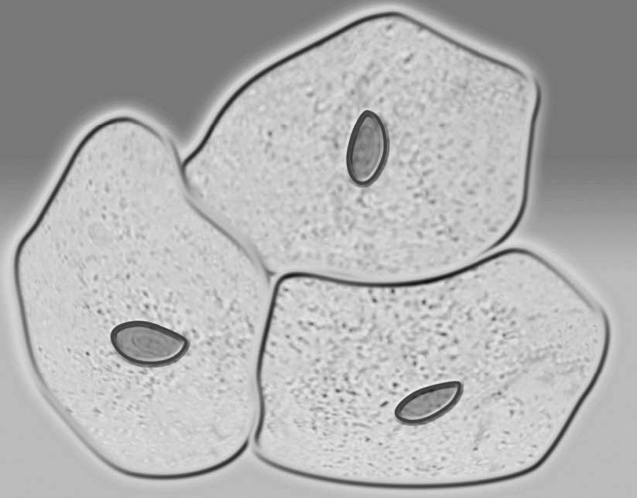
a) What three cell components are visible under a light (optical) microscope?
•
•
•
b) What is the role of each of these components?
2. Cell organelles allow a cell to perform various functions.
a) What organelles produce energy in the cell through
cellular respiration?
b) What organelles are responsible for digesting certain nutrients?
c) What organelle transports material produced by the cell to the cell membrane?
d) What organelle transports material produced by the cell from one place to another inside the cell?
3. Why do we say that DNA possesses a double-helix structure?
4. What is the difference between DNA, genes and genome?
5. What is the function of genes?
6. Complete the following DNA sequence.
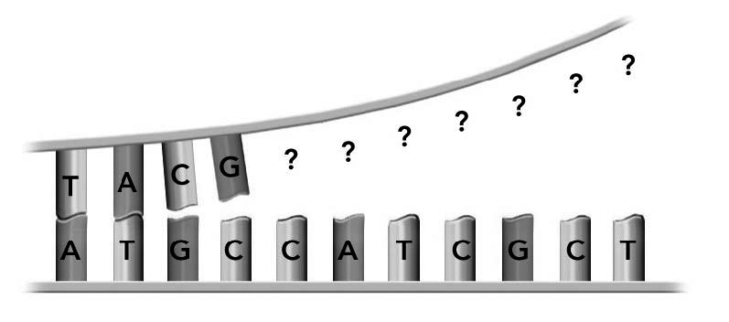
7. Why are more children affected by the Andermann syndrome in the Charlevoix and Saguenay–Lac-Saint-Jean regions than elsewhere in Québec?
2 Cell division (pp. 131–135)
8. Give three reasons why cells divide.
•
•
•
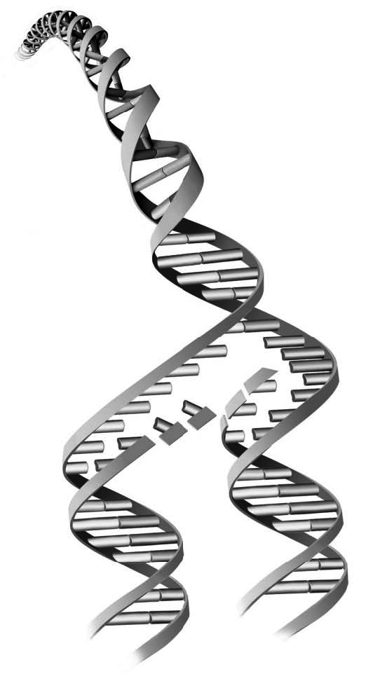
9. What does the illustration at right show?
Explain your answer.
Explanation:
10. What are the two types of cell division?
• |  |  | •
11. Some human cells are said to be diploid while others are said to be haploid.
a) What distinguishes a diploid cell from a haploid cell?
b) How many chromosomes does a human diploid cell contain?
c) How many chromosomes does a human haploid cell contain?
12. During which phase of mitosis are chromosomes formed?
13. What kind of cells are formed during meiosis?

14. Look at the two following illustrations. They show a simplified version of the types of cell division.
Name the type of division represented in a) and in b), then explain your answer.

a) | 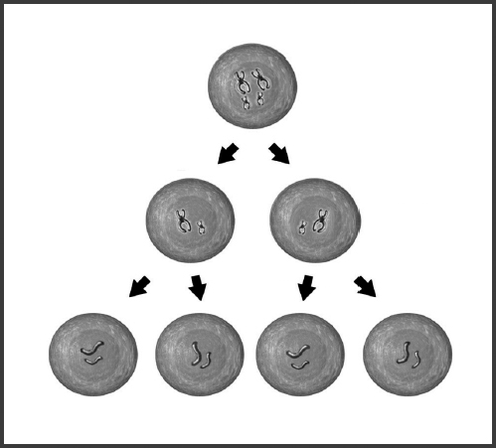 |  | Type of division:
a) |  |  | Explanation:
b) | 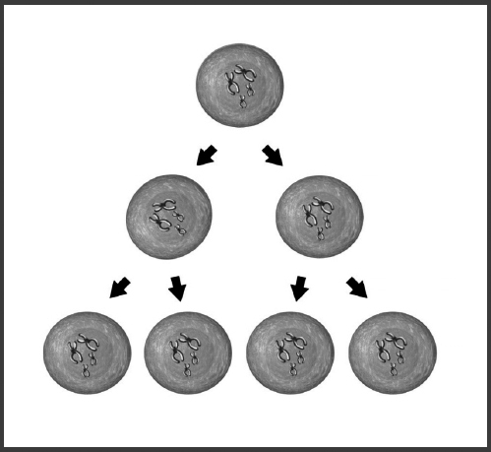 |  | Type of division:
b) |  |  | Explanation:
15. Answer the following questions.
a) What does a cell do when it is not dividing?
b) Why do cells replicate their DNA?
c) What is a gamete?

ST section only
3 Cellular specialization (pp. 136–139)
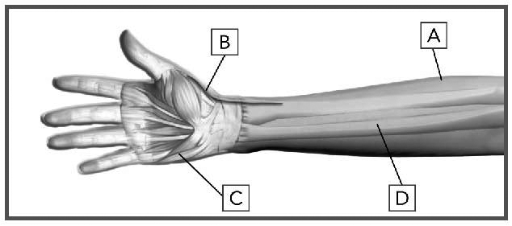
16. Look at the illustration at right. It presents
various tissues found in the arm.
a) Name each type of tissue indicated
in the illustration.
b) Indicate one function for each type
of tissue.

 |  | Name of tissue |  |  | Function of tissue
A
B
C
D
17. What is a system?
18. Each of the following statements describes one of the body’s vital functions. In each case, name the system that manages this function.
a) Eating well is important to keep our
bodies healthy.
b) Nutrients carried by red blood cells provide energy for our cells.
c) When we urinate, we eliminate certain waste products.
d) Our sense of smell allows us to distinguish various odours.
4 The reproductive system (pp. 140–151)
19. What is the name of the process that enables two haploid cells to produce a diploid cell?
20. Answer the following questions.
a) What is a zygote?
b) How is a zygote formed?
21. Name the chemical substances that are produced by the glands and secreted into the bloodstream.
22. What is the difference between adolescence and puberty?
23. Name three secondary sexual characteristics that appear in a boy and in a girl
during puberty.

Secondary sexual characteristics
 | Girl |  |  | Boy
24. Name the two hormones responsible for the maturation of the ovarian follicle.
• |  |  | •
25. Name the two hormones responsible for the production of spermatozoa.
• |  |  | •
26. What distinguishes oogenesis, the ovarian cycle and the menstrual cycle?
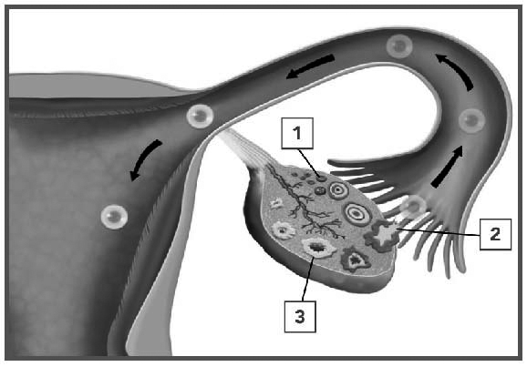
27. The illustration at right presents the various
stages in the ovarian cycle. For each stage,
indicate the hormone(s) involved and give a
brief description of is (their) action.

Stage 1

Stage 2

Stage 3
28. Julie, Sarah and Chloé have regular menstrual cycles: Julie has a 25-day cycle, Sarah a 30-day cycle and Chloé a 33-day cycle. If menstruation began for all three girls on the first day of the month, what will be the probable ovulation date for each one? You may use a calendar to help you.
29. Arrange the following events in chronological order:
maturation of the ovarian follicle
meiosis II of the oocyte
transformation of the ovarian follicle into the corpus luteum
rupture of the follicle
meiosis I of the oocyte
menstruation
1.
2.
3.
4.
5.
6.
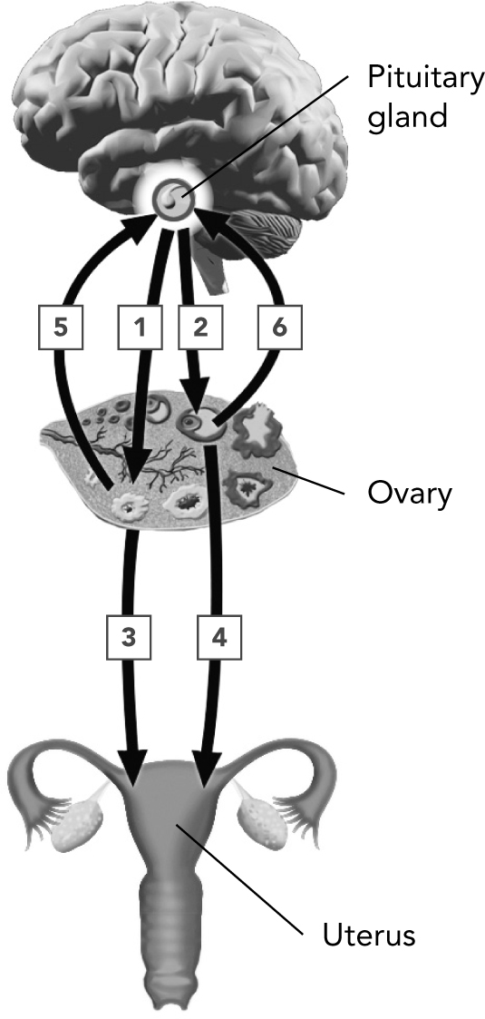
30. Look at the illustration at right. Each arrow represents
an action by a hormone.
a) In the table below, list the gland and hormone
for each arrow involved as well as the organ
targeted by the hormone.
b) In the last column of the table, arrange the following
actions in the correct order:
• inhibits further production of FSH and LH
• causes an increase in the level of progesterone, resulting in a thickening of the endometrium
(secretory phase)
• causes decreases in the level of progesterone, triggering menstruation
• causes a thickening of the endometrium
(proliferation phase)
• initiates ovulation
• transforms an ovarian follicle into a corpus luteum
• stimulates the maturation of an ovarian follicle
• stimulates the production of estrogens
• stimulates the production of FSH and LH in large quantities (hormonal surge)
• stimulates the production of progesterone

Arrow |  | Gland |  | Hormone(s) |  | Targeted organ |  | Action(s)
1

Arrow no. |  | Gland |  | Hormone(s) |  | Targeted organ |  | Action(s)
2
3
4
5
6

31. What changes occur in a woman’s body during menopause?
32. What is spermatogenesis?
33. Name two differences between menopause and andropause.
•
•
34. Contraception makes it possible to stop the process that leads to the conception of a child. Name three contraceptive methods that prevent ovulation.
•
•
•

