Checkup • Chapter 4
1 What is a wave ? (pp. 92–99)
1. True or false?

True |  | False
 |  |  | a) When a wave propagates, it transports the medium in which it moves.
 |  |  | b) When a wave propagates, it transports energy from one point to another.
 |  |  | c) A wave always needs a medium in which to move.
2. Indicate whether the waves in each of the following examples are transverse or longitudinal.
a) sound waves produced by a musical instrument
b) water waves formed on an ocean
c) undulations of a rope
d) compressions and rarefactions of a spring
3. Name the numbered elements in the following diagrams.

a) 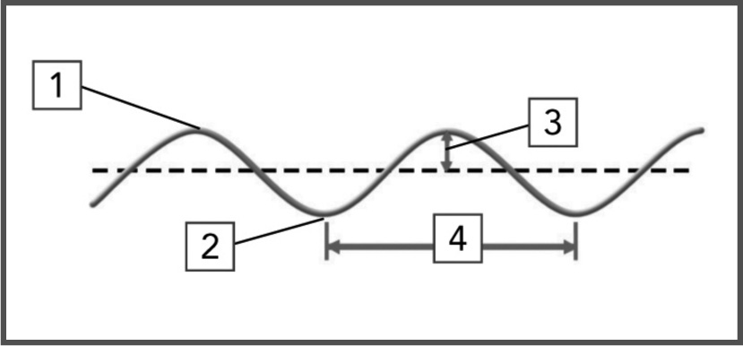 | 1
 | 2
 | 3
 | 4

b) 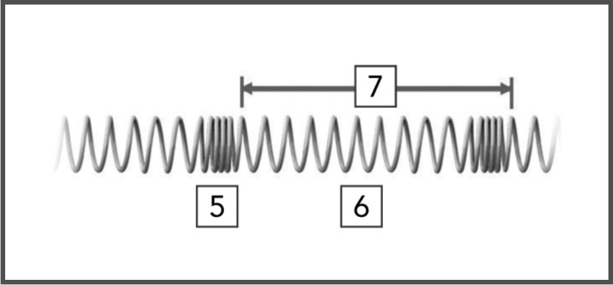 | 5
 | 6
 | 7

4. Look at the following diagrams of waves.

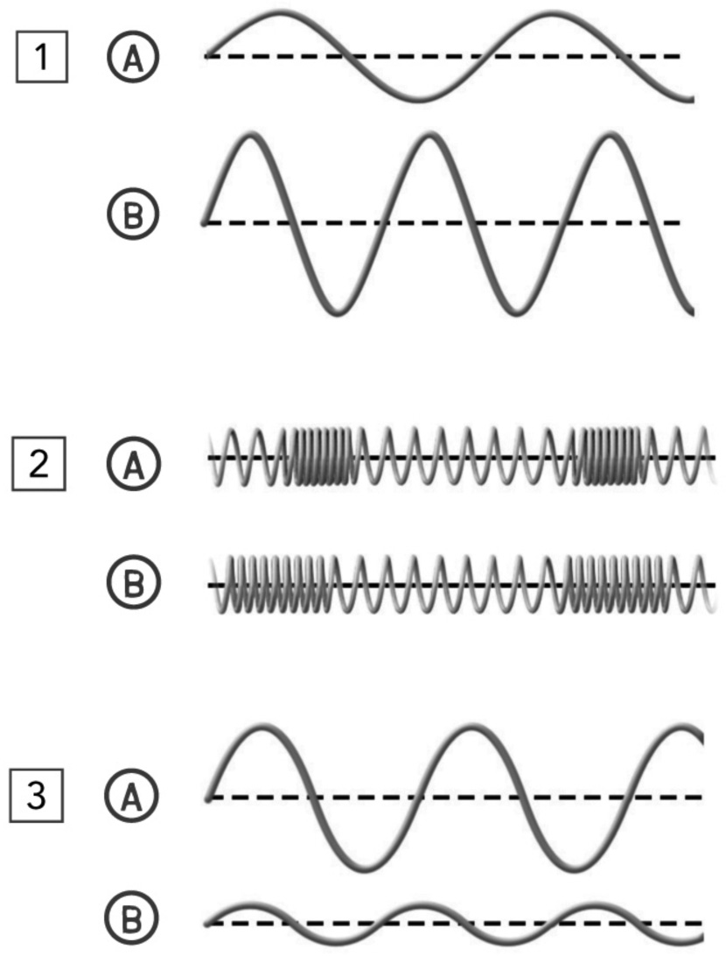
For each pair of diagrams, select the wave with:
a) the greatest amplitude
b) the highest wavelength

 |  | Wave with the  greatest amplitude |  |  | Wave with the  highest wavelength
Pair 1
Pair 2
Pair 3
5. Imagine that you are on vacation by the sea, watching the waves crashing on the beach.
In 10 minutes, you count 60 waves. What is the frequency of the waves in hertz (Hz)?

6. What is the difference between a mechanical wave and an electromagnetic wave?
7. For each of the following examples, describe the type of wave.
a) Bread is browned in a toaster with heat
emitted by its filaments.
b) Televisions capture waves transmitted by
various stations.
c) Some people believe that cellular
telephones are harmful to our health.
d) It is possible to see a rainbow as it forms.
e) Some people believe that tanning salons
should be off-limits to anyone under 18.
f) Doctors order X-rays when they think a
bone may be broken.
2 Sound waves (pp. 100–105)
8. What type of wave is a sound wave? Explain your answer.

9. How does a sound wave travel? Explain your answer.
10. You are listening to music in a car with its windows down.
a) If you increase the volume by 20 dB, how many times is the intensity of the
sound amplified?
b) A truck drives by the car. If the overall sound is twice as loud, would the number of decibels be doubled? Explain your answer.
11. If you were next to a loudspeaker listening to very loud music, would you feel the air moving? Explain your answer.
12. What is the unit of measurement for:
a) the intensity of sound?
b) the frequency of sound?
c) the speed of sound?

13. Some whistles produce sounds that can be heard by dogs, but not by humans. Explain.
14. What is the principle that makes a boat’s sonar work?
3 Light waves (pp. 106–116)
15. What is the difference between specular reflection and diffuse reflection?
16. Imagine that a tomcat looks in a mirror and sees the image of a mouse behind him to the right. Sketch the scene on a piece of paper and include the incident rays and reflected rays to show how the tomcat can see the mouse.

17. For each of the following illustrations, indicate whether the principles of reflection in a plane mirror are being respected. Explain your answer.
Object
Image
Object
Image
Object
Image
Object
Image

a) 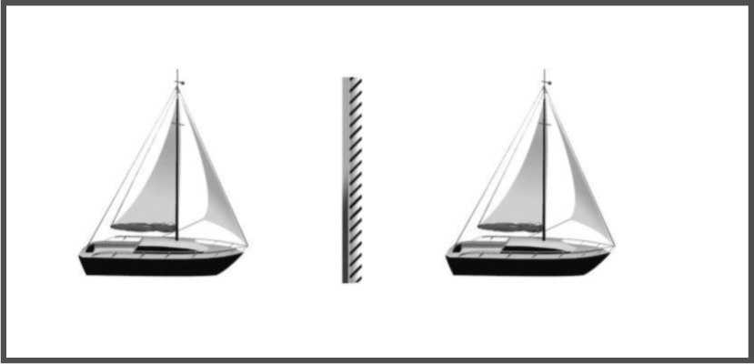

b) 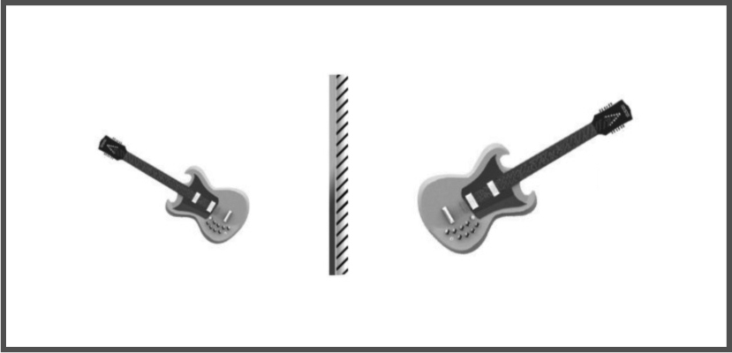

c) 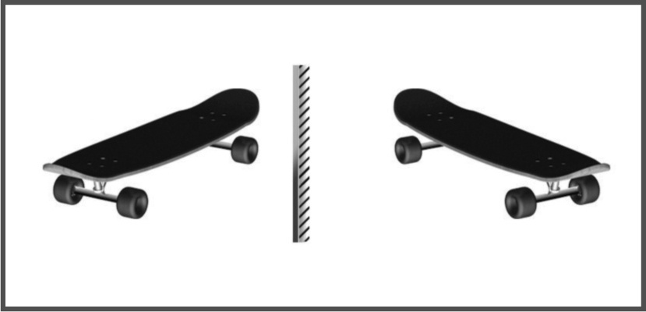

d) 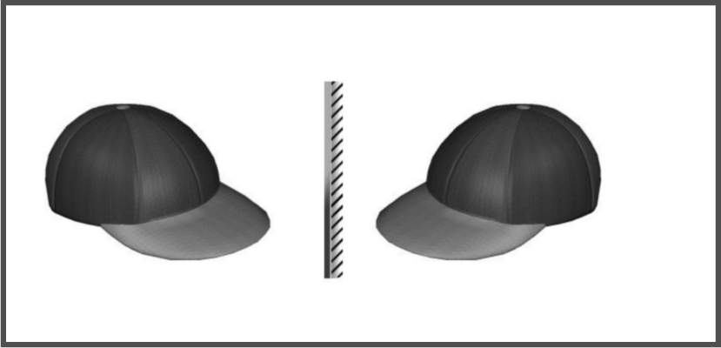
Object
Image
e) 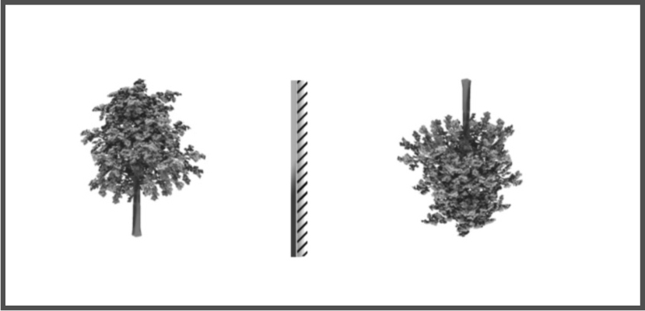

18. For each of the following situations:
a) Draw on a piece of paper two of the three rays involved.
b) Describe the image that is formed.
1) An object located between the focal point of a converging lens and the lens.

2) An object located at twice the distance from the focal point to the converging lens.
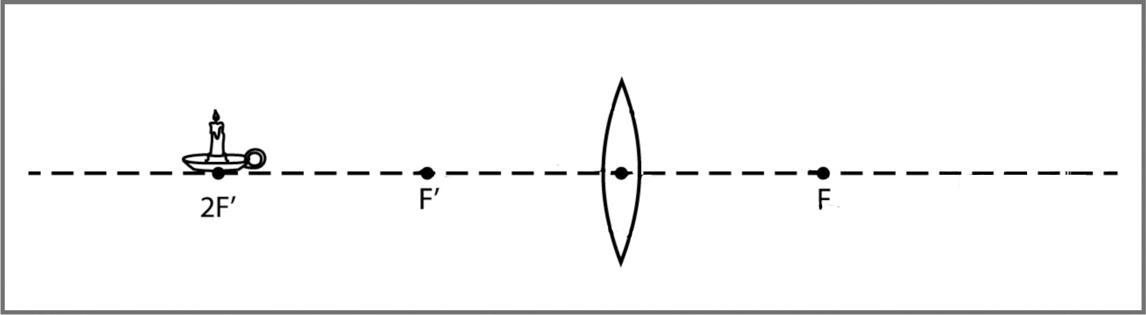
Object
3) An object located at twice the distance from the focal point to the diverging lens.
Object
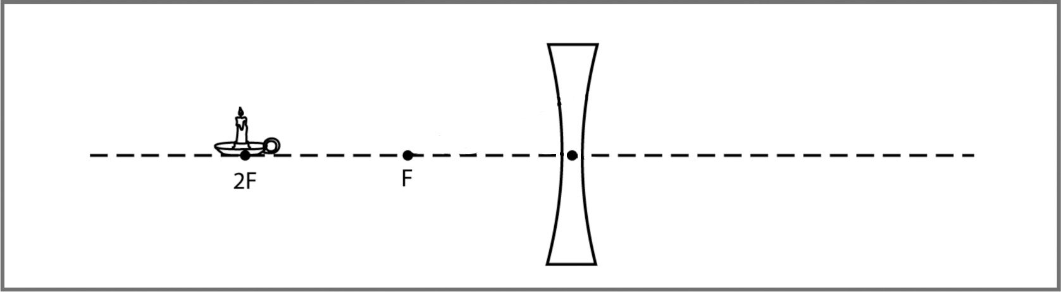

4) An object located at the focal point of a converging lens.
Object

19. Look at the following photo.

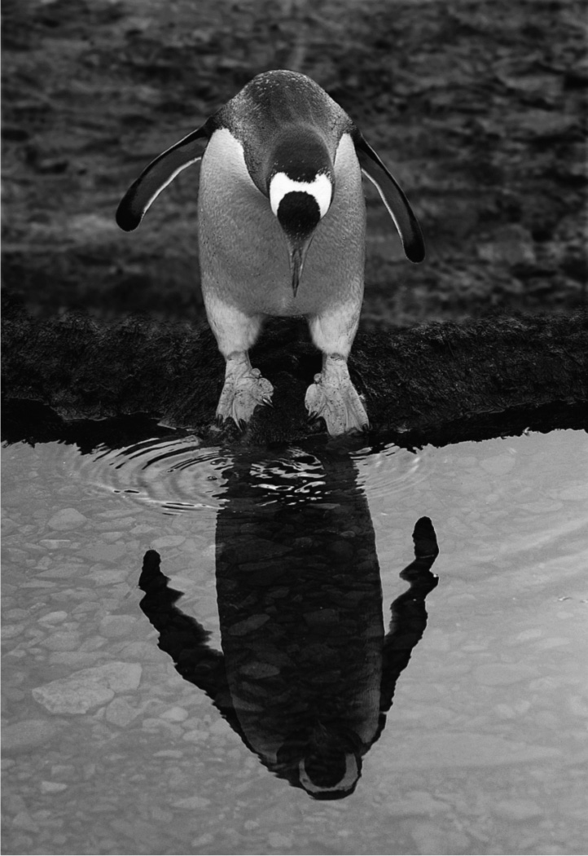
a) Name the phenomenon that allows the penguin to see its reflection in the water.
b) Name the phenomenon that makes the stones in the water seem closer than they
really are.

20. Indicate whether each of the following is a converging lens or a diverging lens.

 | Type of lens
 | Converging | Diverging
a) a magnifying glass
b) a corrective lens for a person with presbyopia
c) the following symbol as it appears on a diagram:
d) a lens that always forms an image smaller than
the object
e) a lens that brings the rays that travel through it
closer together
f) a biconvex lens
21. What is the difference between presbyopia and hyperopia?

