Checkup • Chapter 3
1 What is a fluid? (pp. 66–69)
1. What are the characteristics of a fluid?
2. a) In what states do the substances that we consider to be fluids exist?
b) For each of the states, list the characteristics of the particles that give them the properties of fluids. Present your answers in the table below.

 | State |  |  | Particle characteristics

3. Look at the following photos.

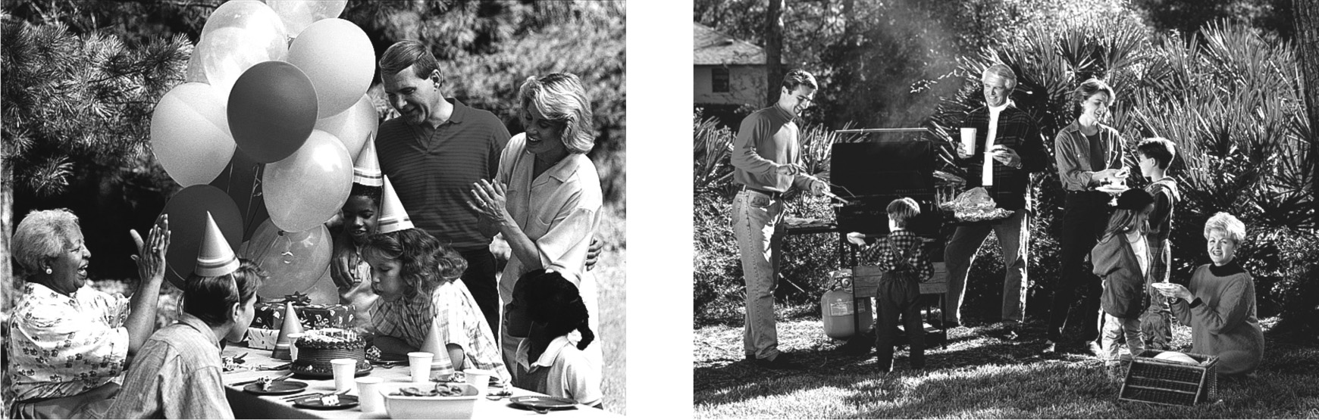
Find the compressible fluids and the incompressible fluids in these photos. Present your answers in the table below.

Compressible fluids |  |  | Incompressible fluids
4. What is the difference between a compressible fluid and an incompressible fluid? In other words, how is it that one can have a variable volume and not the other?

2 What is pressure? (pp. 70–72)
5. In the International System of Units, what is the unit of measure for pressure?
6. There are many types of vehicles on the roads: cars, motorcycles, trucks, etc. Because trucks can damage the road surface, they are sometimes not allowed on certain roads.
a) Using the concept of pressure, explain how trucks damage the roads.
b) Large trucks generally have numerous wide tires. What is the advantage of having these tires for the roadways?
7. A man’s foot has a surface area of 0.03 m² and a snowshoe has a surface area of 0.3 m². How does the pressure exerted on the snow change for this man, with and without snowshoes? Explain your answer.

8. Let’s say you place two rocks on the sand. The first rock has a mass of 5 kg and the second has a mass of 15 kg. If the two have the same contact surface, which of the two rocks exerts more pressure? Explain your answer.
9. A cylinder with a radius of 10 cm (and a surface area of 0.03 m²) and a force of 10 N is placed upright on a table. What is the pressure exerted by the cylinder on the table?

 | Steps |  |  | Problem-solving approach

3 The pressure exerted by fluids (pp. 73–80)
10. What changes the pressure in a liquid?
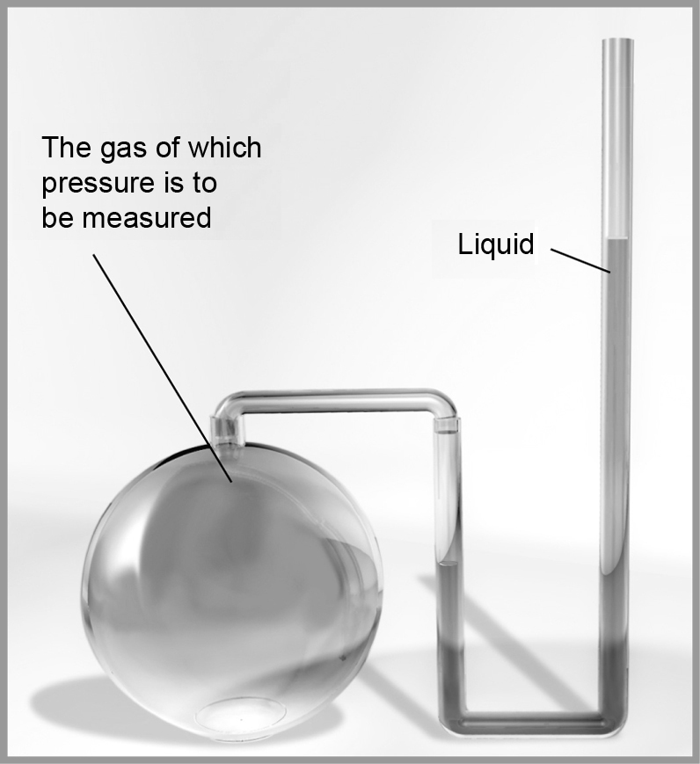
11. In a laboratory, it is useful to measure the
pressure of a gas with a U-shaped manometer
(such as the one illustrated at right). How is
pressure measured with this instrument?
12. Even if a gas is very light, it can still exert a lot of pressure. What is the principal element that determines the pressure of a gas?
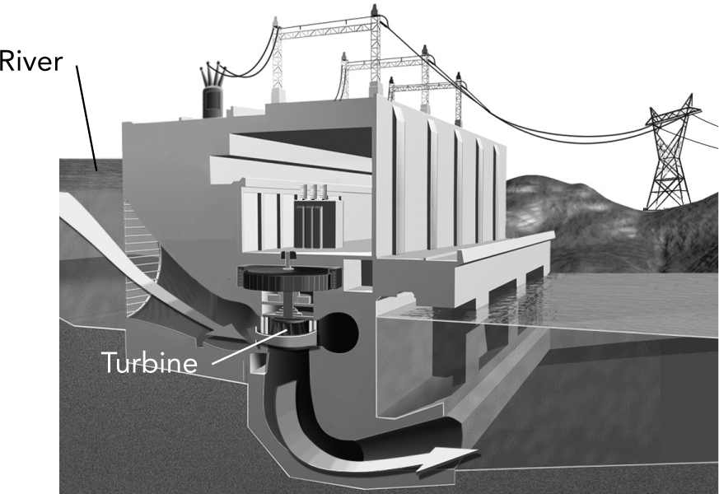
13. Look at the illustration of a
hydroelectric dam at right.

Why do you think that it is preferable to install an inflow pipe to the turbine as low as possible with respect to the dam?
14. Decompression sickness, also known as the bends, is a well-known condition among deep-sea divers. It is caused by gas bubbles developing in the blood when a diver ascends to the surface too quickly. The bubbles are formed by changes in pressure. Explain the relationship between the pressure and the volume of gas bubbles.
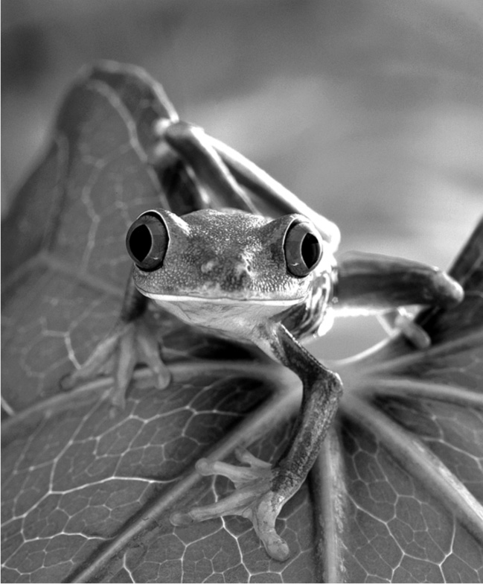
15. Certain animals such as tree frogs have suction cups
on their feet. These suction cups reduce the amount
of air beneath their feet and stick to surfaces easily.
a) Explain how these tiny suction cups help tree
frogs “stick” to surfaces.
b) Would this system work in space where pressure is practically nonexistent? Explain your answer.

16. When we increase the temperature of a gas, what happens to its pressure?
Explain your answer.
4 Mechanisms related to variations
in the pressure of fluids (pp. 81–84)
17. In the summer, some people find fun playing with water guns. When the trigger of a water gun is pulled, water shoots out. The further away the target is, the harder the trigger has to be pulled. Explain what happens to the pressure of the water in the water gun when the trigger is pulled.
18. How do fluids circulate through a (closed) system?
19. When pulling away the tab on a can of soda pop, why does some of the gas escape?
20. We know that on Earth a canister of gas can never fully empty on its own. Would the same be true in space, where pressure is practically nonexistent? Explain your answer.

21. A hydraulic system like the one illustrated below allows us to increase a force. Using the concept and principles of pressure, explain how this is possible.

