Checkup • Chapter 2
1 What is energy? (pp. 34–35)
1. Energy has the ability to do two things: what are they?
•
•

2. What unit of measurement is used to
measure energy?
3. Read the passage below.

Name each type of work and each change (mentioned in the text above) that is produced by energy. List your answers in the table below.
In the past, water wheels were used to carry out hard work. The wheels were generally built close to fast-running rivers. The water’s movement turned the wheel for the mill. This movement was connected to other functions; for example, a saw for cutting wood, millstones for grinding grain into flour or devices for spinning wool. In this way, small industry was born. Water wheels were later replaced by steam engines. The steam from boiling water kept the engines running.

 | Work |  |  | Change

2 Forms of energy (pp. 35–41)
4. What forms of energy are involved in each of the examples below?

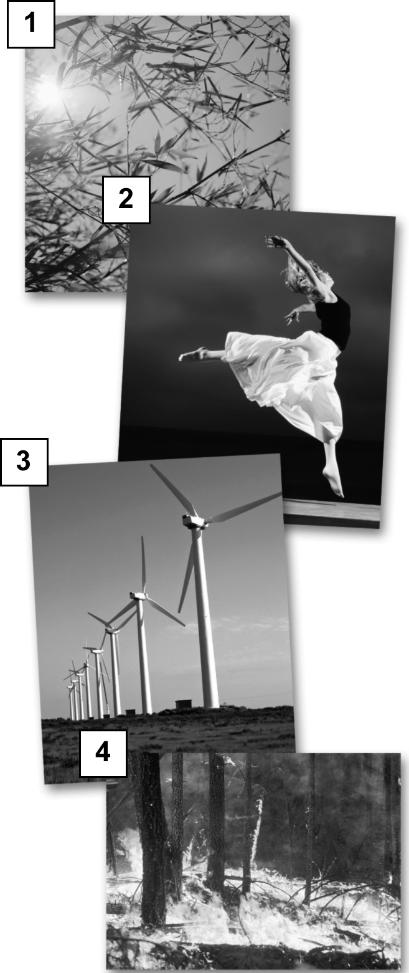
5. Look at the photos at right. In the first column of
the table below, list the action shown in each photo.
In the second column, list at least one form of energy
involved in each action.
Form of energy
a) causes particles of a substance to move
b) produces a beam of light
c) is stored in the bonds between atoms in
a molecule
d) results from the speed of an object, its mass or its relationship to its surroundings

Action |  |  | Form of energy

Action |  |  | Form of energy
6. Imagine that you are watching a diving competition. There are three platforms: the first is
1 m high, the second is 3 m high and the third is 10 m high. Three divers with relatively the same mass are preparing for their dives. Which one will hit the water with the most mechanical energy? Explain your answer.
3 Energy transformation and transfer (pp. 41–42)
7. Look at the photo at right.
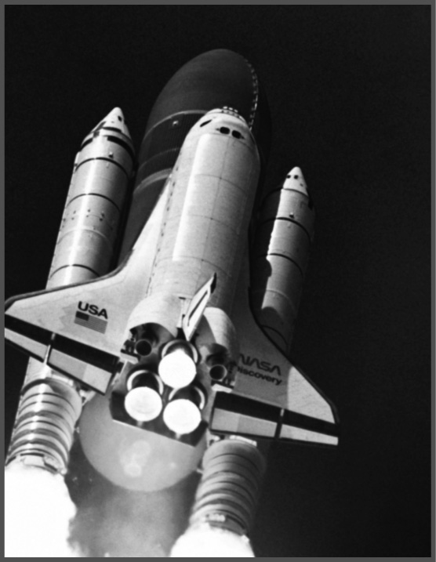
The chemical energy of the substances contained in
the rocket boosters is launching the space shuttle. During
the launch, is there energy transformation or energy
transfer or both? Explain your answer.
Explanation:

8. Heat is a transfer of what form of energy?
4 Physical changes (pp. 43–50)
9. Name two examples of physical change.
10. Carbon dioxide freezes at –80°C. It can then be used for a variety of purposes. For example, it can be used to keep certain substances frozen during transportation. It is a good choice because it is very cold and doesn’t make a mess. When it undergoes a change of state or phase, it is as if carbon dioxide just disappears: it changes from a solid to a gas, hence its nickname “dry ice.”
a) What is this change of state called?
b) During this change of state, what form of energy is transferred?
c) How is energy transferred during this change of state? Indicate the direction of the transfer and where it takes place.
11. Let’s say you dissolve a certain quantity of a substance in water. You observe that the temperature of the resulting solution is higher than the temperature of the water. Did this dissolution absorb or release energy? Explain your answer.

5 Chemical changes (pp. 50–58)
12. Give two examples of chemical change.
13. Your body needs energy. Does it need to synthesize or decompose molecules in order to fill its need? Explain your answer.
14. In a natural gas fireplace, the flame is produced by the combustion of methane. During this reaction, a methane molecule (CH₄) and two oxygen molecules (O₂) react to form one carbon dioxide molecule (CO₂) and two water molecules (H₂O).
a) Is this an oxidation process? Explain your answer.
b) Does this process absorb or release energy? In what form(s)?
c) Write the chemical equation for this reaction.

15. For each of the following examples, indicate whether a physical change or a chemical change is involved and indicate the name of the change.

 | Type of change |  | Name of change
 | Physical | Chemical
a) a person making clouds with
their breath
b) a cut apple turning brown
c) a person digesting a meal
d) a crumpled piece of paper
e) a person cleaning a grease spot
with soap
f) a factory producing ammonia (NH₃)
from nitrogen (N₂) and hydrogen (H₂)
g) limewater that becomes milky when
exposed to carbon dioxide

