Checkup • Chapter 1
1 What is matter? (pp. 6–9)
1. How do we define matter?
2. What holds the particles of a solid together?
3. Using the particle model, describe two differences between a solid, a liquid and a gas.

 | Solid |  |  | Liquid |  |  | Gas

4. The particles in a sample of matter are very close together.
a) Using only this information, can you confirm that this sample is a solid? Explain
your answer.
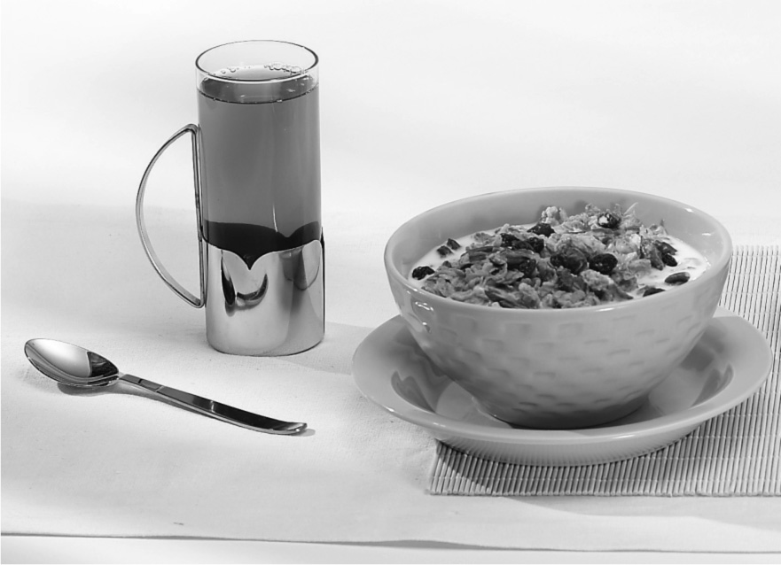
b) What other information could you use to be certain that the sample is a solid?

5. What is the name of the smallest particle
of matter that cannot be chemically divided?
2 Mixtures (pp. 10–20)
6. Look at the photo at right. What type of
mixture is each of the items in the photo?

 | Heterogeneous mixtures |  |  | Homogenous mixtures

7. What type of mixture is each of the following?

 | Heterogeneous  mixture | Homogeneous  mixture
a) a handful of earth
b) air
c) smog
d) a stainless steel fork
e) seawater
f) whipping cream
g) a raisin muffin
8. Give the term for each of the following definitions.
a) a substance that can dissolve another
substance
b) a substance that can dissolve into another
substance
c) a homogeneous mixture made up of one
substance dissolved in another substance
9. What determines the concentration of a solution?
10. A patient receives a prescription from the doctor for a medication that needs to be dissolved in water at a concentration of 2 g/L. The dosage is the following: one teaspoon
(5 mL) three times a day for 10 days.
a) What is the minimum volume of the medication in solution that the patient will need?

b) If you were the pharmacist, how would you prepare the medication from a powder? Describe what you would do and show all of the calculations you need to prepare the right quantity of medication for the patient.

 | Steps |  |  | Problem-solving approach

11. A woman wants to dye her hair lighter than her natural colour. Her hairdresser uses a hydrogen peroxide solution at 3 percent V/V to lighten her hair. He needs to prepare 100 mL of this solution by diluting a concentrate to 30 percent. How should he do it? Describe how you reached your answer, showing all your calculations.

 | Steps |  |  | Problem-solving approach

12. The label on a bottle of wine indicates that the wine contains 12 percent alcohol m/V.
How much alcohol does a 750-mL bottle of wine contain? Show all the steps leading
to your answer.

 | Steps |  |  | Problem-solving approach

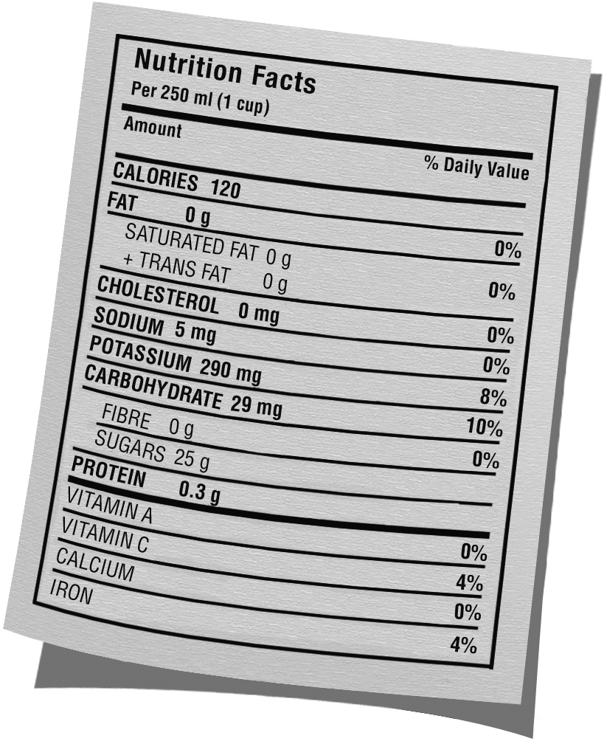
13. The Nutrition Facts label on a container of
apple juice indicates that 250 mL of juice
contains 25 g of sugar. Calculate the
concentration of sugar in the juice in g/L.
Show all the steps leading to your answer.

 | Steps |  |  | Problem-solving approach

14. Name four factors that can affect the solubility of a substance.
15. How does the solubility of table salt in water change with temperature?
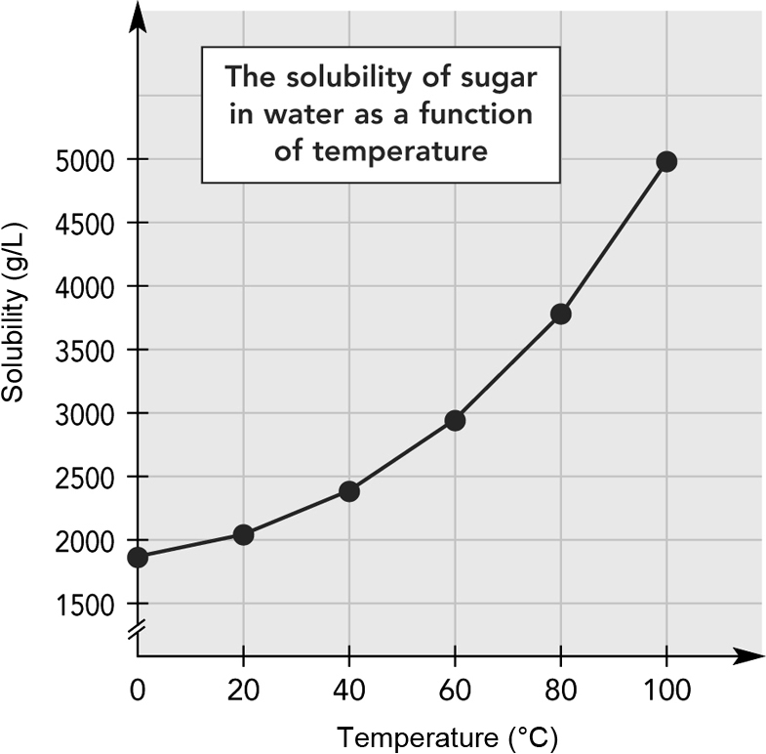
16. Look at the graph at right. What is the solubility
in g/L of this solid at a temperature of 60ºC?
17. Some industries dump hot water into the environment. How is this practice harmful to fish?

18. How can we obtain pure substances from a mixture?
19. Indicate which separation technique you think would be the most appropriate for each of the following mixtures:

3 Pure substances (pp. 21–26)
Separation technique
a) a saltwater solution
b) water mixed with sand
c) a blood sample
d) an oil-and-vinegar dressing
e) water mixed with alcohol
f) black ink
g) toxic smoke
h) oil
20. Give two examples of non-characteristic properties.
21. We can identify a substance by observing its characteristic properties.
a) What is the difference between a characteristic physical property and a characteristic chemical property?

b) Give an example of a characteristic physical property.
c) Give an example of a characteristic chemical property.
22. Why is density a characteristic physical property, but not mass or volume?
23. You are given three solid substances, all in the form of a white powder. How can solubility help you to identify each of the three substances?

24. A technician is given a gas sample to identify. She performs a series of tests and compiles her results as follows:

Properties | Results
Freezing point | –259ºC
Density | 0.000 09 g/mL
Colour | Colourless
Odour | Odourless
Reaction to limewater | No change
Reaction to open flame | An explosion
a) Study the results in the table. Which tests can be used to identify the gas?
b) What is the gas in the sample?

