Dissecting
a sheep’s brain
LAB 62
OBSERVATION
STUDENT BOOK | Chapter 7, page 206

Goal
Locate and observe structures of the brain.
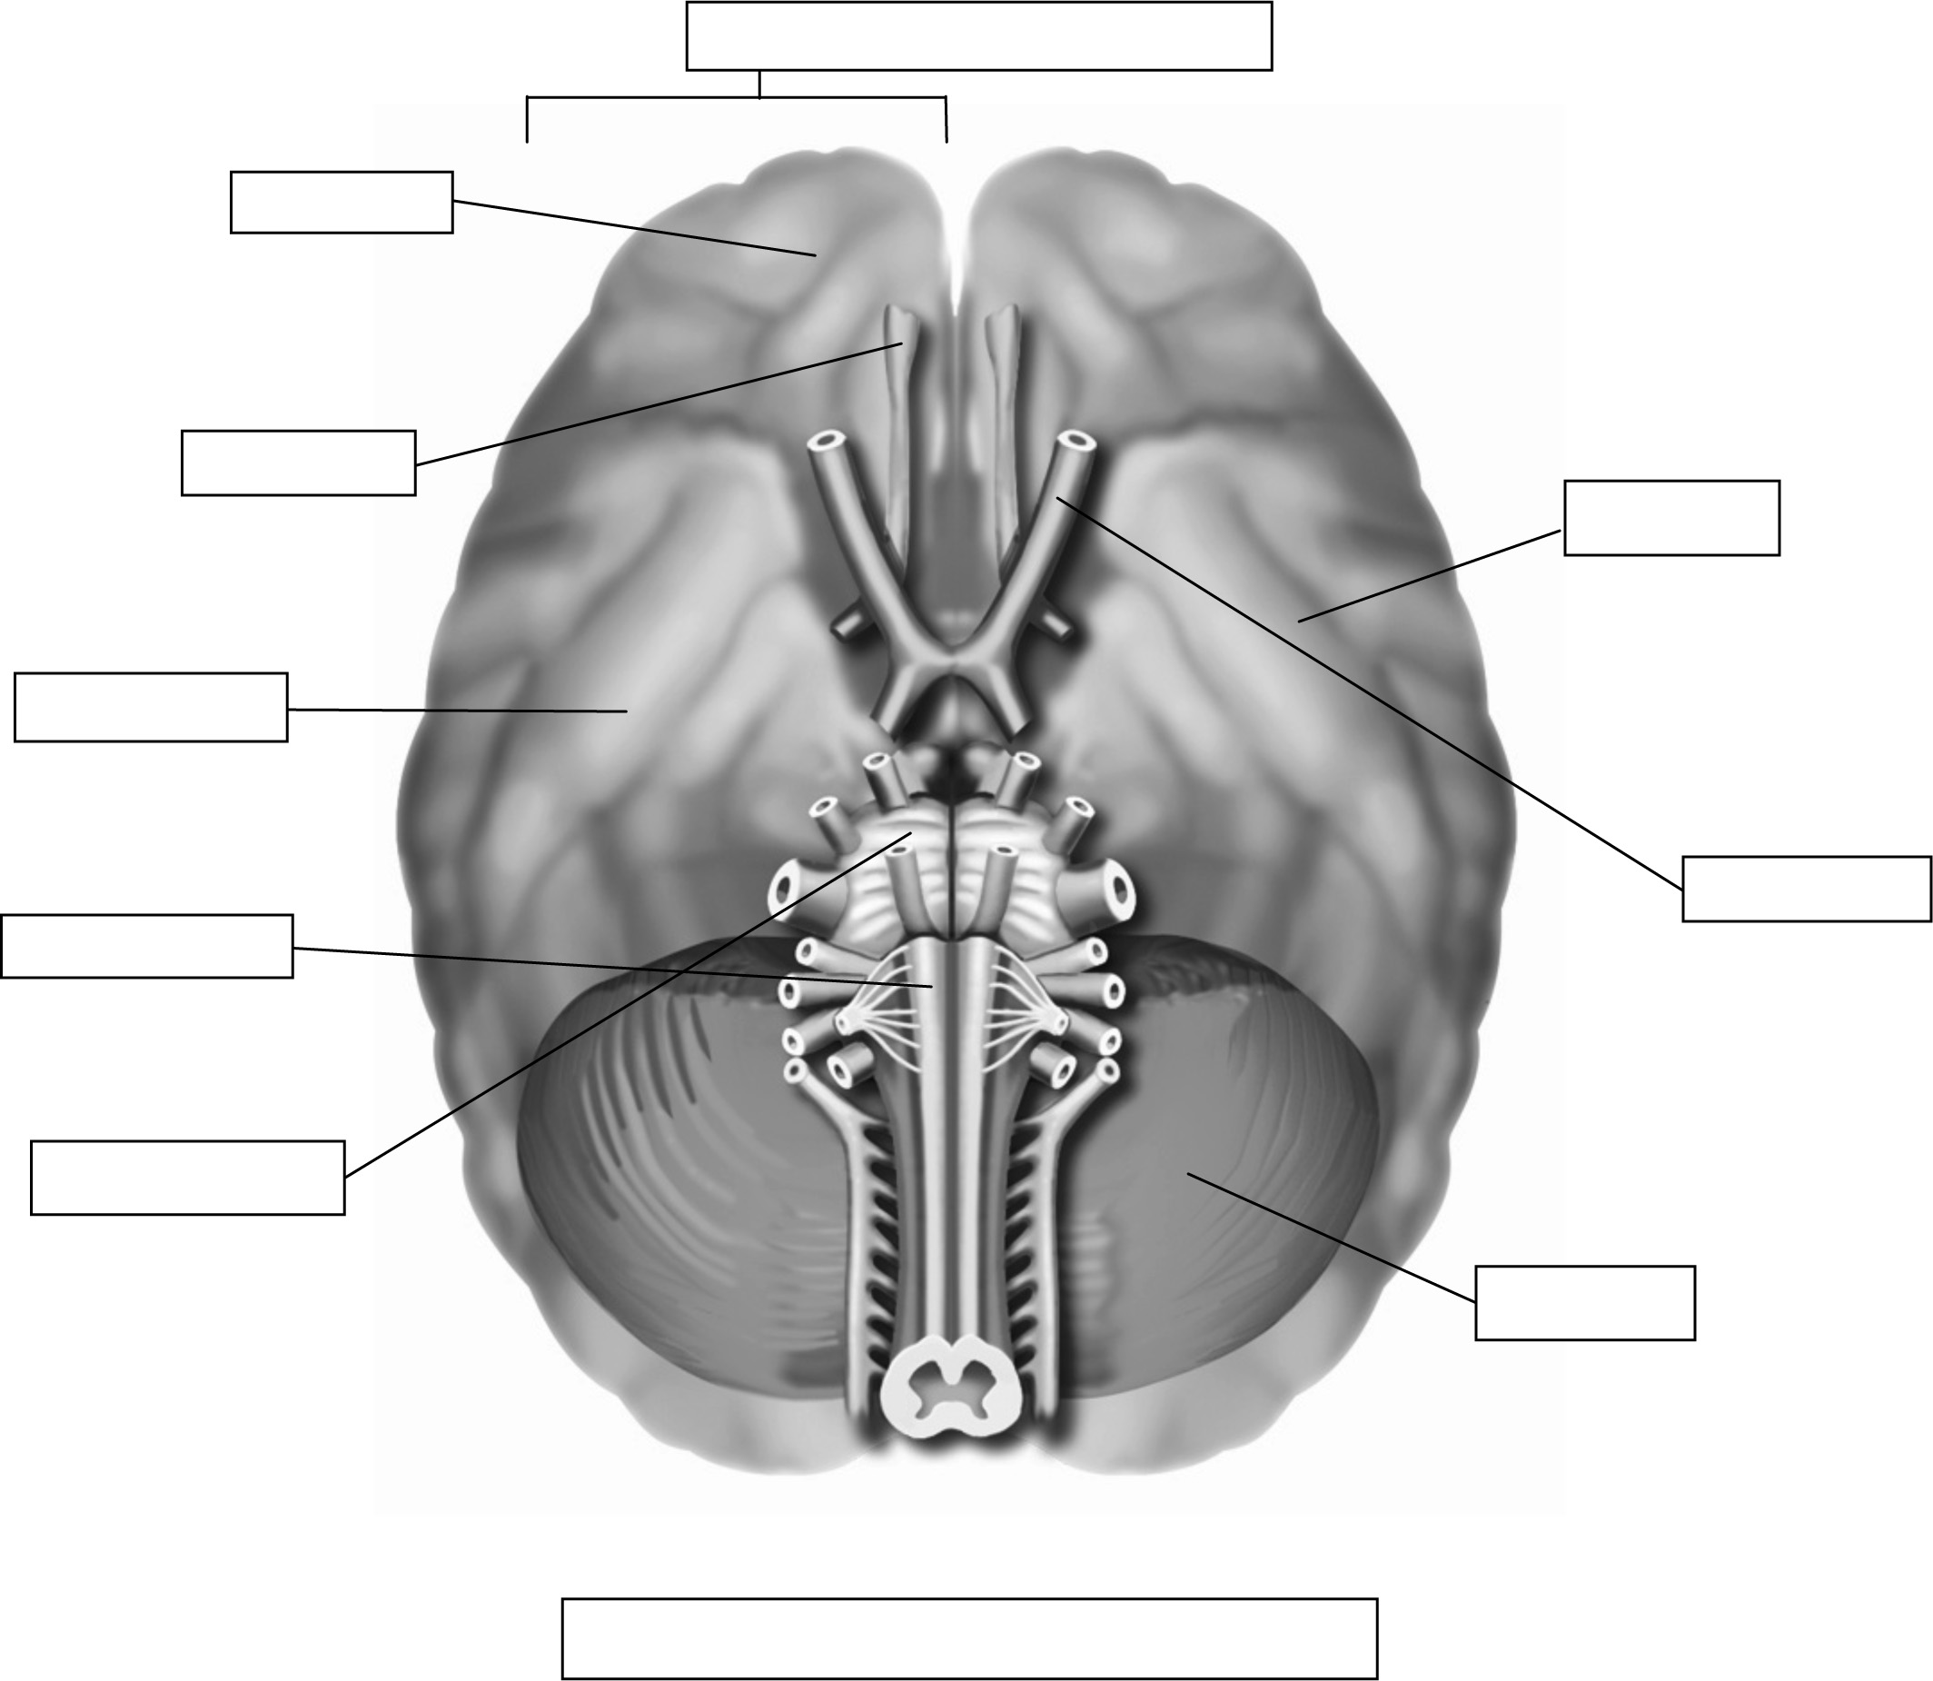
Observation criteria
Medulla oblongata
Temporal lobe
Olfactory nerve
Frontal lobe
Optic nerve
Bottom view of sheep’s skull
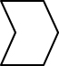
Cerebral hemisphere
1. Identify the three main structures of the brain in the above illustration.
2. In the table below, record the characteristics that will help you to identify each of these structures
when observed during this lab.
Structure | Characteristics
Materials
• gloves
• brain of a sheep
• scalpel or knife
• dissecting forceps
• dissecting scissors
• dissecting pan
• toothpicks
• adhesive paper
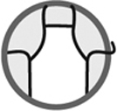
Procedure
External examination
1. Observe the outer membrane of the brain. Note the colour and texture.
2. Locate each visible structure of the brain without cutting. Observe and describe the structure.
3. Spread the two hemispheres of the brain and separate them with the dissecting scissors.
4. With the scalpel, slice the cerebellum into two equal pieces. Note the colour and texture.
5. Complete the cut lengthwise above the centre of the medulla oblongata with the dissecting scissors. Note the colour and texture of the brainstem.
6. Observe the interior of the cerebrum. Note the colours and textures.
7. With toothpicks and adhesive paper, locate and identify each structure observed.
8. Dispose of the brain as directed by your lab instructor.
9. Clean up and put away materials.
Observations
Record your observations in the table below. Give the table a title.

Title:
Structure | Observations
External membrane | Colour:  Texture:
Cerebrum | Description:  Colour:  Texture:
Cerebellum | Description:  Colour:  Texture:
Brainstem | Description:  Colour:  Texture:
Reflecting on your observations
1. Do your observations help you to better understand the structures of the brain?
Explain your answer.
2. Do you think the size of a human brain is the same as that of a sheep? Explain your answer.
3. How could you improve the protocol for this lab?

