Dissecting a kidney
Goal
Locate and observe structures of a mammal’s kidney.
Observation criteria
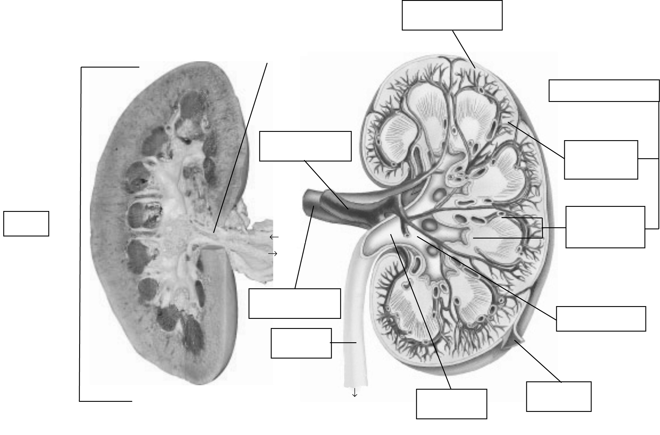
Identify the structures of the kidney indicated in Figure 1.
Renal
pelvis
Renal
capsule
Cortex
Medulla
Renal
columns
Renal
pyramids
Renal calices
Hilum
Blood
Blood
 | a) | Internal view (photo) | b) | Internal view (illustration)
Figure 1 Structures of the kidney

Materials
• gloves
• kidney of a mammal
• dissecting pan
• scalpel or knife
• dissecting forceps
• glass stirring rod
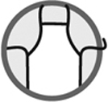
Procedure
External examination
1. Observe the exterior of the kidney. Note its overall shape, colour and texture.
2. Locate the ureter. Note its appearance and colour.
3. Locate the renal artery slightly above the ureter. If the renal artery was cut very close to the kidney, it may be possible to observe up to five openings (instead of one) because of the branching of the artery.
4. Locate the renal vein. Its diameter is greater than that of the renal artery.
5. Compare the thickness of the renal vein wall to that of the renal artery.
Internal examination
1. Cut the kidney into two pieces lengthwise with the scalpel, cutting over the centre of the
kidney above the ureter.
2. Set aside the piece containing the ureter.
3. Detach part of the renal capsule. Note the colour and thickness of the renal columns and
the renal pyramids.
4. Observe the appearance and colour of the cortex.
5. Observe the medulla. Compare the colour of the renal columns and the renal pyramids.
6. Observe the calices. Note their colour and identify the structures of the kidney they link.
7. Observe the renal pelvis. Note the colour.
8. Insert the glass stirring rod into the ureter. Note the structure into which it is positioned.
9. Dispose of the kidney as directed by your lab instructor.
10. Clean up and put away materials.
Observations
Record your observations in the table below. Give the table a title.

Title:
Step | Observations
External examination
Overall shape, colour and texture of kidney
Appearance and colour of ureter
Thickness of renal vein wall compared to renal
artery wall
Internal examination
Thickness and colour of renal capsule
Appearance and colour of cortex
Colour of renal columns compared to
renal pyramids
Colour of calices and structures they link
Colour of renal pelvis
Structure that stirring rod enters when inserted
into ureter
Reflecting on your observations
1. Why is there a difference in thickness between the renal vein wall and the renal artery wall?
2. What structures of the kidney contain numerous blood vessels? Explain your answer by
describing the colour of these structures.
3. Each kidney contains more than a million microscopic structures called nephrons. These
structures filter blood and produce urine. The base of the nephrons is located in the renal
pyramids. Through what structures does urine flow after exiting the nephrons on its way to
the bladder?
4. Did your observations help you to better understand the structures and functioning of a kidney?
Explain your answer.
5. How could you improve the protocol for this lab?

