
THE case study
ANNOUNCEMENT
Internship at an addiction centre
As a medical student, you will soon intern at an addiction treatment centre. You will be asked to complete a case study. The patient you will be treating must overcome a serious drug, alcohol or anabolic steroid dependency. At the end of your internship, you must present information to your patient that will help him or her stop consuming.
To complete your case study, you are to:
• Select one of the cases included in the table at the bottom of this page.
• Prepare an outline of a poster illustrating the desired and adverse effects of consumed substance(s) on the nervous, musculoskeletal and reproductive systems.
• Present written information that complements the information on the poster including measures for remedying the adverse effects, community resources, valuable sources of information consulted, and so on.

In this case study, you are to play the role of a medical student interning at an addiction treatment centre.
Cases to be studied
Patient |  |  |  |  | Toxic substances consumed and  duration of consumption
Case No. | Physical characteristics |  |  |  | Toxic substances consumed and  duration of consumption
Case No. | Gender | Age  (years) | Weight  (kg) | Height  (m) | Toxic substances consumed and  duration of consumption
1 | M | 22 | 98 | 1.75 | Anabolic steroids for four years
2 | F | 14 | 56 | 1.64 | Cannabis (hashish, marijuana) for nine months
3 | F | 19 | 53 | 1.61 | Hallucinogens (LSD, MDA, mushrooms, ecstasy,  PCP) for four years
4 | M | 22 | 61 | 1.65 | Stimulants (amphetamines, cocaine) for two years
5 | M | 15 | 73 | 1.60 | Solvents and glue for 14 months
6 | F | 28 | 59 | 1.69 | Tranquilizers and sleeping pills (GHB, barbiturates)  for three years
7 | F | 21 | 52 | 1.58 | Opiates (heroin, opium) for five months
8 | M | 29 | 102 | 1.87 | Alcohol for six years

creating the context
I ask myself questions
Case studied:
1. What is addiction?
2. For whom is this case study intended?
3. What questions might guide you as you gather information?
I must
4. Restate the goal of your case study.
I think
5. In your opinion, what are the effects of the substance(s) consumed by your patient on his or her body? Explain your answer.
6. In your opinion, what measures would allow your patient to overcome his or her
dependency? Explain your answer.

creating the context (continued)
What I know and what I must find out
7. Write down the information you already know and what you need to find out.

What I know . . . |  | What I must find out . . .
I prepare my work
8. Where will you find the information to give to your patient?
9. Organize the principal steps of your work in chronological order.
Reflection Yes No
Do I fully understand what I need to do?  

gathering information
I do research
Case studied: |  | Substance(s) consumed:
1. What are the effects of the consumed substance(s) on the systems of the human body?
2. What measures could be taken to remedy the adverse effects of the substance(s)?
What community resources exist for people with addictions?
3. What other information would be helpful to give to the patient?
4. What are your principal sources of information?

gathering information (continued)
I apply my research results
5. Link the effects of the consumed substance(s) to the corresponding systems of the human body, as well as to their organs or tissues.

Effects of anabolic steroids on the systems of the human body
Affected systems
Name of system |  | Affected organs  or tissue | Effects
Reproductive  system | Male
Reproductive  system | Female
Nervous system
Musculoskeletal
system
Reflection Yes No
Do I fully understand the scientific concepts involved in this situation?  

completing the case study
I make suggestions
1. Prepare the outline of your poster.
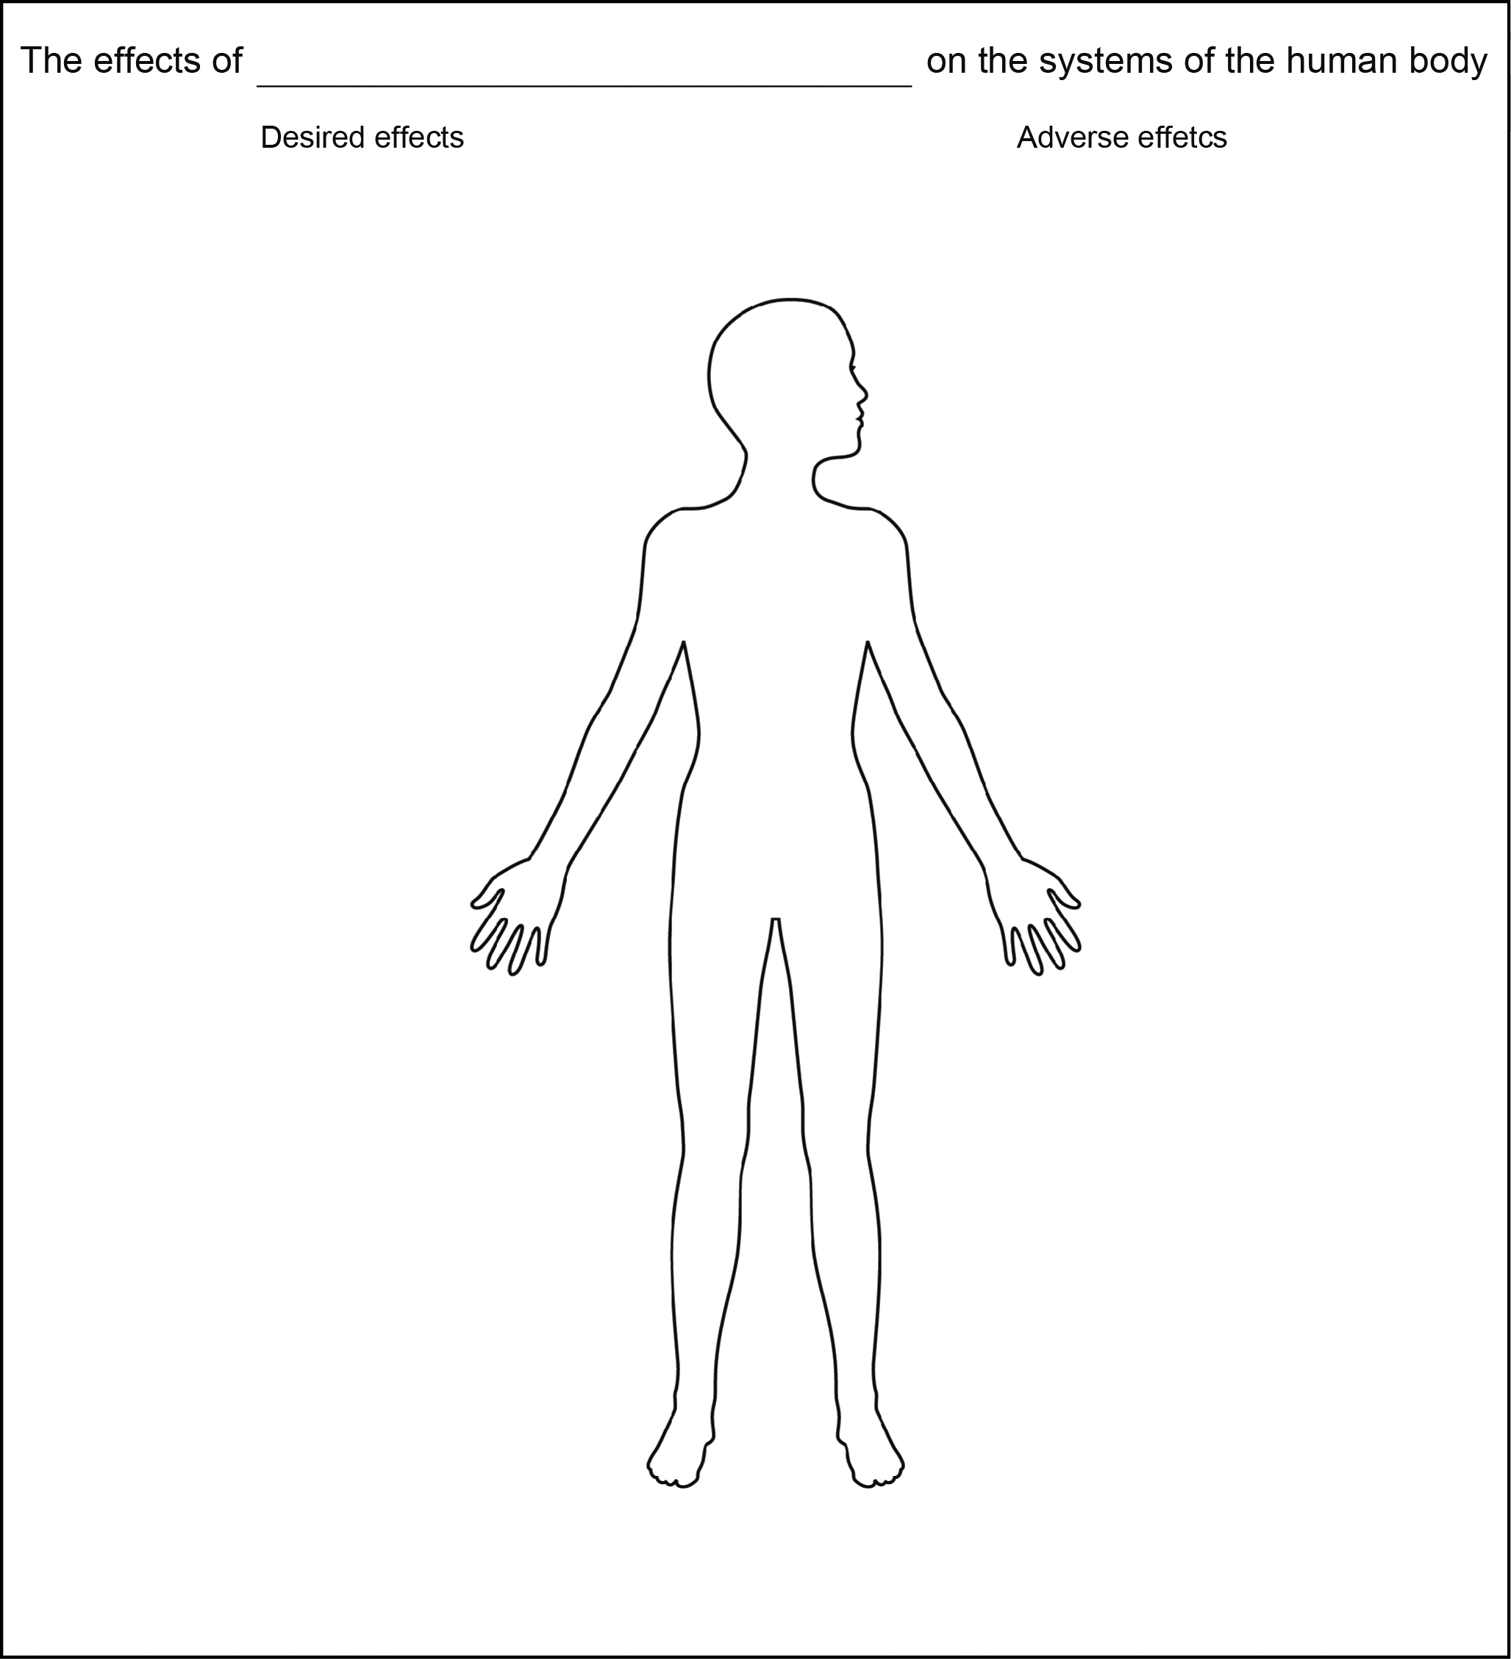

COMPLETING THE case study (continued)
2. Write down other information to give to your patient such as ways to remedy adverse effects, community resources, sources of information, etc.
Reflection Yes No
Have I considered other solutions or explanations?  

Validating the project
I justify my approach
1. What are the most adverse effects of the consumed substance(s) on your patient’s health?
2. Do you think the information you will give to your patient will help him or her stop consuming? Is certain information more convincing than others? If yes, explain your answer.
3. What are the benefits and drawbacks of the measures you are suggesting to your patient to encourage him or her to stop consuming?
4. Among your sources of information, are certain ones more useful than others? Justify your answer.
5. Do you think your poster is a good method for giving useful information to your patient? If not, what would you suggest? Explain your answer.

MY EVALUATION
Use the evaluation grid on the next page to do a self-evaluation. Write A, B, C, D, or E
in the appropriate space.
SSC2 Makes the most of his/her knowledge of science
and technology
Criteria* | Observable indicators | Me | Teacher | Comments
1 | Creating the context |  |   With help
 | Formulation of questions for information gathering and definition of the case study goal |  |   With help
2 | Gathering information |  |   With help
 | Listing of effects produced by consumed substances and identification of their repercussions on systems and organs (or tissues) |  |   With help
3 | Completing the case study |  |   With help
 | Grouping of listed effects into desired and adverse ones, and citing of community resources |  |   With help
4 | Validating the case study |  |   With help
 | Justification of the solution using information sources |  |   With help
* Evaluation criteria
1 Formulation of appropriate questions
2 Appropriate use of scientific and technological concepts, laws, models and theories
3 Relevant explanations or solutions
4 Suitable justification of explanations, solutions, decisions or opinions

evaluation grid
Makes the most of his/her knowledge of science and technology | E | The work needs to  be redone. |  | The work needs to  be redone. |  | The work needs to  be redone. |  | The work needs to  be redone.
 | D | The questions directing the information gathering process are more or less relevant AND  the case study goal is more or  less clear. |  | Some effects are listed but are not linked to the appropriate systems and organs (or tissues). |  | The grouping of listed effects into desired and adverse ones contains several errors. |  | The information presented is not supported by any sources of information.
 | C | The questions directing the information gathering process are more or less relevant  OR  the case study goal is more or  less clear. |  | Some effects are listed and linked to the appropriate systems and organs (or tissues). |  | The grouping of  listed effects into desired and adverse ones; contains some errors; at least one community resource  is mentioned. |  | The information presented is supported by sources of information that are more or less reliable and varied.
 | B | The questions directing the information gathering process are relevant. The case study goal is clear. |  | Many effects are listed and most  are linked to the appropriate systems and organs  (or tissues). |  | All the listed effects are correctly grouped into desired and adverse effects;  a few community resources are mentioned. |  | The information presented is supported by reliable but unvaried sources of information.
 | A | The questions directing the information gathering process are relevant. The case study goal is very clear. |  | Many effects are listed and all are linked to the appropriate systems and organs (or tissues). |  | All the listed effects are correctly grouped into desired and adverse effects; several community resources are mentioned. |  | The information presented is supported by varied and reliable sources of information.
 | Observable indicators | CREATING THE CONTEXT | Formulation of questions for information gathering and definition of the case study goal | GATHERING INFORMATION | Listing of effects produced by consumed substances and identification of their repercussions on systems and organs (or tissues) | COMPLETING  THE CASE STUDY | Grouping of listed effects into desired and adverse ones, and citing of community resources |  | VALIDATING  THE CASE STUDY | Justification of the solution using information sources
 |  | 1 |  | 2 |  | 3 |  |  | 4
* Evaluation criteria
1 Formulation of appropriate questions
2 Appropriate use of scientific and technological concepts, laws, models and theories
3 Relevant explanations or solutions
4 Suitable justification of explanations, solutions, decisions or opinions

