
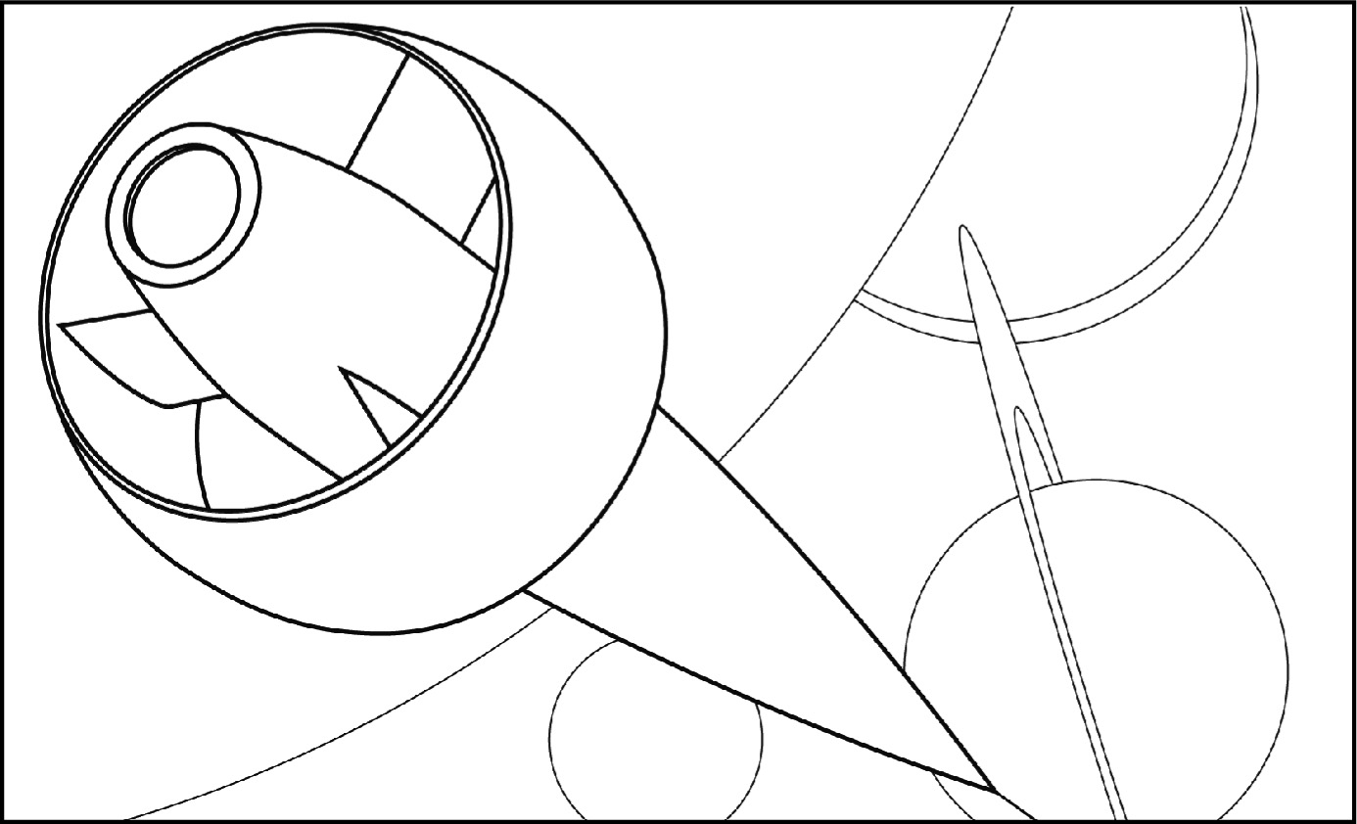
THE PROJECT
PUT ON
your sports
shoes!
The solar system . . .
like you’ve never seen
it before
A gigantic exhibit
A journey light years away . . .
or almost!
• June 20–
September 2,
• An exhibit created by the Science Museum
• To go on display at a sports facility near you
The Science Museum is planning an exhibit on the solar system. In order to reach the largest possible audience, the exhibit will go on display in various sports facilities around Québec. The museum will use one sports facility at each chosen location to allow technicians in museology to use a scale reduction as they reproduce distances within the solar system. It hopes to correct a popular misconception—fuelled by science fiction films—that distances in the solar system can be spanned with ease.

In this simulation exercise, you are to play the role of a technician in museology and your mandate is to design an installation of the exhibit by creating a scale model (poster, mock-up, etc.) of the eight planets of the solar system projected on the “platform” of a sports area. To complete the task, you are to:
• Select a platform for your model from among the various sports areas listed below:
A soccer field
B Canadian football field
C basketball court
D Olympic ice rink
• Determine the scale for your model.
Then, using your model:
• Estimate greater distances in the Universe.
• Compare your model to those of your classmates.

the project (continued)
A Soccer field
Goal
Goal area
Penalty area
Penalty spot
Penalty arc
R
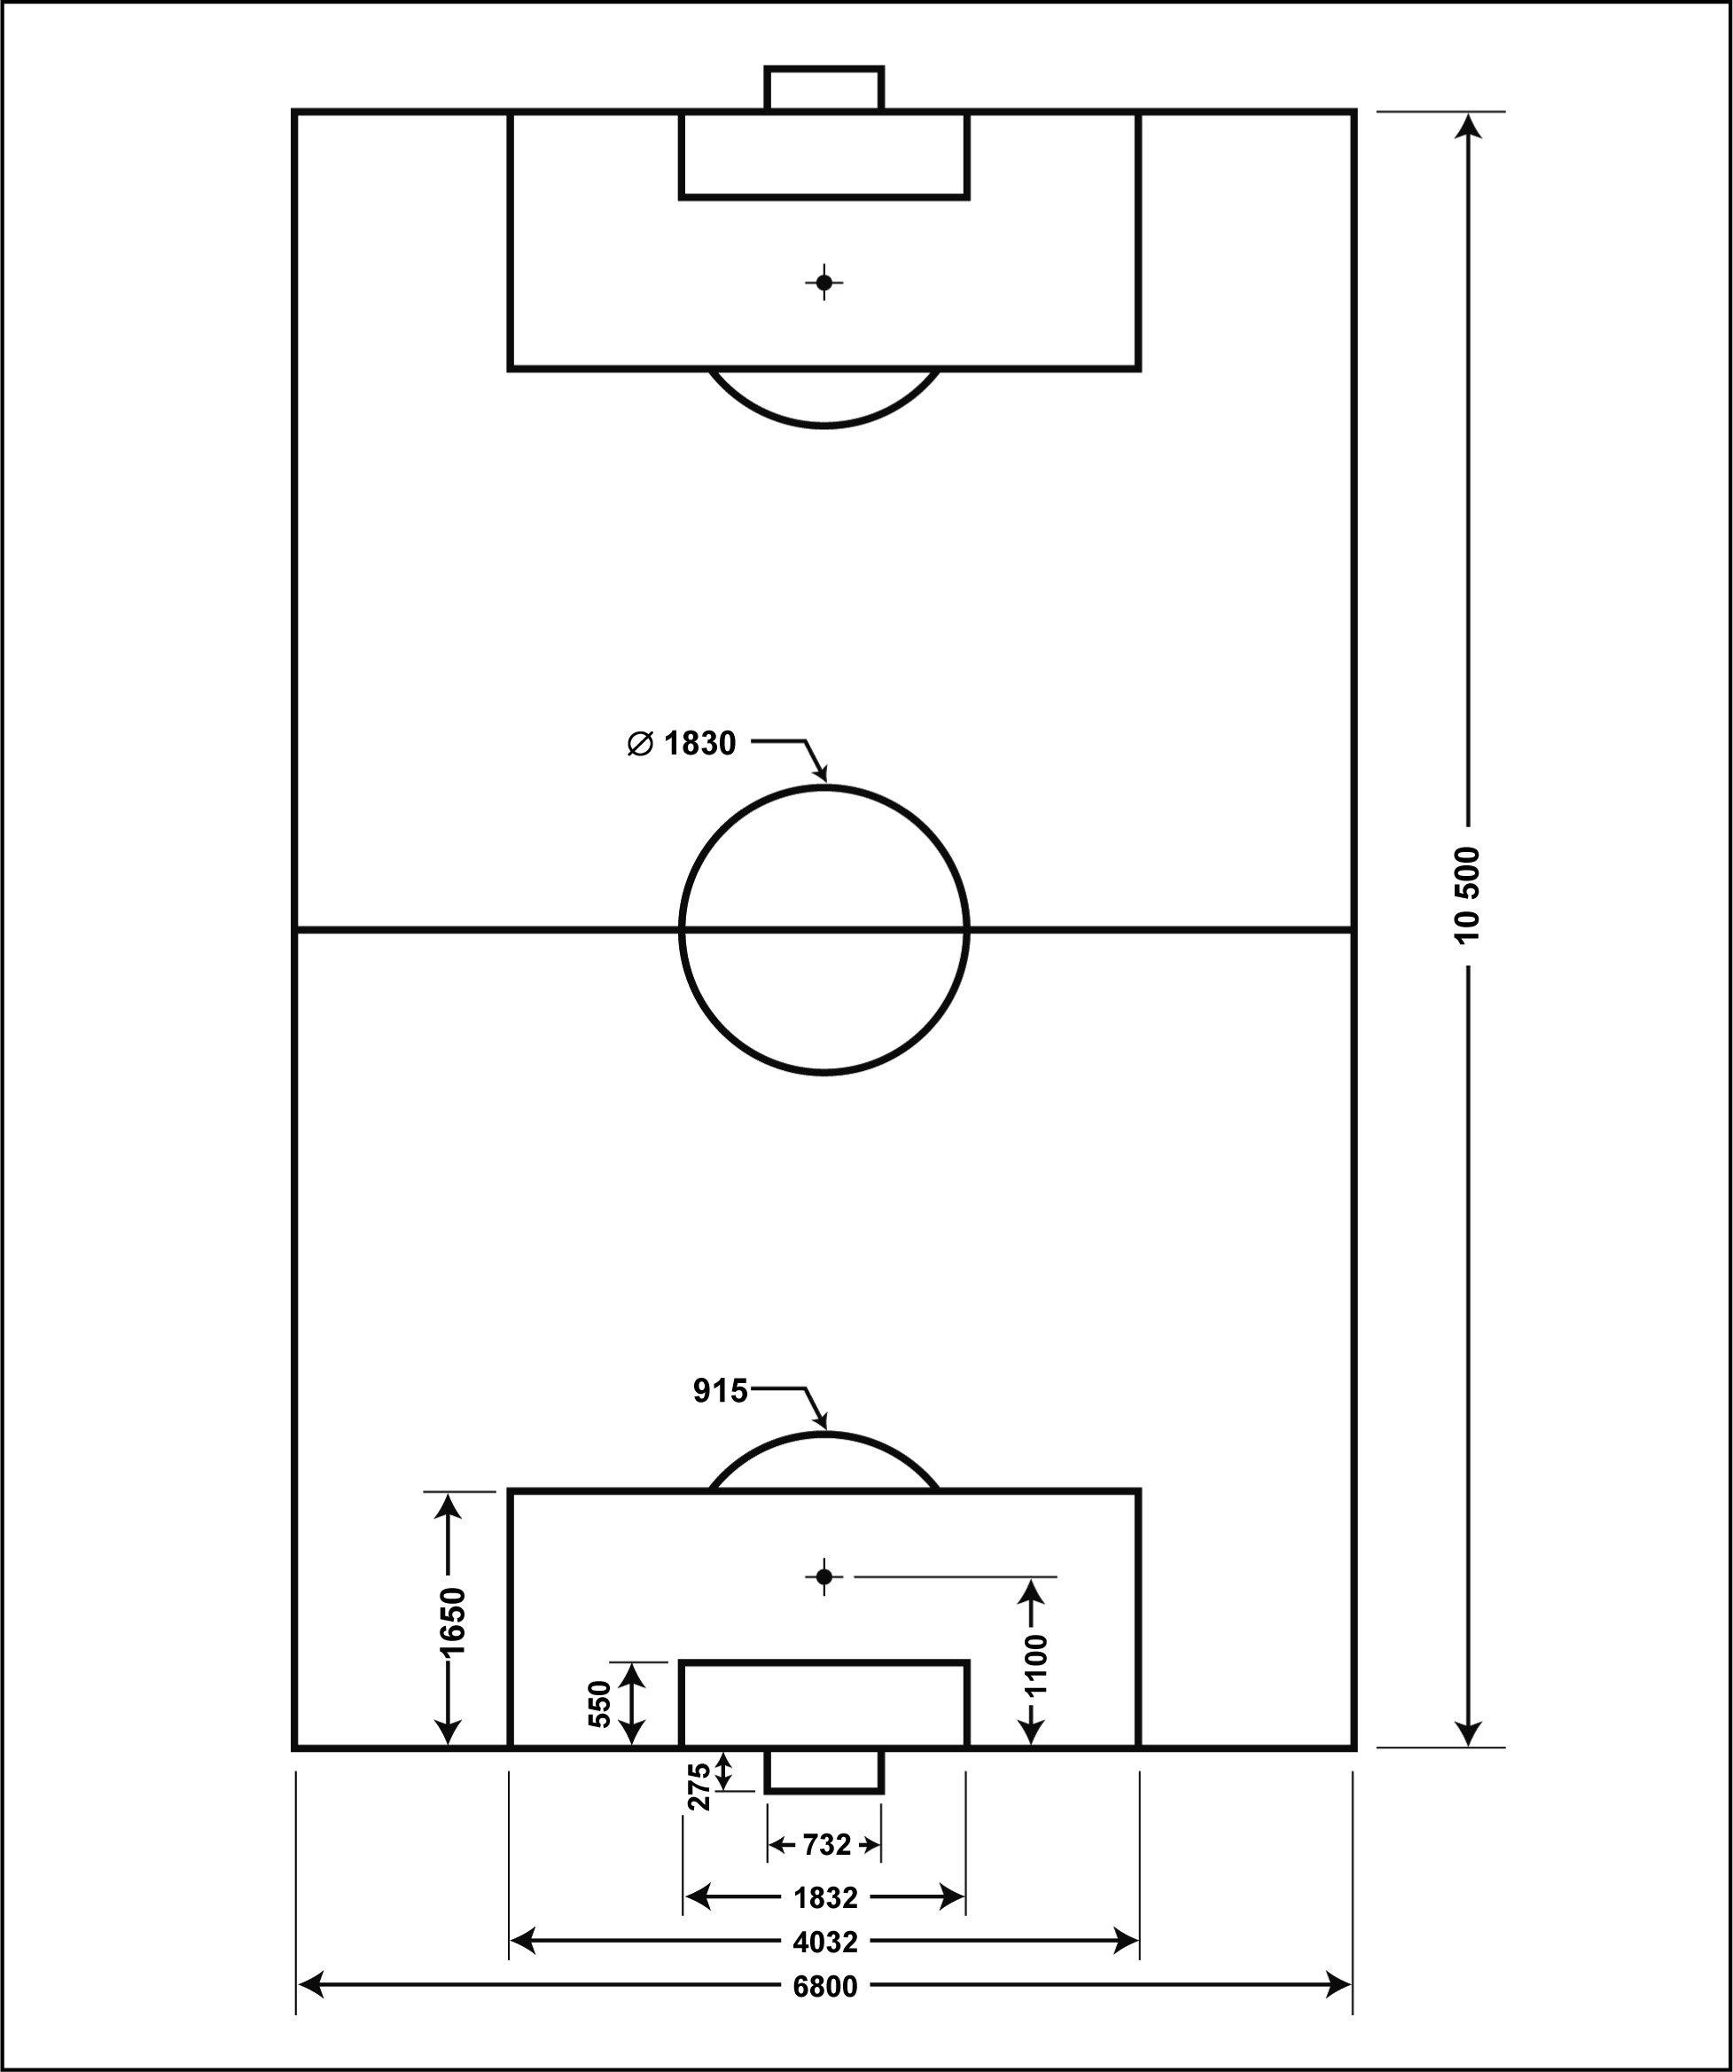
(Dimensions in centimetres)

the project (continued)
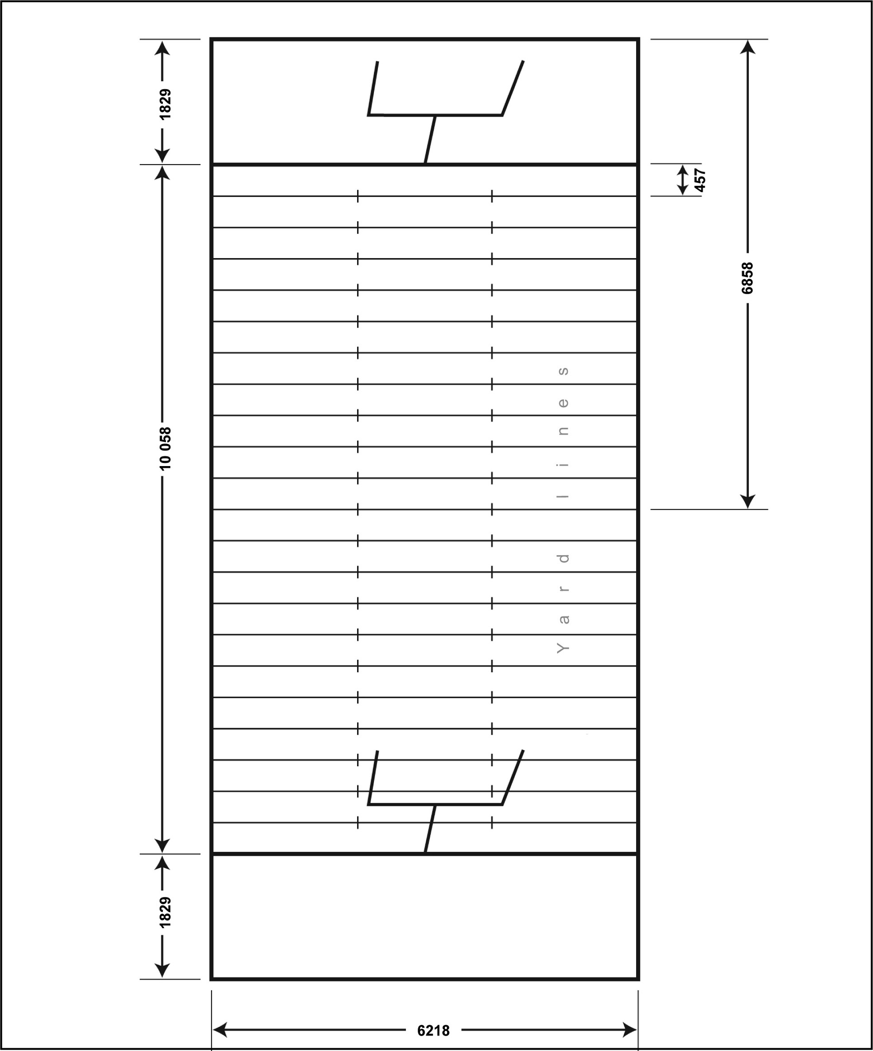
B Canadian football field
(Dimensions in centimetres)
Centre line
Goal line
End zone
Dead line
the project (continued)
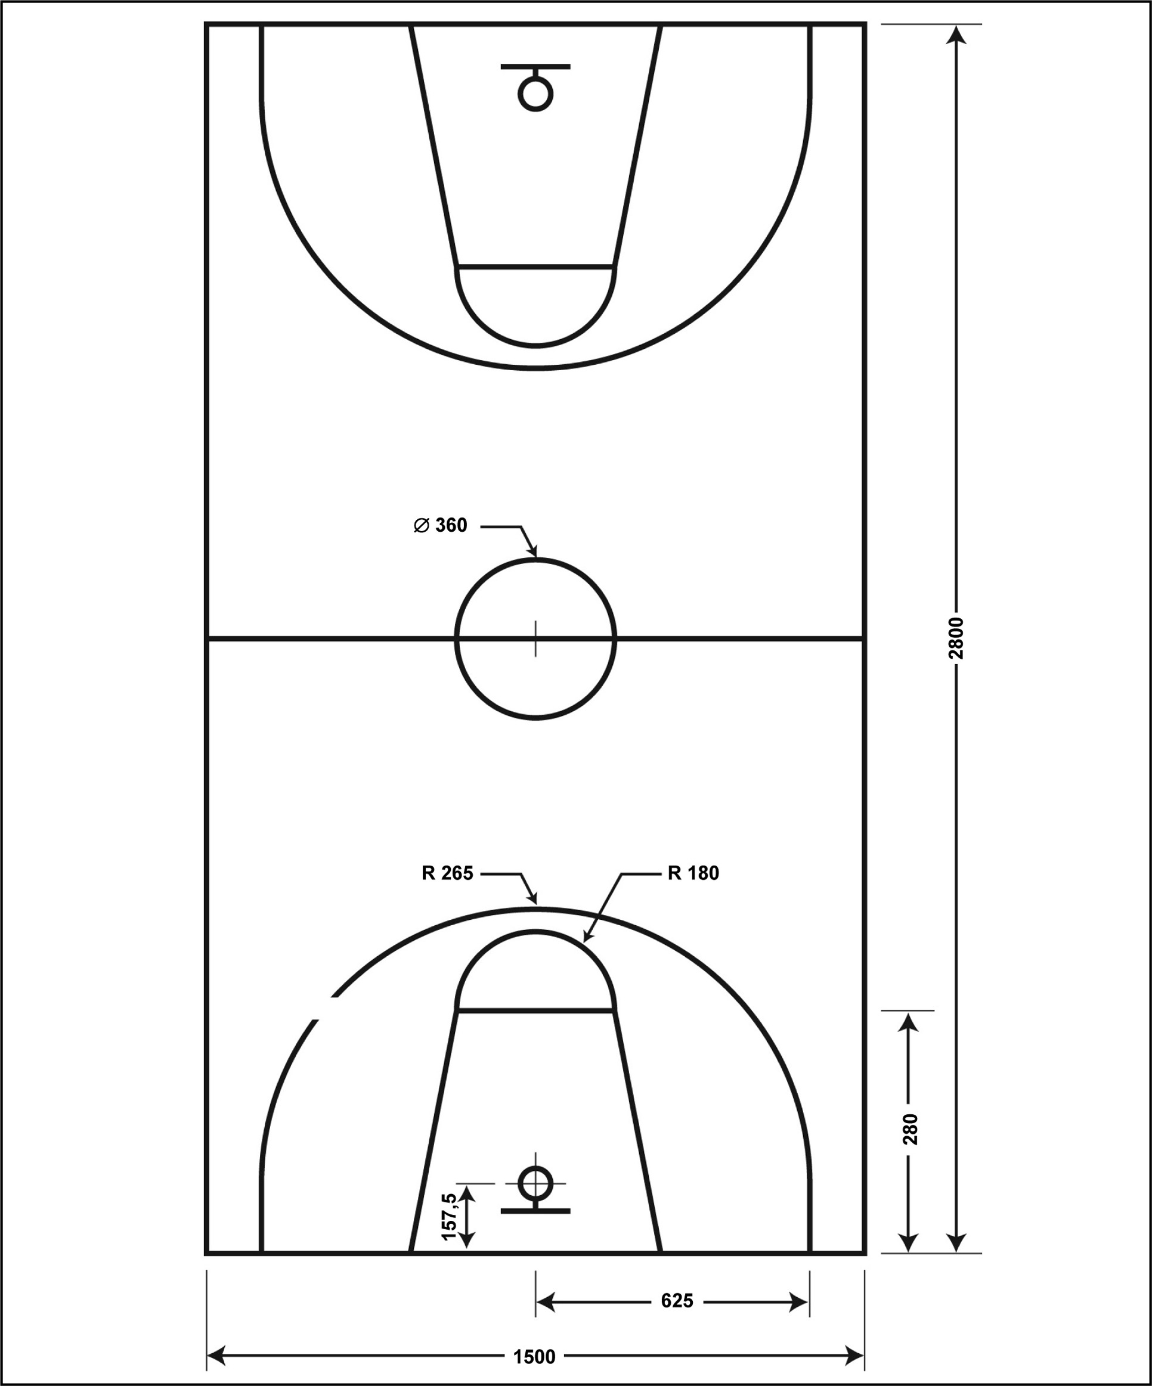
C Basketball court
Circle
Centre line
Base line
Free-throw line
(Dimensions in centimetres)
Three-point line

THE PROJECT (continued)
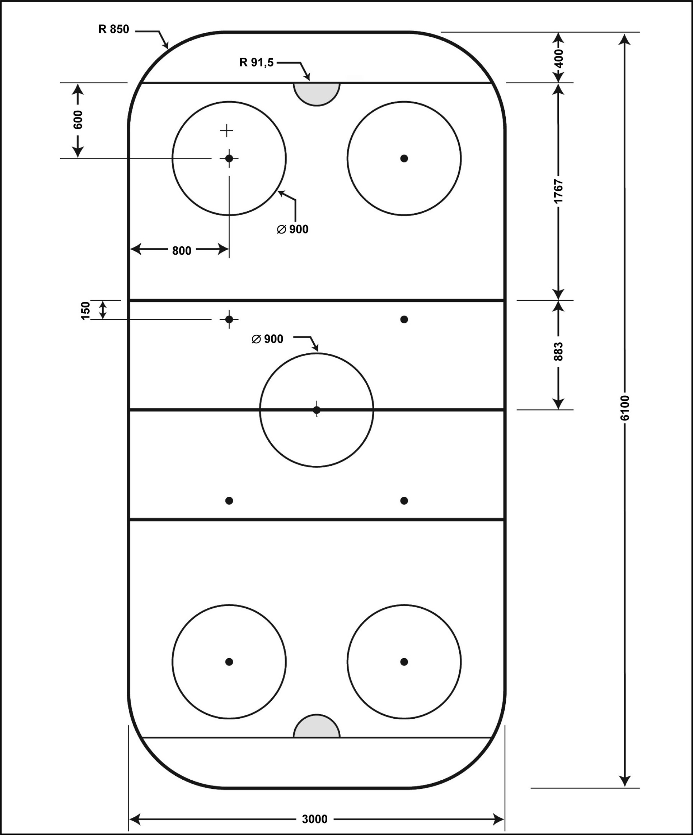
D Olympic ice rink
Goal line
Blue line
Centre line
End zone face-off
Spot and circle
Neutral zone
face-off spot
Centre face-off
spot and
circle
Goal crease
(Dimensions in centimetres)

CREATING THE context
I ask myself questions
1. What is modelling?
2. What is the advantage of creating a model?
3. Who is your model intended for?
4. What aspect of the solar system should viewers of your model be able to see easily?
5. Write down the questions that will guide you in gathering the necessary information you need to create your model.
I must
6. Reformulate the goal of the project in my own words.
7. In your opinion, what would be the medium to use to model the distances between the planets on a sports area (diagram, poster, 3D model, drawing, etc.)? Justify your choice.

CREATING THE context (continued)
8. In your opinion, what factors will influence your choice of materials to use in creating your model? Justify your answer.
What I know and what I must find out
9. Write down the information you already have and what you must find out.
What I know . . . |  | What I must find out . . .
I prepare my work
10. Where will you find the information you need to create your model?
11. List in chronological order the principal steps of your work.
Reflection Yes No
Do I understand what I need to do?  

GATHERING INFORMATION
I do research
1. Look at the factors below and check the ones you think are necessary for creating your model.
 Availability of materials
 Cost of objects
 Availability of tools at school
 Allocation of time for creating the model
 Size of objects
2. List the materials you will need to create your model.

Medium: |  | Size: |  | × |  |  |  | (unit of measurement)

List of materials:
• |  |  | •
• |  |  | •
• |  |  | •
• |  |  | •
• |  |  | •
Where appropriate, underline any materials to be brought from home.
3. What are the distances between each of the eight planets of the solar system and the Sun?
I. Distances in the solar system
Planet name |  | Mean distance from the Sun (AU)
Mercury
Venus
Earth
Mars
Jupiter
Saturn
Uranus
Neptune

Gathering information (continued)
4. Consult the drawing of your chosen sports area (pp. 2–5 in the LES12 Student log) and indicate in the table below the following information: the type of sports area, the names of the zones
(or lines) on the area and the measurements of each of these zones.
II. Sports area measurements
Chosen area:
Names of zones on sports area |  |  | Sports area measurements (cm)
Field (total length)
Field (total width)
5. What is a scale?
6. What type of scale will you use to convert the distances of your sports area and the solar system to the dimensions of your model?
7. What mathematical equations will you use to convert these distances to the scale of your model?
– Distances between the planets and the Sun?

– Sports area measurements?

Gathering information (continued)
8. Convert the distances to the scale of your model. Write your results in the following tables.
III. Distances in the solar system to scale of model
Names of planet |  | Distances to scale of model (cm)
Mercury
Venus
Earth
Mars
Jupiter
Saturn
Uranus
Neptune

IV. Measurements of the sports area to scale of model
Chosen area:
Names of zones on the sports area |  |  | Distances to scale of model (cm)
Field (total length)
Field (total width)

Gathering information (continued)
9. Calculate the scales to be indicated in your model. What will the scale of the model be in order
to represent:
• the solar system?
• the sports area?
Reflection Yes No
Do I understand the following concepts:
• scale?  
• astronomical unit?  
• light year?  
• the location of Earth in the Universe?  

COMPLETING THE PROJECT
I make suggestions
1. On a separate sheet, create a rough draft of your model. You are to:
• Draw the eight planets of the solar system and the sports area so as to clearly
differentiate them.
• Organize the information so that your model is easy to understand.
2. Once your rough draft has been approved, create your model. Check the following items after they have been clearly indicated on your model:
 the Sun and its eight planets
 the sports area
 the names of the planets
 the names of the zones on the sports area
 the scales
 the units of measurements
3. Using your model, estimate distances beyond the eight planets of the solar system.
a) You must extend your model to illustrate the distance from the Sun to the outer edge of the solar system. How many of your models would you need at this scale to represent this distance? Justify your answer.
Calculation:

COMPLETING THE PROJECT (continued)
b) You must extend your model to illustrate the distance from the Sun to the Canis Major galaxy. How many of your models would you need at this scale to represent this distance?
Justify your answer.
Calculation:
c) Would you be able to create a model of the entire Universe in your classroom?
What would it look like?
Reflection Yes No
Have I explored several solutions for creating my model?  

VALIDATING THE PROJECT
I justify my approach
1. What are the advantages of your model?
2. Which aspects of your model are not realistic?
3. How could you present these aspects in a realistic manner?

COMPARING THE MODELS
Compare the different models in the class using the following questions:
1. Are the scales identical? Explain.
2. Describe the similarities among the models in the class.
3. Describe the differences among the models.
4. What are the strong points of the models that most adequately represent the solar system?

MY Evaluation
Use the evaluation grid on the next page for your self-evaluation. Enter A, B, C, D or E
in the appropriate space on that table.
SSC3 Communicates in the languages used in
science and technology
Criteria* | Observable indicators | Me | Teacher | Comments
1 | Gathering information |  |   With help
 | Gathering data and converting measurements to scale |  |   With help
2 | Completing the project |  |   With help
 | Accuracy and clarity of the model of the solar system; the model itself |  |   With help
3 | Completing the project |  |   With help
 | Notation of the two scales and units of measurement on the model;  the model itself |  |   With help
* Evaluation criteria
1 Accurate interpretation of scientific and technological messages
2 Appropriate production or sharing of scientific and technological messages
3 Use of appropriate scientific and technological terminology, rules and conventions

evaluation grid
* Evaluation criteria
1 Accurate interpretation of scientific and technological messages
2 Appropriate production or sharing of scientific and technological messages
3 Use of appropriate scientific and technological technological mesterminology, rules and conventions
Communicates in the languages used in science and technology | E | The work needs to  be redone. |  | The work needs to  be redone. |  | The work needs to  be redone.
 | D | Little useful information has been gathered. Almost all of the measurements converted to scale  are incorrect. |  | Some information  is correct  OR  most of the  elements are not  clearly presented. |  | One of the scales is  not correctly indicated on the model, or there  is a scale missing on  the model  AND  the units of measurement are  not indicated or are  not relevant.
 | C | Most of the useful information has been gathered. Most of the measurements converted to scale  are correct. |  | Most of the information presented is correct.  The visual presentation clearly distinguishes some of the elements. |  | One of the scales is not correctly indicated on the model  OR  the units of measurement are  not relevant.
 | B | All the useful information has  been gathered.  Most of the measurements converted to  scale are correct. |  | All the information presented is correct. The visual presentation clearly distinguishes most  of the elements. |  | The two scales are correctly indicated on the model. The units of measurement are appropriate, but the abbreviations used contain errors.
 | A | All the useful information has  been gathered.  All the measurements converted to scale  are correct |  | All the information presented is correct. The visual presentation clearly distinguishes all the elements. |  | The two scales are correctly indicated on the model. The units  of measurement are appropriate and the correct abbreviations are used.
 | Observable indicators | Gathering information | Gathering data and converting measurements to scale | Completing  the project | Accuracy and clarity of the model of the solar system;  the model itself | Completing  the project | Notation of the two scales  and units of measurement  on the model; the model itself
 |  | 1 |  | 2 |  | 3

