THE PROBLEM
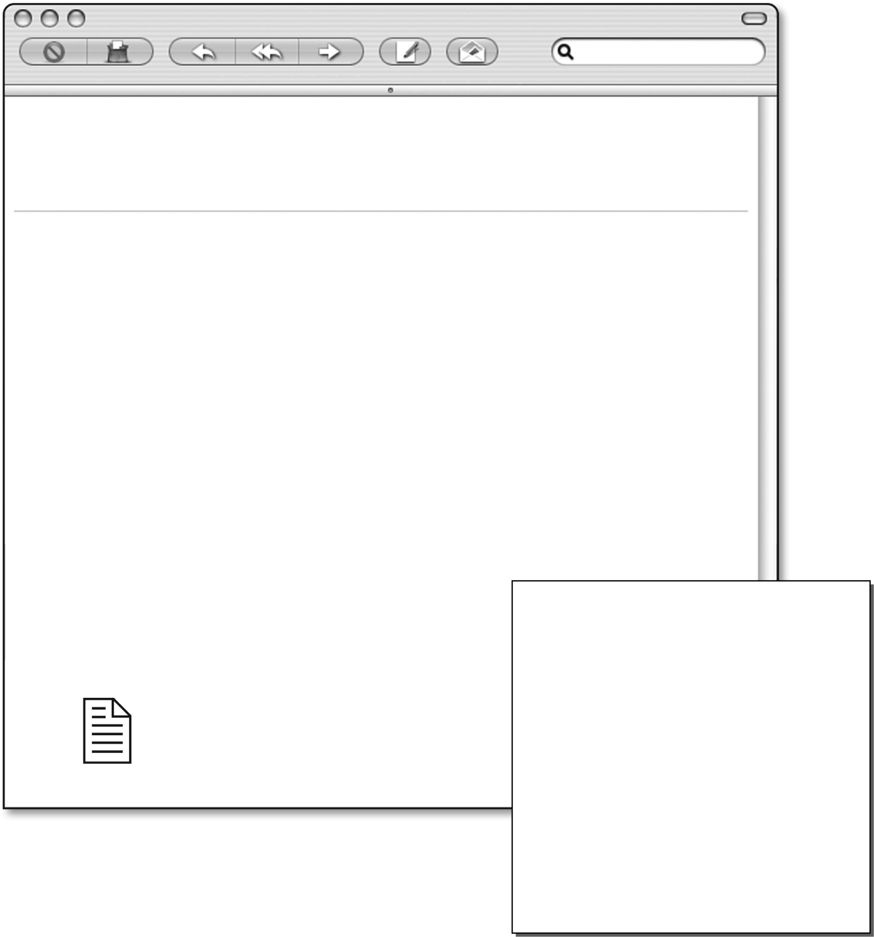
Protocol
Dear Sir/Madam,
A team of young scientists has won first prize in the contest “Take a deep breath—be
healthy!” with their prototype of a spirometer. This instrument, which examines the
relationship between vital lung capacity and physical activity, will be commercialized.
Before the spirometer is put on the market, however, we believe it needs to be analyzed
to see if it requires any improvements.
We would like you to take care of the testing process because of your knowledge of
medical instruments and how to market them. Below is what we want you to do:
Assemble a spirometer and test it to make sure it works properly.
Analyze how it works, producing a design plan and a technical drawing.
Propose modifications for improving the instrument to be done before it is
manufactured and put on the market.
The attached document contains the calibration protocol and the user’s guide for the
prototype submitted by the winners of the contest.
Sincerely,
Mathieu Lavoie
Contest “Take a deep breath—be healthy!”
From: Contest “Take a deep breath—be healthy!”
To: Firm of Analysts and Marketing, Inc.
CC: Contest Winners
Date: July 24 2008 08:55
Subject: Assessment and improvement of a spirometer prototype
December 6, 2006
If you wish to measure the impact of your physical activity on your health, use a spirometer. This instrument measures vital lung capacity, that is, the volume of air that a person can blow out of his/her lungs. It has been proven that physical activity increases lung capacity, which has an impact on, among other things, intellectual capacity and performance.
In this LES, you will play an employee of the firm, of Analysts and Marketing, Inc.

THE PROBLEM (continued)
Calibrating the spirometer
Materials
• 4-L plastic bottle with its stopper or a rubber stopper
• 100-mL graduated cylinder
• marker
procedure
1. Using the graduated cylinder, measure 100 mL of water.
2. Pour the 100 mL into the bottle.
3. Mark the water level on the bottle.
4. Repeat the operation until the bottle is full.
5. Empty the bottle and turn it upside down.
6. Write beside each mark the corresponding volume.
The spirometer is now calibrated. Each mark on the bottle corresponds to a volume of 100 mL.
Measuring vital lung capacity
procedure
1. Fill the calibrated bottle with water.
2. Use the stopper to close the bottle.
3. Pour water into a basin or a sink until it is about 5 cm deep.
4. Place the bottle, upside down, in the basin and make sure the bottle opening is under water.
5. Remove the stopper.
6. Insert the end of the tubing in the bottle.
7. Ask the subject to take a deep breath and then to blow as long as possible into the tubing.
8. Record the volume of air in the bottle.
9. Perform this protocol another time with this subject and then two times for each of the
remaining subjects.
Note: The end of the tubing must be cleaned with rubbing alcohol.

CREATING THE CONTEXT
I ask myself questions
1. What is vital lung capacity?
2. What is a design plan?
3. What is a technical drawing?
4. Who is involved in solving this problem?
5. What questions could you ask before beginning your technological analysis of the
spirometer prototype?
I must
6. Redefine the problem’s goal.
I think
7. In your opinion, what are some of the factors that could influence the commercialization of the
spirometer? Explain your answer.

CREATING THE CONTEXT (continued)
What I know and what I must find out
8. Make lists of the information you have and of the information you need to find out.
I know . . . |  | I must find out . . .
I prepare my work
9. Where and how could you find the information you need to propose improvements to the
spirometer prototype?
10. List, in chronological order, the principal steps for your work.
Reflection Yes No
Do I understand everything that needs to be done?  

GATHERING INFORMATION
I do research
1. What is a fluid?
2. What is an incompressible fluid? Is there one such fluid that plays a part in the function of a
spirometer? If so, what is the fluid?
3. What is a compressible fluid? Is there one such fluid that plays a part in the function of the
spirometer? If so, what is the fluid?
4. What is pressure?
5. What is force?
6. How does pressure act on the volume of a compressible fluid?
7. What happens when pressure is applied to the surface of a fluid in a closed container?
8. How does a fluid behave?

GATHERING INFORMATION (continued)
I analyze my results
1. Using page 2 in your student log, calibrate and assemble the spirometer.
2. Using the spirometer, measure the vital lung capacity of each member of your team at least
three times. If necessary, refer back to page 2 of the student log.
Vital lung capacity of team members
Measurement  Team member | 1st  measurement  (mL) | 2nd  measurement  (mL) | 3rd  measurement  (mL) | Average vital  lung capacity  (mL)
1
2
3
4
3. Explain how the spirometer works.

GATHERING INFORMATION (continued)
4. Complete the following design plan, which will help you to analyze how your spirometer works.
Your design plan should include the following information:
• names of the parts • zones of high and low pressure for each of
• names of the fluids and their types the fluids
• forces at work • behaviour of the fluids
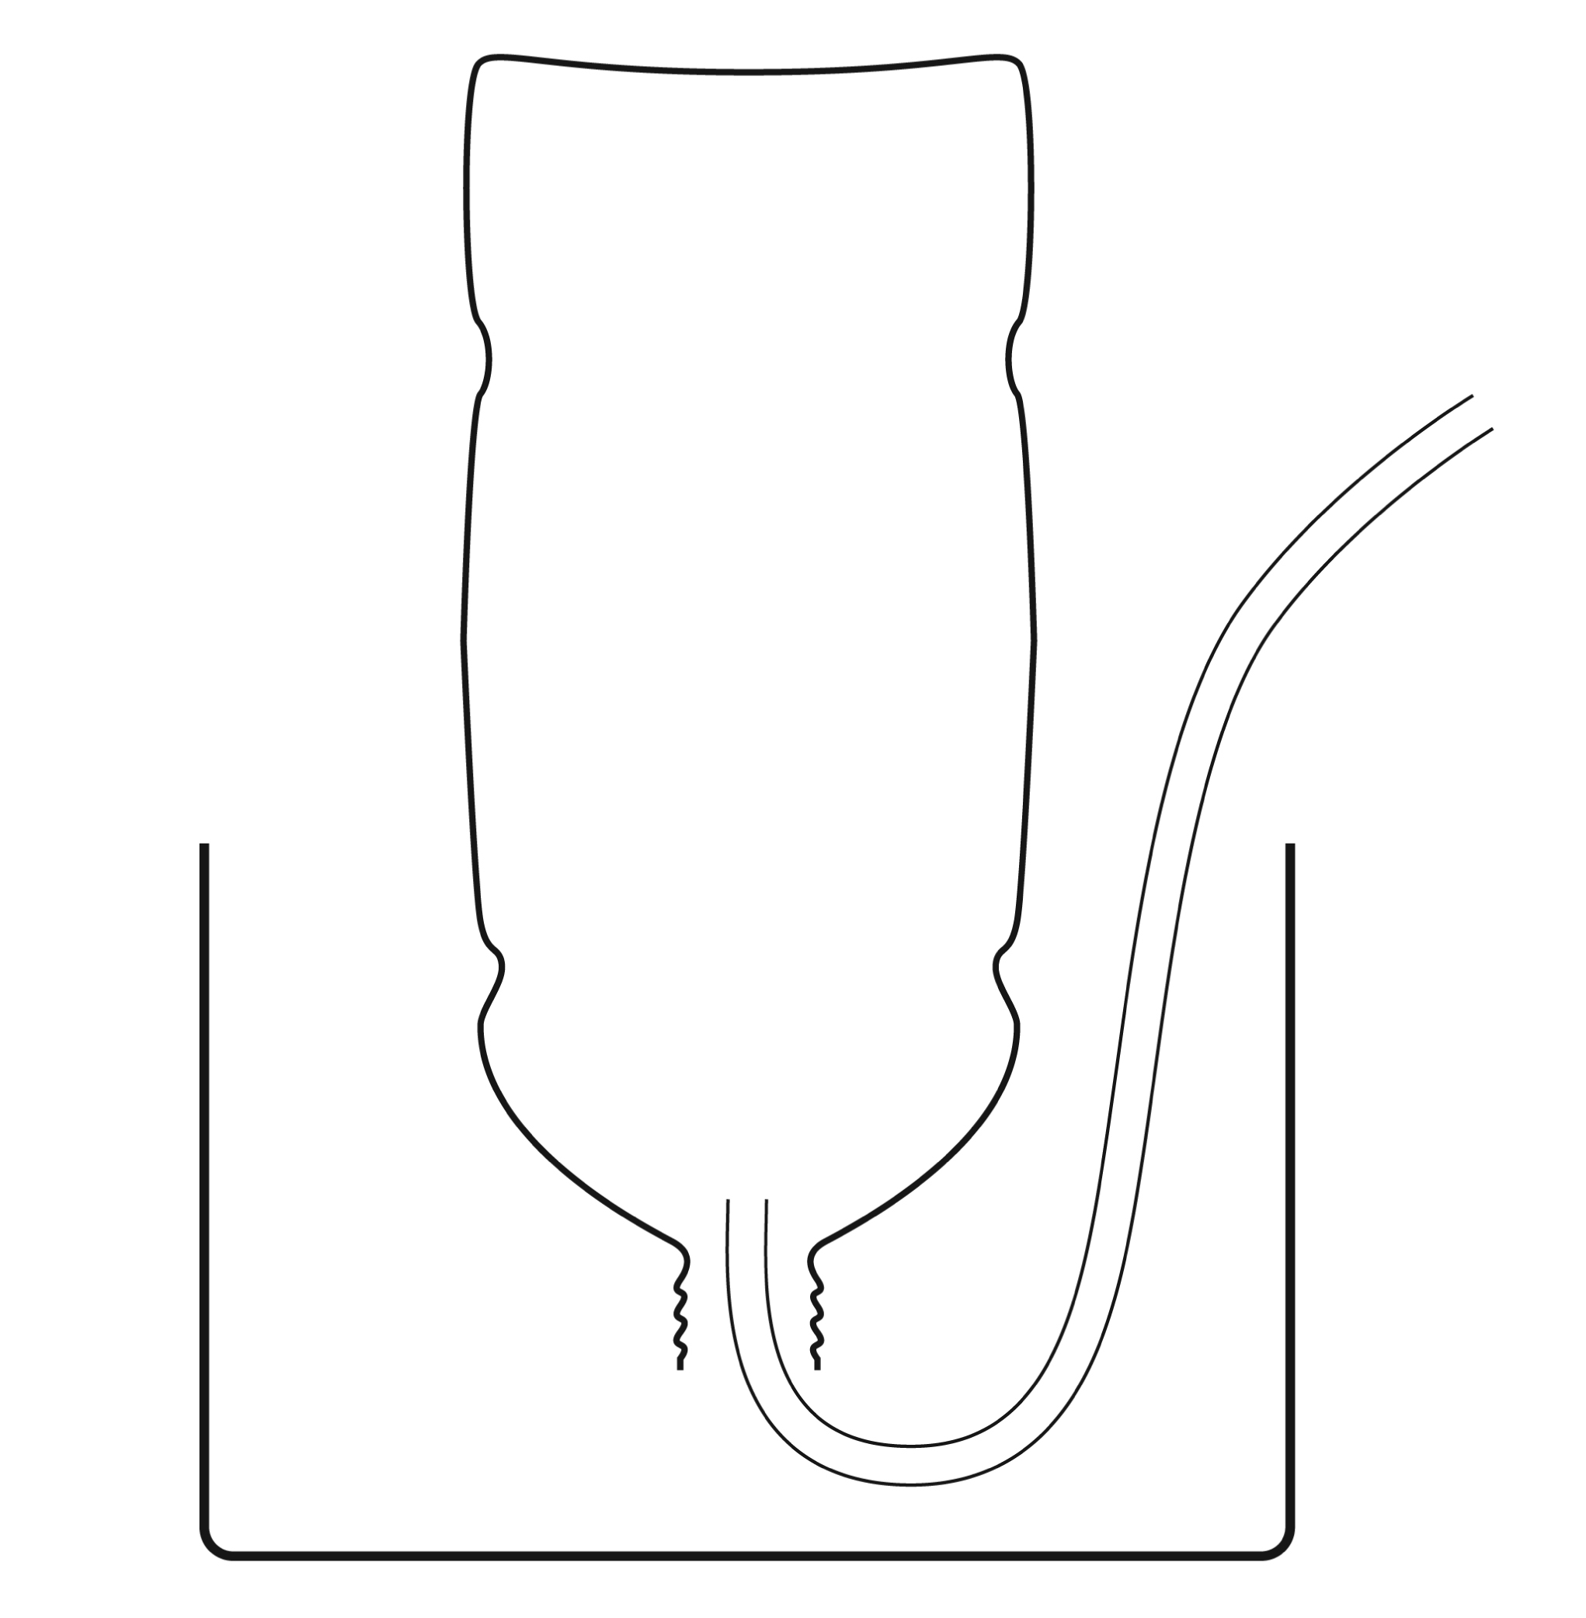

GATHERING INFORMATION (continued)
5. Complete the following technical drawing for the spirometer. Ensure that the following
information appears on the drawing:
• names of the parts • other useful information for manufacturing
• materials used • the spirometer
Reflection Yes No
Do I have a good understanding of:
• Compressible and incompressible fluids?  
• Pressure?  
• The relationship between pressure and volume?  
• The behaviour of fluids?  

COMPLETING THE PROject
I propose
1. What are the advantages of the spirometer?
2. What are the disadvantages of the spirometer?
3. Which improvements would you make to the spirometer? List at least three.
I reflect Yes No
Can I think of any other solutions or explanations?  

validating the project
I explain
1. Justify each of the improvements that you propose to improve the design of the spirometer.
Refer back to your analysis of how the instrument works.

MY EVALUATION
Use the evaluation grid on the following page to do a self-evaluation. Write A, B, C, D or E
in the appropriate place in the table.
SSC2 Makes the most of his/her knowledge of science
and technology
Criteria* | Observable indicators | Me | Teacher | Comments
1 | Creating the context |  |   With help
 | Definition of the goal and formulation of the questions for analyzing the spirometer |  |   With help
2 | Gathering Information |  |   With help
 | Production of a design plan and a technical drawing |  |   With help
3 | Completing the project |  |   With help
 | Formulation of improvements to  be made |  |   With help
4 | Validating the project |  |   With help
 | Justification for each proposed improvement |  |   With help
* Evaluation criteria
1 Formulation of appropriate questions
2 Appropriate use of scientific and technological concepts, laws, models and theories
3 Relevant explanations or solutions
4 Suitable justification of explanations, solutions or opinions

evaluation grid
* Evaluation criteria
1 Formulation of appropriate questions3 Relevant explanations or solutions
2 Appropriate use of scientific and technological concepts, laws, models and theories4 Suitable justification of explanations, solutions, decisions or opinions

Makes the most of his/her knowledge of science and technology | E | The work needs to  be redone. |  | The work needs to  be redone. |  | The work needs to  be redone. |  | The work needs to  be redone.
 | D | The goal is defined more or less clearly  AND  the questions for analyzing the spirometer are more or less pertinent. |  | The design plan and technical drawing  are incomplete  AND  contain many errors. |  | The proposed improvements are more or less relevant. |  | The justifications are not very relevant.
 | C | The goal is defined more or less clearly  OR  the questions for  analyzing the spirometer are more or less pertinent. |  | The design plan and technical drawing  are incomplete  OR  they contain  many errors. |  | One or two of  the proposed improvements are clearly formulated  and relevant. |  | Some of the justifications  are relevant.
 | B | The goal is clearly defined. The questions for analyzing the spirometer are pertinent. |  | The design plan and technical drawing are complete, but contain some minor errors. |  | The three proposed improvements are clearly formulated  and relevant. |  | Most of the justifications  are relevant.
 | A | The goal is very clearly defined. The questions for analyzing the spirometer are pertinent. |  | The design plan and technical drawing are complete. |  | More than three improvements were proposed. They are all very clearly formulated and relevant. |  | All of the justifications  are relevant.
 | Observable indicators | CREATING THE CONTEXT | Definition of the goal and formulation of the questions for an analysis of the spirometer | GATHERING INFORMATION | Production of a design plan and a technical drawing | COMPLETING  THE PROJECT | Formulation of improvements to be made | VALIDATING THE PROJECT | Justification for each proposed improvement
 |  | 1 |  | 2 |  | 3 |  | 4

