The CASE STUDY


TRANSCRIPT
DECEMBER 17, 2006 – CKFL, MONTRÉAL
News bulletin – 7:01:36 pm
ROAD SAFETY
JULIEN LACHAPELLE (ANNOUNCER): While we await another snowfall in Montréal and Québec City, the season’s first snowmobile accident involving two people took place on Sunday in Rouyn-Noranda.
The driver lost control of his vehicle, which skidded off the path and hit a tree. The driver suffered serious back injuries. The passenger, a 14-year-old boy, received a head injury and is currently in critical condition.
This accident will no doubt revive the debate over the safety of Québec’s
off-road vehicles.
–30–

TRANSCRIPT

DECEMBER 17, 2006 – CKFL, MONTRÉAL

News bulletin – 8:03:40 am
ROAD SAFETY
Julien Lachapelle (Announcer): Attempts to save the life of a teenager involved in a snowmobile accident yesterday in Rouyn-Noranda have failed.
Two medical specialists declared the young boy brain-dead this morning. Coroner Jean Gauthier has been directed to investigate the circumstances of the accident and make safety recommendations.
Doctors, coordinators and the family members of the victim are exploring the possibility of organ donation, even though the young man never signed an organ donor card.
Those who wish to express their sympathy to the victim’s family are welcome to attend the memorial service next Saturday in Rouyn-Noranda.
–30–
In this case study, you will be asked to play the roles of the doctors, transplant coordinators and family members of the victim, and to assess whether the boy’s organs should be donated.
Take a moment to familiarize yourselves with the roles of the different people involved, using the chart on the next page to help you understand the legal, medical, ethical and social issues surrounding organ donation.

the CASE STUDY (continued)
The roles of the actors in this case study
The roles of the doctors, coordinators and family members of the victim are summarized in the
table below.
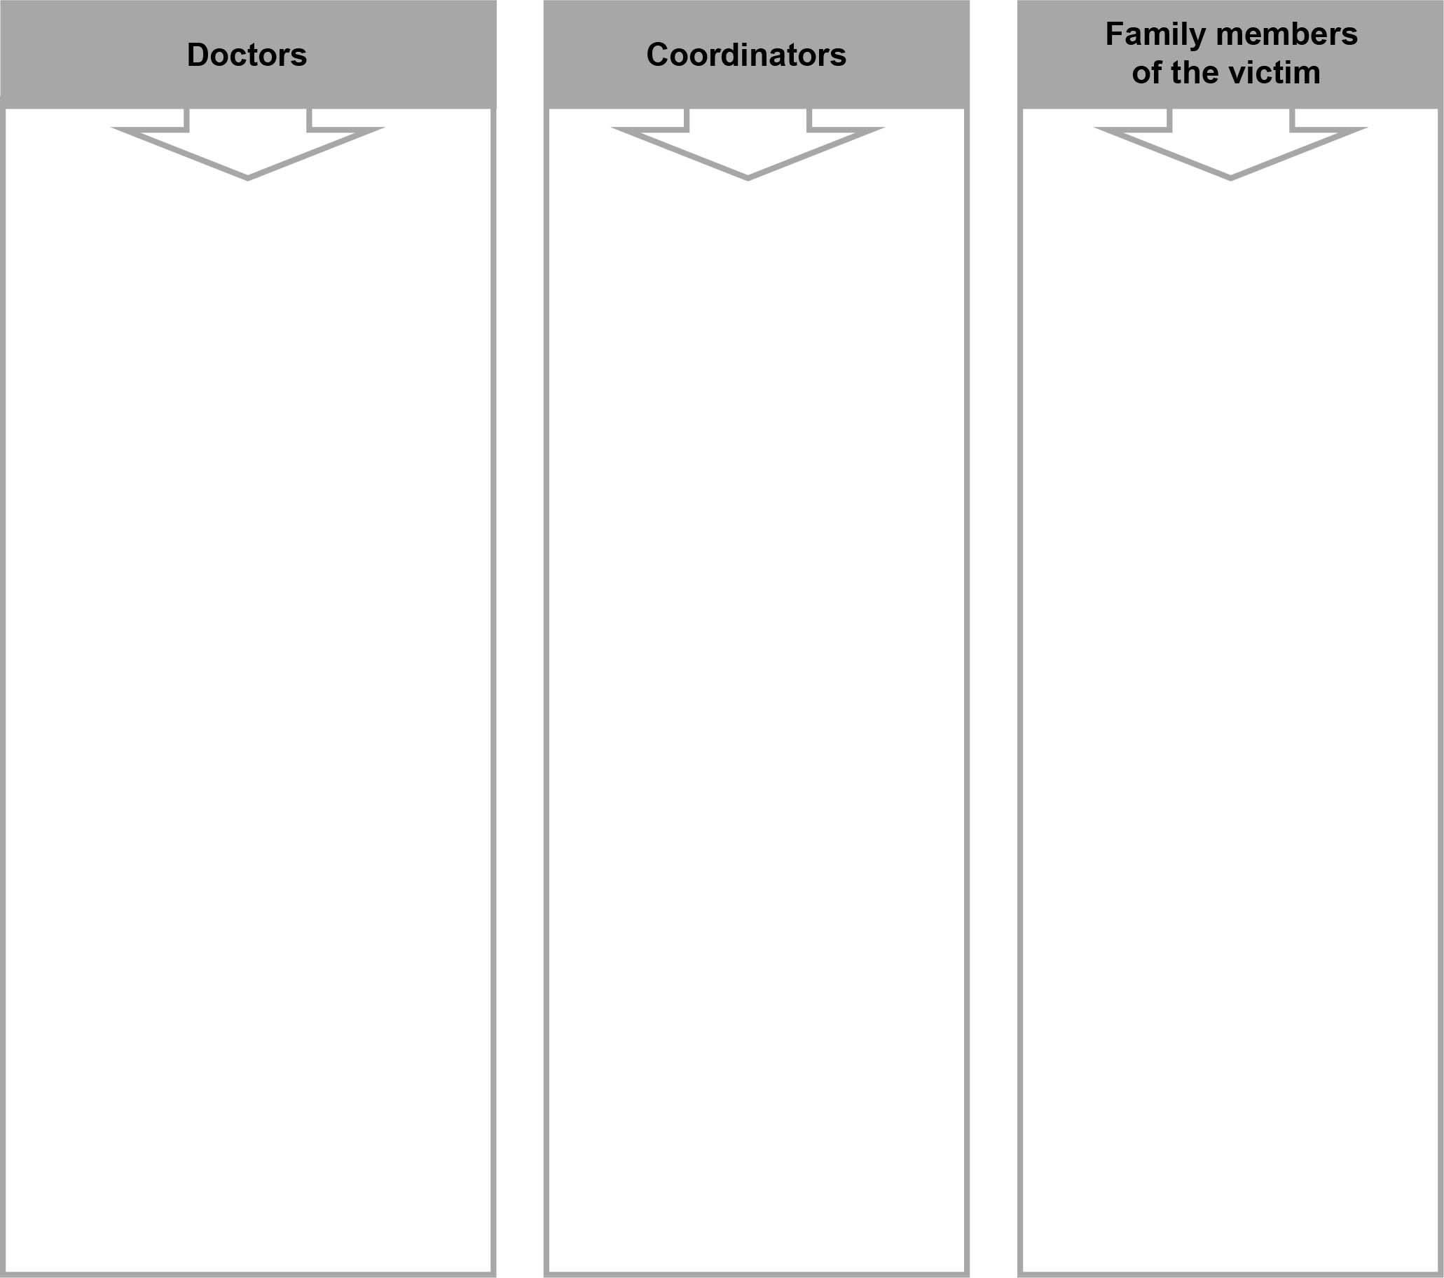

Role

Role

Role
• Study the functions of the different types of tissues and organ systems that could be transplanted.
• Evaluate the donor’s health.
• Measure the effects of blood incompatibility.
• Assess the compatibility of
the donor and recipients, taking the following factors into consideration:
– The organs of donor and recipients must be the same size.
– The donor’s organs must
be in good condition.
– The blood types of donor and recipients must be compatible.
• Decide whether to recommend the transplanting of this
young man’s organs.
• Research the legal conditions that must be respected when organs are donated.
• Consider the social, ethical and legal implications of authorizing an organ donation.
• Decide whether to recommend the transplanting of this young man’s organs.
• Decide whether to give or refuse consent for an organ donation.
• Take into account the values and beliefs of everyone involved.
• Try to come to a consensus as you make this decision.

the CASE STUDY (continued)
Donor profile
The medical history of an accident victim must be reviewed in order to evaluate the feasibility of organ donation. For this case study, the necessary information from the medical file of the
14-year-old boy who suffered a head injury is included below.
• Blood type A⁺
• Suffered from an illness that affects the pancreas: diabetes
• Suffered from an intestinal illness: Crohn’s disease
• Height: 1.63 m
• Weight: 52 kg
Profiles of potential organ recipients
Here are the relevant medical details of the individuals on the waiting list for organ transplants.
They must be studied in order to evaluate the individuals’ compatibility with the donor.
Potential  recipient |  | Age |  | Weight |  | Height |  | Blood type |  | Organ
Individual 1 |  | 48 |  | 78 kg |  | 1.78 m |  | A⁻ |  | Heart
Individual 2 |  | 15 |  | 50 kg |  | 1.60 m |  | A⁺ |  | Kidney
Individual 3 |  | 14 |  | 60 kg |  | 1.70 m |  | O⁺ |  | Pancreas
Individual 4 |  | 13 |  | 55 kg |  | 1.65 m |  | AB⁺ |  | Heart
Individual 5 |  | 51 |  | 80 kg |  | 1.79 m |  | O⁻ |  | Pancreas
Individual 6 |  | 47 |  | 85 kg |  | 1.85 m |  | A⁺ |  | Kidney
Individual 7 |  | 39 |  | 70 kg |  | 1.74 m |  | B⁻ |  | Heart
Individual 8 |  | 52 |  | 77 kg |  | 1.80 m |  | A⁺ |  | Intestine
Individual 9 |  | 10 |  | 30 kg |  | 1 m |  | AB⁺ |  | Kidney

CREATING THE CONTEXT

I ask myself questions
1. What is an organ donation?
2. What does “brain-dead” mean?
3. Who are the actors in this case study?

4. What questions do the doctors need to ask in order to make their recommendations regarding
an organ donation?

CREATING THE CONTEXT (continued)

5. What questions do the coordinators need to ask to make their recommendations regarding an organ donation?

6. What questions do the family members of a potential donor need to ask in order to make a decision regarding an organ donation?
I must

7. Restate the case study’s goal.
I think

8. In your opinion, for this case study, is an organ donation possible? Explain your answer.

CREATING THE CONTEXT (continued)

What I know and what I must find out

9. List the information that you have and the information that you need to find.
What I know . . . |  | What I must find out . . .
I plan

10. Where will you find the information you need to do your work?
11. List in chronological order the principal steps you need to take to carry out this case study.
I reflect Yes No
Do I understand everything that needs to be done?  

GATHERING INFORMATION
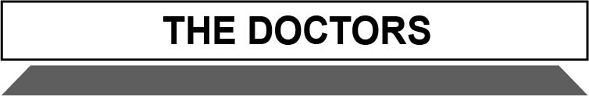

I do research
You are one of the doctors responsible for the organ transplant. You need to evaluate the compatibility of the donor and recipients. First, you must study the medical history of the potential donor.
1. Name the tissue types that make up the potential donor’s various organs that are listed below.
Explain their functions.
Organ |  | Type of tissue |  |  | Function of the tissue
Skin
Heart
Pancreas
Intestines
Spinal
cord
Kidneys
Bones

GATHERING INFORMATION (continued)
2. Name the systems to which the organs listed below belong. List the primary functions of
each system.
Organ |  | Type of tissue |  |  | Function of the system
Skin
Heart
Pancreas
Intestines
Spinal
cord
Kidneys
Bones
3. In order to proceed with a transplant, we must ensure that the donor’s organs are in good health. Which organs in this case study cannot be transplanted? Explain your answer.
4. What was the cause of the donor’s death?

GATHERING INFORMATION (continued)
5. Organ rejection depends on many factors including the incompatibility of blood types. The concept map below deals with blood and the roles of the various blood constituents that come into play in the case of blood type incompatibility. Copy the words from the box below
into their correct place in the concept map, and explain the functions of each blood constituent.
• Agglutination of red blood cells  • Clot formation  • Formed elements | • White blood cells  (leucocytes)  • Platelets  (thrombocytes) | • Liquid element  • Plasma  • Red blood cells (erythrocytes)
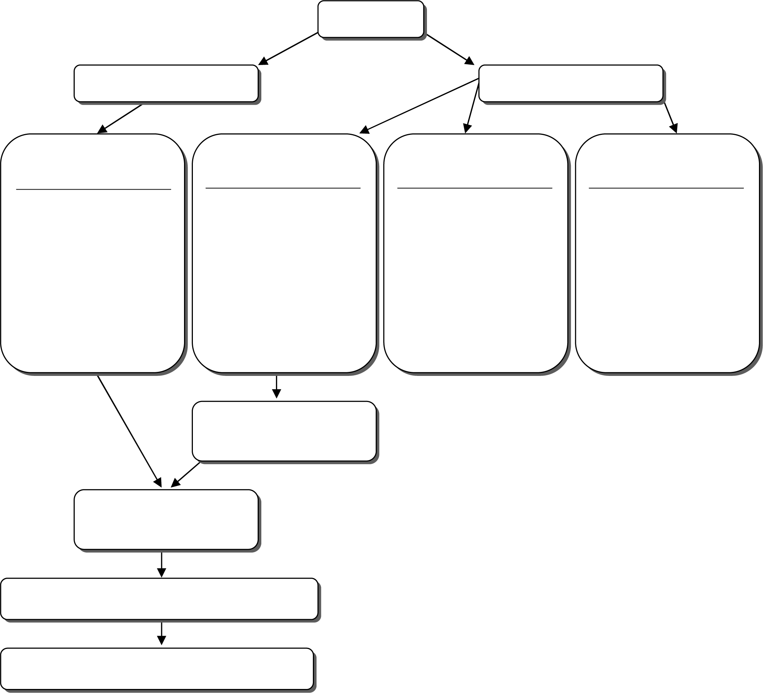
Blood
Function:
Function:
Function:
Function:
Introduction
of agglutinogens
Reaction of
plasma’s antibodies

GATHERING INFORMATION (continued)

I apply my research results
6. You must evaluate organ compatibility between the donor and recipients. Below is the list of the individuals waiting for an organ transplant.
Using the information that you have gathered about the recipients, indicate below whether they are compatible with the donor and explain your conclusions.
Recipient |  | Compatibility  (Yes/No) |  |  | Explanation
Individual 1
Individual 2
Individual 3
Individual 4
Individual 5
Individual 6
Individual 7
Individual 8
Individual 9

GATHERING INFORMATION (continued)

I apply my research results
7. Can a donor and a recipient with different blood types still be compatible? Explain your answer.
I reflect Yes No
Do I have a good understanding of:
• Blood type compatibility?  
• Systems?  
• The functions of blood constituents?  
• Types of tissue?  
• Organs?  

GATHERING INFORMATION (continued)
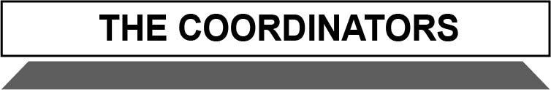

I do research
You are one of the coordinators of organ transplant procedures. You need to take into account the legal, social and ethical issues surrounding organ donation. Your answers to the following questions should guide your thinking.

1. How many people are currently waiting for an organ transplant in the province of Québec?
2. How many organ transplants are there every year?
3. What is the success rate for transplant operations?
4. Are most Canadians in favour of organ donation?
5. Can the recipient’s family contact the donor’s family members?

GATHERING INFORMATION (continued)

6. What are the legal conditions that must be respected with respect to organ transplants
and consent?
I apply my research results

7. In this case study, what legal conditions were respected in order for an organ donation to
take place?
8. In this case study, which legal conditions have so far not been satisfied with regard to an organ donation?

GATHERING INFORMATION (continued)

I do research
You now need to play the roles of the family members of the donor. Each member of your team represents a different family member. Taking into consideration the information that the team has gathered, each member must either give consent or refuse consent for the organ donation.
1. Summarize your arguments and those presented by the other team members.
Name of  team member |  | For or against  the organ donation |  | Arguments presented
I apply my research results
2. Has your team decided to give its consent for the organ donation? Explain why or why not.

COMPLETING THE CASE STUDY
Use the following questions to help determine whether an organ donation is possible in this
case study.
1. Do the doctors recommend a transplant? Which organs? For which individuals?
2. What are the conclusions of those representing the donor’s family members? Was a consensus reached concerning an organ donation? Explain your answer.
3. Were the coordinators in this case study able to recommend an organ transplant, while respecting all of the legal conditions?
4. According to your research, will any organs be transplanted? Explain your answer.
I reflect Yes No
Have I explored a variety of solutions?  

VALIDATING THE CASE STUDY
I justify my approach
1. Explain why the donor and recipients are compatible.
2. Explain why, in this case study, an organ donation can or cannot take place. Explain which legal and medical conditions are being respected.

VALIDATING THE CASE STUDY (continued)
Reflection
3. How has your opinion about organ donation changed since the beginning of this case study?
4. What did you learn that changed your opinion?
5. How will this case study modify your attitude toward organ donation?

My evaluation
Use the evaluation grid on the next page to do a self-evaluation. Write A, B, C, D or E
in the appropriate place in the table.

SSC2 Makes the most of his/her knowledge of science
and technology
Criteria* | Observable indicators | Me | Teacher | Comments
1 | Creating the context |  |   With help
 | Formulation of the questions for information gathering and statement of the case study goal |  |   With help
2 | Gathering Information |  |   With help
 | Verification of the compatibility between the potential donor and recipients |  |   With help
3 | Completing the case study |  |   With help
 | Pooling of the recommendations and the making of a decision |  |   With help
4 | Validating the case study |  |   With help
 | Justification of the decision |  |   With help
* Evaluation criteria
1 Formulation of appropriate questions
2 Appropriate use of scientific and technological concepts, laws, models and theories
3 Relevant explanations or solutions
4 Suitable justification of explanations, solutions, decisions or opinions

evaluation grid
* Evaluation criteria
1 Formulation of appropriate questions3 Relevant explanations or solutions
2 Appropriate use of scientific and technological concepts, laws, models and theories4 Suitable justification of explanations, solutions, decisions or opinions

Makes the most of his/her knowledge of science and technology | E | The work needs to  be redone. |  | The work needs to  be redone. |  | The work needs to  be redone. |  | The work needs to  be redone.
 | D | The questions for information gathering are more or less relevant  AND  the statement of the case study goal is more or less clear. |  | Most of the tests for compatibility are inadequate  AND  most of the summary of factors for compatibility and incompatibility is incorrect. |  | The decisions and recommendations articulated by the doctors, coordinators and family members are more or less coherent  AND  the recommendations are more or less in line with the gathered information. |  | The legal and medical justifications for or against organ transplant are incomplete.
 | C | The questions for information gathering are more or less relevant  OR  the statement of the case study goal is more or less clear. |  | Some tests for compatibility are inadequate  OR  much of the summary of factors for compatibility and incompatibility is incorrect. |  | The decision and recommendations articulated by the doctors, coordinators and family members are more or less coherent  OR  the recommendations are more or less in line with the gathered information. |  | The legal justification for or against organ transplant is adequate, but the medical explanation is incomplete.
 | B | The questions for information gathering are relevant. The statement of the case study goal is clear. |  | Tests for compatibility are adequate, and the summary of factors for compatibility and incompatibility is correct, but it contains some minor errors. |  | The decision and recommendations articulated by the doctors, coordinators and family members are coherent. The recommendations are in line with the gathered information. |  | The medical justifications for or against organ transplant are adequate, but the legal justification is incomplete.
 | A | The questions for information gathering (from the doctors, coordinators, and family members) are relevant. The statement of the case study goal is very clear. |  | Tests for compatibility are adequate, and the summary of factors for compatibility and incompatibility is correct. |  | The decision and recommendations articulated by the doctors, coordinators and family members are coherent. The recommendations are in line with the gathered information and are well written. |  | The medical and legal justifications for or against organ transplant are adequate.
 | Observable indicators | CREATING THE CONTEXT | Formulation of the questions for information gathering and statement of the case study goal | GATHERING INFORMATION | Verification of the compatibility between the potential donor and recipients | COMPLETING  THE case study | Pooling of the recommendations and the making of a decision |  | VALIDATING  THE case study | Justification of the decision
 |  | 1 |  | 2 |  | 3 |  |  | 4


Information Documents
Extracts of the Québec Civil Code relating to organ donations
A person of full age may determine the nature of his funeral and the disposal of his body; a minor may also do so with the written consent of the person having parental authority or his tutor. Failing the expressed wishes of the deceased, the wishes of the heirs or successors prevail; in both cases, the heirs and successors are bound to act; the expenses are charged
to the succession.
Article 42, Québec Civil Code
A person of full age or a minor 14 years of age or over may, for medical or scientific purposes, give his body or authorize the removal of organs or tissues therefrom. A minor under 14 years of age may also do so with the consent of the person having parental authority or of his tutor.
These wishes are expressed verbally before two witnesses, or in writing, and may be revoked in the same manner. The expressed wishes shall be followed, except for a compelling reason.
Article 43, Québec Civil Code
A part of the body of a deceased person may be removed in the absence of knowledge or presumed knowledge of the wishes of the deceased, with the consent of the person who
could give consent to care or could have given it.
Consent is not required where two physicians attest in writing to the impossibility of obtaining
it in due time, the urgency of the operation and the serious hope of saving a human life or of improving its quality to an appreciable degree.
Article 44, Québec Civil Code
No part of the body may be removed before the death of the donor is attested by two physicians who do not participate either in the removal or in the transplantation.
Article 45, Québec Civil Code
Source: Éditeur officiel du Québec. Code Civil, du Québec, updated on May 14, 2009. Retrieved from: http://www.canlii.org/en/qc/laws/stat/sq-1991-c-64/latest/sq-1991-c-64.html
(accessed June 1, 2009).

INFORMATION DOCUMENTS (continued)
Qualification criteria for organ donation
Organs can be donated for transplant only in cases of brain death, a most unusual way of dying. Brain death consists of the permanent cessation of brain function because the brain has been damaged beyond repair. This condition is very rare (less than two percent
of all deaths fulfil the criteria for brain death). It occurs when a person has sustained catastrophic and irreversible injury to the brain (such as spontaneous cerebral hemorrhage,
a ruptured aneurysm or some other incident that deprives the brain of oxygen). A mechanical ventilator is then used to supply oxygen to the blood to keep the potential donor's organs
viable for transplantation.
We must be careful not to confuse brain death with coma (coma does not necessarily lead to death because the brain is only partially damaged). With brain death, the patient's heartbeat
and breathing are artificially maintained so that the organs continue receiving the oxygen
they need to function. This mechanical support can be continued for only a few hours. While
the brain-dead patient is on artificial respiration, respiratory rhythm is maintained and the heart goes on beating because the ventilator is working. Without the ventilator, the heart stops.
Brain death is confirmed after two doctors not involved in removing or grafting the organs have completed a series of rigorous tests showing complete and irreversible loss of all brain function. If clinical death has been declared and the heart is no longer beating, organs cannot be donated because the cells of the body deteriorate rapidly once blood stops circulating. Tissue donation is possible, however, because it does not require mechanical ventilation in order to prolong blood circulation. Under the right conditions, corneas, heart valves, bones and skin can survive for several hours after death.
Once brain death is declared and the family consents to the donation of organs or tissues, the patient is maintained on artificial respiration while medical personnel act quickly to find compatible recipients. One organ-and-tissue donor can save or improve several lives. The removal of organs and tissues takes place in the operating room and is surrounded by the same respect and dignity as any other surgery. The donor's body is then released to the designated funeral home.
Source: Québec Department of Health and Social Services, Don d'organes et de tissus, 2007
(accessed March 10, 2007). [Translation]


INFORMATION DOCUMENTS (continued)
Organ and tissue donation: myths or facts
Myth: I am 70 years old and too old to donate anything.
Fact: If you want to donate your organs and tissues after death, you should consider yourself
a potential donor regardless of your age or medical history. There are no absolute guidelines when it comes to age, and your medical condition at the time of your death is more important than your past history.
To be an organ donor, you must die in a hospital with your body supported by a ventilator. With a ventilator, oxygen is circulated in the blood so organs can be used for transplant. Neurological determination of death must be completed and the family’s consent obtained before organ donation can occur. Organs that can be donated after death include the heart, liver, kidneys, pancreas, lungs, and small bowel. Living donors can also provide a kidney or part of their liver. On rare occasions, living donors have donated a portion of their lung or small bowel to relatives who were waiting for a transplant.
If you die at home or in the community, you cannot donate your organs. Tissues, however,
can be donated because blood circulation is not required. Almost everyone can donate tissues within certain time limits after death. Tissue donors can be referred from chronic care facilities, emergency departments, any patient floor in a hospital, and even from funeral homes. Tissues that can be donated include corneas from eyes, heart valves, bones and skin. Bone marrow is retrieved only from living donors.
Myth: If doctors see my signed donor card they won’t work as hard to save my life.
Fact: Doctors who care for seriously injured patients are not involved with the transplant process. Their only concern is to save lives. Organ donation is only considered after all attempts to save your life have failed, death has been declared, and your family has been consulted regarding your wishes.
Myth: Funeral plans will have to be changed to accommodate organ donation.
Fact: In most cases there will be no need to change funeral arrangements. Organ donation is
a surgical procedure that takes place in an operating room. An open casket is still an option following donation should the family wish.


INFORMATION DOCUMENTS (continued)
Myth: The donor’s family will be charged the extra costs involved in organ donation.
Fact: In Canada, organ retrieval is covered by the health-care system. There is no cost to
the donor's family for this surgical procedure. The family, however, is still responsible for funeral arrangements.
Myth: Having “organ donor” noted on your driver's license or carrying a donor card or provincial health card is all you have to do to become a donor.
Fact: While a signed donor card and a driver's license with an “organ donor” designation are legal documents, organ and tissue donation is always discussed with family members prior to the donation. For that reason, it is very important that you discuss your wishes with your family. At the same time, find out their wishes. Have this discussion—save a life!
Myth: I wear glasses so I can’t donate my eyes.
Fact: Poor eyesight does not prohibit eye donation. Only the cornea, the clear front covering
of your eye, is used for corneal transplantation. The sclera (white part of the eye) can be used for research (if you wish) to aid in future treatment of eye diseases. Each month, more than 200 eyes are donated to the Eye Bank of Canada.
Myth: My religion prohibits donation.
Fact: Most of the major religions either openly support organ and tissue donation, or support the individual’s choice at his or her time of death.
Myth: Transplants are experimental and rarely successful.
Fact: Generally, transplantation success rates are excellent—between 80-95 percent of patients are doing well one year after their transplant. Overall, transplant recipients enjoy an excellent quality of life, and are able to work, attend school, travel, and play sports. They are encouraged to engage in all activities that anyone would participate in.
Source: Canadian Association of Transplantation. “Organ and Tissue Donation – Myths and Facts,” 2005. Retrieved from http://www.transplant.ca/pubinfo_orgtiss.htm (accessed June 6, 2009).

INFORMATION DOCUMENTS (continued)
Numbers of people on organ transplant waiting list (1995–2005)
Year | Heart | Heart/  Lungs | Lungs | Liver | Pancreas | Kidney/  Pancreas | Kidney | Other  combinations | Total
1995 | 27 | 1 | 27 | 30 | 2 | 8 | 450 | – | 514
1996 | 24 | 1 | 28 | 32 | 5 | 16 | 471 | – | 577
1997 | 31 | 3 | 29 | 42 | 8 | 26 | 498 | – | 637
1998 | 29 | 4 | 27 | 38 | 6 | 37 | 486 | – | 627
1999 | 28 | 3 | 34 | 53 | 15 | 38 | 593 | – | 764
2000 | 17 | 4 | 35 | 46 | 29 | 47 | 637 | 0 | 815
2001 | 31 | 7 | 28 | 67 | 30 | 57 | 716 | 0 | 936
2002 | 36 | 4 | 39 | 90 | 28 | 38 | 689 | 5 | 925
2003 | 27 | 6 | 48 | 91 | 18 | 32 | 638 | 4 | 860
2004 | 34 | 4 | 42 | 103 | 23 | 40 | 626 | 0 | 872
2005 | 30 | 5 | 70 | 107 | 22 | 45 | 724 | 6 | 1009
Source: Québec-Transplant Website, excerpts

Numbers of people who died while waiting for organ transplants (1995–2005)
Year | Heart | Heart/  Lungs | Lungs | Liver | Pancreas | Kidney/  Pancreas | Kidney
1995 | 14 | 2 | 1 | 9 | N/D | N/D | N/D
1996 | 11 | 0 | 7 | 14 | N/D | N/D | N/D
1997 | 11 | 0 | 8 | 10 | N/D | N/D | N/D
1998 | 7 | 1 | 2 | 9 | N/D | N/D | N/D
1999 | 12 | 0 | 2 | 9 | N/D | N/D | N/D
2000 | 3 | 1 | 8 | 13 | 0 | 2 | 23
2001 | 8 | 0 | 7 | 9 | 1 | 1 | 25
2002 | 12 | 1 | 7 | 18 | 0 | 0 | 24
2003 | 12 | 2 | 5 | 12 | 0 | 3 | 12
2004 | 8 | 1 | 12 | 110 | 0 | 0 | 11
2005 | N/D | N/D | N/D | N/D | N/D | N/D | N/D
Source: Québec-Transplant Website, excerpts

INFORMATION DOCUMENTS (continued)
Number of organ transplants (1995–2005)
Year | Heart | Heart/  Lungs | Lungs | Liver | Pancreas | Kidney/  Pancreas | Kidney | Total
1995 | 51 | 2 | 14 | 87 | 1 | 2 | 199 | 382
1996 | 37 | 0 | 10 | 95 | 2 | 1 | 184 | 329
1997 | 44 | 2 | 22 | 86 | 3 | 1 | 167 | 341
1998 | 36 | 2 | 17 | 90 | 8 | 3 | 170 | 356
1999 | 39 | 2 | 22 | 112 | 13 | 7 | 201 | 427
2000 | 44 | 2 | 29 | 111 | 17 | 3 | 217 | 454
2001 | 39 | 1 | 25 | 100 | 11 | 6 | 214 | 442
2002 | 43 | 4 | 19 | 99 | 23 | 8 | 191 | 432
2003 | 47 | 2 | 25 | 113 | 17 | 3 | 229 | 488
2004 | 36 | 0 | 26 | 106 | 7 | 1 | 204 | 424
2005 | 40 | 0 | 23 | 94 | 8 | 10 | 187 | 362
Source: Québec-Transplant, Website excerpts

INFORMATION DOCUMENTS (continued)
Surveys
The attitude of Canadians toward organ donation: Survey, Léger Marketing, March 2004
• Close to three out of four Canadians intend to donate their organs.
• The majority of Canadians (73%) intend to donate their organs upon their death. However, 34% of them have not taken the necessary measures to do so, against 39% who have. It is worth mentioning that close to one out of five Canadians (17%) would refuse to donate their organs when they die.
• Among those who refuse to donate their organs, 29% give no particular reason to explain their choice.
• Notably, 58% of people over 65 years of age consider themselves to be too old or too sick to donate their organs when they die and are among those who refuse to donate their organs.
• The majority of Canadians would donate a kidney if a close or immediate relative needed one.
Source: Organ Donation, Report. Retrieved from http://www.legermarketing.com/documents/SPCLM/040419ENG.pdf
(accessed June 12, 2009).
The attitude of Quebeckers toward organ donation: Survey Léger Marketing, April 1999
In April 1999, Léger & Léger carried out a survey that revealed that more than 80% of Quebeckers were in favour of organ donation and considered it very important that medical professionals be well informed on the subject.
Survey details:
• 82.9% said that they are completely in favour of donating their organs.
• 59.0% have made arrangements to make their intentions known regarding the donation of their organs.
• 59.7% have informed their families or closest friends regarding their intentions concerning the donation of their organs.
• 69.2% did not think there was an age limit for donating organs.
• 79.3% believe that medical professionals take the maximum care before determining the brain death of a patient.
• 94.9% believe that the information and explanations relayed by medical professionals play a very important role in helping the family of a patient who has been declared brain dead.
Source: Québec-Transplant, “Les Sondages,” 2007, [online]
(accessed March 23, 2007). [Translation]

