Measuring THE
boiling point
Goal
Apply a technique for measuring boiling point.
Materials
• 100-mL beaker  • container of liquid  • hot plate  • ring stand  • thermometer | • thermometer clamp or universal clamp  and perforated cork stopper  • beaker tongs  • ceramic plate

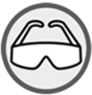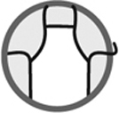
Procedure
1. Pour 40 mL of liquid into the beaker.
2. Place the beaker on the hot plate.
3. Insert the thermometer into the test tube and clamp it so the bulb is submerged completely and not touching the test tube.
4. Heat at medium temperature.
5. Record the temperature at which bubbles form.
6. Turn off the hot plate.
7. Remove the beaker from the hot plate using the beaker tongs and place it on the ceramic plate.
8. Clean up and put away materials.
Results
Record your results in the table below. Give the table a title.

Title:
Liquid | Experimental boiling point (°C) | Reference boiling point (°C)
Reflecting on the lab technique
Compare the boiling point obtained during the experiment with that of tables of characteristic properties. Are they similar? If not, explain why.

