Determining blood type
LAB 57
OBSERVATION
STUDENT BOOK | Chapter 6, page 180

Goal
Identify different blood types using serums.
Observation criteria
1. For each blood type in the following table, identify substances found on red cells by placing a
checkmark in the appropriate box.
Blood type | Substance found on red cells
Blood type | A | B | Rh
A–
A⁺
B–
B⁺
AB–
AB⁺
O–
O⁺
2. The anti-A serum coagulates red cells that carry substance A. Red cells of what blood types
coagulate when exposed to this serum?
3. The anti-B serum coagulates red cells that carry substance B. Red cells of what blood types
coagulate when exposed to this serum?
4. The anti-Rh serum coagulates red cells that carry substance Rh. Red cells of what blood types
coagulate when exposed to this serum?

Materials
• marker  • spot plate  • dropper bottle of blood sample 1  • dropper bottle of blood sample 2  • dropper bottle of blood sample 3  • dropper bottle of blood sample 4 |  | • box of toothpicks  • clean cloth or paper towel  • dropper bottle of anti-A serum  • dropper bottle of anti-B serum  • dropper bottle of anti-Rh serum  • stopwatch or watch
 | 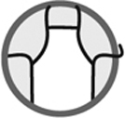
Procedure
1. Label the spot plate with the marker as indicated in Figure 1.
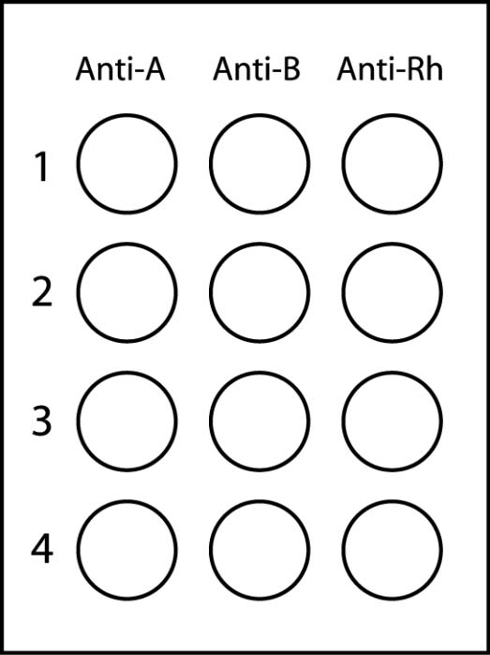
Figure 1 Preparing spot plate
2. Add 2 drops of blood sample 1 to each well of row 1.
3. Add 2 drops of blood sample 2 to each well of row 2.
4. Add 2 drops of blood sample 3 to each well of row 3.
5. Add 2 drops of blood sample 4 to each well of row 4.
6. Add 2 drops of anti-A serum to each well of left column.
7. Mix the contents in each well of left column in turn with a toothpick, wiping it clean after each use.
8. Add 2 drops of anti-B serum to each well of centre column.
9. Mix the contents in each well of centre column in turn with a toothpick, wiping it clean after
each use.
10. Add 2 drops of anti-Rh serum to each well of right column.
11. Mix the contents in each well of right column in turn with a toothpick, wiping it clean after
each use.
12. Set aside the spot plate for 3 minutes.
13. Observe if a precipitate forms in each well and record your observations.
14. Clean up and put away materials.
Observations
Fill in each circle corresponding to a well of the spot plate in which a precipitate forms.
Give the figure a title.

Title:
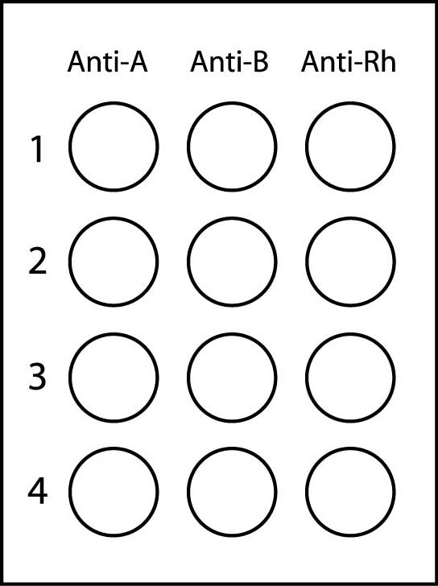
Reflecting on your observations
1. What is the blood type of each test sample based on your observations?

Sample | Blood type
2. Which test sample contains blood referred to as “universal recipient”?
3. Which test sample contains blood referred to as “universal donor”?
4. A person whose blood type matches that of test sample 1 could be given blood of the type
contained in which other test sample?
5. Do your observations help you to better understand different blood types?
6. How could you improve the protocol for this lab?

