Detecting fats
Goal
Apply a technique to determine if a food or a solution contains fats.
Materials
• 2 test tubes (15 mm × 125 mm) and stoppers (No. 00)
• test-tube rack
• marker
• dropper bottle of distilled water
• dropper bottle of vegetable oil
• weighing pan containing Sudan IV particles
• spatula
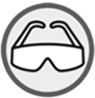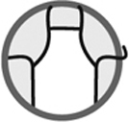
Procedure
1. Number the test tubes 1 and 2 with the marker.
2. Add 20 drops of distilled water to test tube 1.
3. Add 20 drops of vegetable oil to test tube 2.
4. Add a few particles of Sudan IV to each test tube.
5. Stopper the test tubes tightly.
6. Shake the test tubes and set them aside for 2 minutes.
7. Observe the contents of the test tubes and record your observations.
8. Clean up and put away materials.
Results
Record your observations in the table below. Give the table a title.

Title:
Test tube | Substances in test tube | Observations
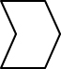
Reflecting on the lab technique
1. What indicator is used to detect fats?
2. How is the presence of fats in a food or a solution confirmed using this indicator?
3. How is the absence of fats in a food or a solution confirmed using this indicator?
4. Is Sudan IV a hydrophilic substance or a lipophilic substance? Explain your answer.
5. Why is a test tube containing only distilled water and the indicator prepared?
6. Are the results you obtained conclusive? If not, what are the possible sources of error?

