Forming images
with a diverging lens
LAB 36
EXPERIMENT
STUDENT BOOK | Chapter 4, page 113

Goal
Determine how characteristics of images obtained using a diverging lens vary according
to object position.
1. What is the independent variable in this lab?
2. What is the dependent variable in this lab?
Hypothesis
I think that
because
Materials
• diverging lens  • optical bench  • screen (white cardboard) |  | • small light bulb on base or candle  • 1-m ruler
Procedure
1. Secure the lens at the centre of the optical bench.
2. Position the screen on the opposite side of the lens.
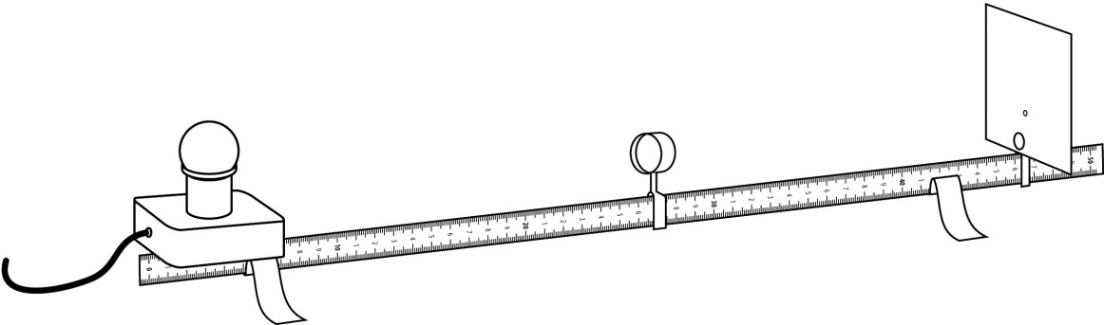
3. Measure and record the height
of the light bulb and base.
4. Position the light bulb and base at a
distance from the lens. The light bulb
will serve as both light source and object.
5. Note the position of the light source (light bulb) in relation to the lens.
6. Move the screen until a clear image is obtained.
7. Observe and record the characteristics of the image.
8. Repeat steps 4 to 7 by positioning the light source at various locations.
9. Put away materials.
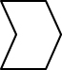
Results
Record your results in the table below. Give the table a title.

Object size (cm):
Title:
Distance  between  object and lens  (cm) | Image characteristics
Distance  between  object and lens  (cm) | Type  (real or virtual) | Distance between  image and lens  (cm) | Size  (cm) | Direction  (straight, reversed  or inverted)
Analysis of the results
1. What happens to the size of the image as an object is positioned closer to a lens?
2. Does the type of image obtained vary?
3. Does the direction of the image vary?
4. What are the possible sources of error in this lab?
5. How could you improve the protocol for this lab?
Conclusion
1. Complete the following sentences:
a) |  | The image obtained with a diverging lens is |  |  |  |  |  |  |  |  | , in the same
 |  |  | and |  |  | than the object.
b) | Image type and direction |  |  |  |  |  | on the |  |  |  |  | of an object in
 | relation to a diverging lens.
2. Was your hypothesis confirmed or not? Explain your answer.
Application
Why do the eyes of a person wearing glasses for short-sightedness seem smaller?

