Forming images
with a converging lens
Goal
Determine how characteristics of images obtained using a converging lens vary according
to object position.
1. What is the independent variable in this lab?
2. What is the dependent variable in this lab?
Hypothesis
I think that
because
.
Materials
• converging lens  • optical bench  • screen (white cardboard) |  | • ray box  • small light bulb on base or candle  • 1-m ruler
Procedure
1. Secure the lens at the centre of the optical bench.
2. Position the screen on the opposite side of the lens.
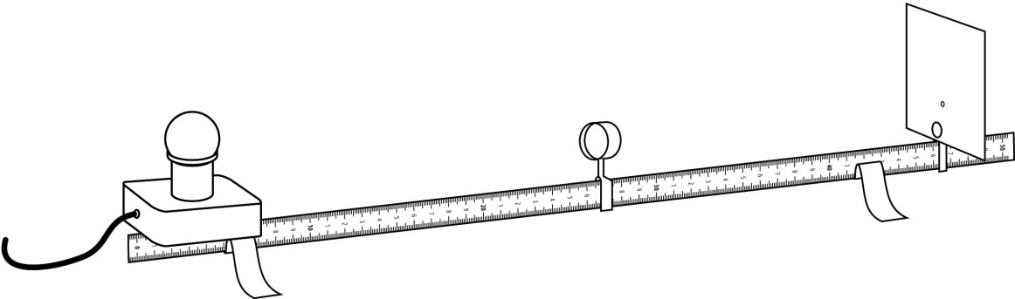
3. Identify the principal focal point (F)
of the lens with the ray box.
4. Measure and record the height of
the light bulb and base.
5. Position the light bulb and base at a distance greater than 2F.
6. Measure and record the distance between the object (light bulb) and the lens.
7. Move the screen until a clear image is obtained.
8. Observe and record the characteristics of the image.
9. Repeat steps 5 to 8 by positioning the object at the following distances:
a) 2F b) between 2F and F c) F d) between F and the lens
10. Put away materials.
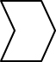
Results
Record your results in the table below. Give the table a title.

Object size (cm):
Title:
Position of  object | Distance between  object  and lens  (cm) | Image characteristics
Position of  object | Distance between  object  and lens  (cm) | Type  (real or virtual) | Distance  between  image  and lens  (cm) | Size  (cm) | Direction  (straight, reversed  or inverted)
Greater than 2F
2F
Between 2F and F
F
Between F and lens
Analysis of the results
1. How can an image that is real and an image that is virtual be distinguished?
2. When an object is placed closer to the focal point of a lens, what happens to the size of the
image?
3. In what circumstances is no image obtained?
4. In what circumstances is a real image obtained?
5. In what circumstances is a virtual image obtained?
6. Is an image always oriented the same way? Explain your answer.
7. What are the possible sources of error in this lab?
8. How could you improve the protocol for this lab?
Conclusion
1. Complete the following sentences:
a) |  | When an object is positoned beyond the focal point of a converging lens, the image
 |  | obtained is
b) | When an object is positioned |  |  |  |  |  |  |  |  |  | of a converging lens, no image
 | is obtained.
c) | When an object is positioned between the focal point and a converging lens, the image
 | obtained is |  |  |  |  |  |  |  |  | in size, on |  |  | side as/of the lens
 | and in the same
2. Was your hypothesis confirmed or not? Explain your answer.
Application
Why do the eyes of a person wearing glasses for far-sightedness seem larger?

