Separating a mixture
by distillation
LAB 13
TECHNIQUE
STUDENT BOOK | Chapter 1, page 23
toolbox | Page 34

Goal
Separate the constituent substances of a liquid mixture based on their different boiling points.
Materials
• cobalt chloride paper strips  • 50 mL of a liquid mixture  • 125-mL Erlenmeyer flask and two-hole stopper  • 2 or 3 porous stones  • thermometer  • hot plate |  | • condenser tube  • ring stand  • universal clamp  • glass elbow tube and one-hole stopper  • 2 flexible tubings  • 2 100-mL beakers
 | 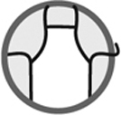
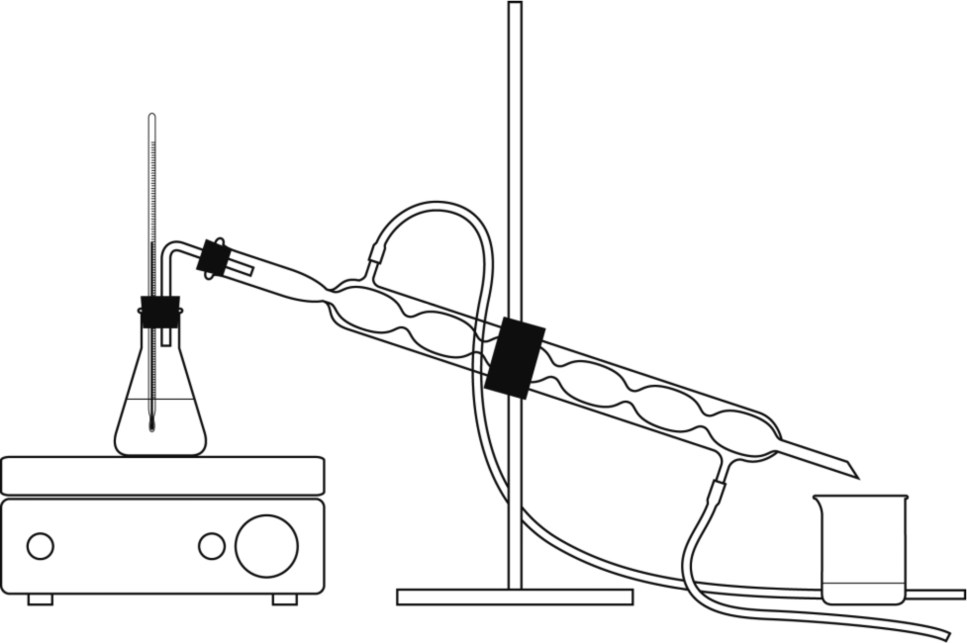
Procedure
1. Dip a cobalt chloride paper strip into the liquid
mixture. Record the result.
2. Pour the liquid mixture into the flask and add
2 or 3 porous stones.
3. Seat the two-hole stopper in the opening of
the flask.
4. Insert the thermometer into one hole of the
stopper so the bulb is submerged completely
and not touching the flask.
5. Place the flask on the hot plate.
6. Secure the condenser tube to the ring stand
with the universal clamp.
7. Seat the one-hole stopper in the opening at the wide end of the condenser tube and
connect the condenser tube to the flask with the glass elbow tube.
8. Use flexible tubing to connect the condenser tube water inlet (furthest from liquid mixture)
to a cold-water faucet.
9. Use flexible tubing to connect the condenser tube water outlet (closest to liquid mixture)
to a sink basin.
10. Position one beaker under the opening at the narrow end of the condenser tube.
11. Open the cold-water faucet. Ensure there is no leak and water flows well into the sink basin.
12. Heat the liquid mixture to the boiling point of one constituent substance. Record the boiling point.
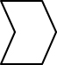
13. Continue to heat as long as the temperature remains stable.
14. Replace the beaker with the second beaker when the temperature starts to rise.
15. Record the temperature at the boiling point.
16. Stop heating when evaporation is almost complete.
17. Dip a cobalt chloride paper strip into each liquid collected. Record the results.
18. Clean up and put away materials.
Results
Record your results in the table below. Give the table a title.

Title:
Characteristic | Liquid mixture | Liquid 1 | Liquid 2
Reflecting on the lab technique
1. Were the constituent substances of the liquid mixture successfully separated?
Explain your answer.
2. According to your results, what is the nature of the liquids collected?
3. Is it possible to identify the liquids beyond any doubt? Explain your answer.
4. What are the possible sources of error in this lab?
5. How could you improve the protocol for this lab?

