A HEALTHY LUNCH BOX
STUDENT BOOK: Chapter 6, pp. 160–166
Concepts: Types of food
Method: Empirical
The latest edition of Canada’s Food Guide, published by Health Canada in February 2007, emphasizes the four major food groups. It provides information on food choices suited to your age, state of health, needs and personal preferences. It is a big help in putting together a healthy lunch-box menu.
IDENTIFYING THE RESEARCH SUBJECT
Read pp. 160–166 in your student book for help in answering the following questions.
1. In the following table, write the different categories of nutrients and the roles they play in the human organism.
Role of nutrients in the human organism
Nutrient |  |  |  | Role in the organism

Role of nutrients in the human organism (continued)
Nutrient |  |  |  | Role in the organism
2. Name the four food groups.
• |  | •
• |  | •
3. What information does the Nutrition Facts food label provide?
PLANNING YOUR RESEARCH
4. According to Canada’s Food Guide, what is the recommended daily intake for your age and sex? Indicate portion number and size for each food group.
Age:
Sex:
Canada’s Food Guide recommendations
Food group |  | Number of portions |  | Sample portion
Vegetables and fruits
Grain products
Milk and alternatives
Meat and alternatives
5. Complete the sentences below.
To put together a healthy menu for your lunch box, you need to consider:
• | The |  |  |  | food groups.
• | The number of |  |  |  |  |  | from each group.
• | The recommendations for your |  |  |  |  |  |  | , your
 | and your |  |  |  |  | .
CONDUCTING YOUR RESEARCH
6. Based on your answers to questions 4–5 and the recommendations of Canada’s Food Guide, complete the table on the following pages to make up your healthy lunch box.

My healthy lunch-box menu
Food group |  | Portion size  and number |  | Justification of choice (according to  Canada’s Food Guide recommendations)
Food:
Food:
Food:
Food:
My healthy lunch-box menu (continued)
Food group |  | Portion size  and number |  | Justification of choice (according to  Canada’s Food Guide recommendations)
Food:
Food:
REFLECTING ON YOUR APPROACH
7. Would you use the menu you created to prepare your lunch box? If not, explain why.
8. What are the benefits of combining a healthy menu with an active lifestyle?

Appendix
Canada’s Food Guide
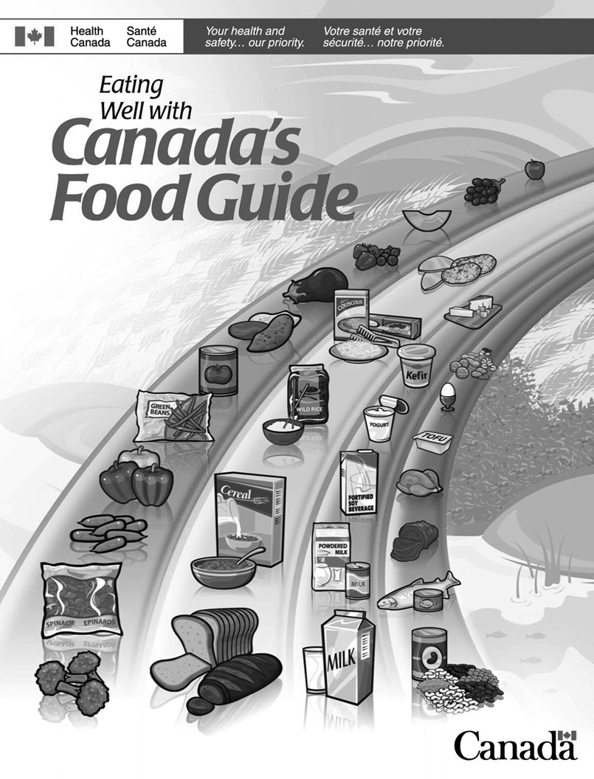
Canada’s Food Guide (continued)
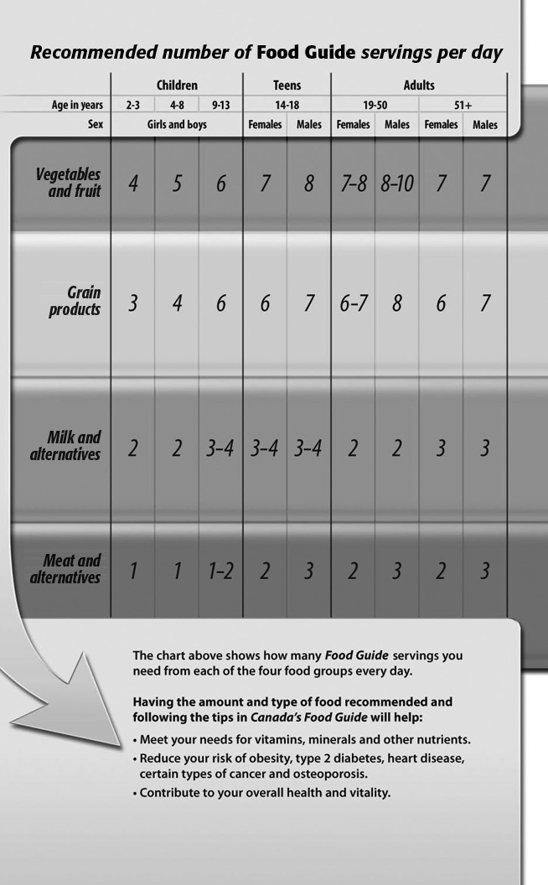
Canada’s Food Guide (continued)
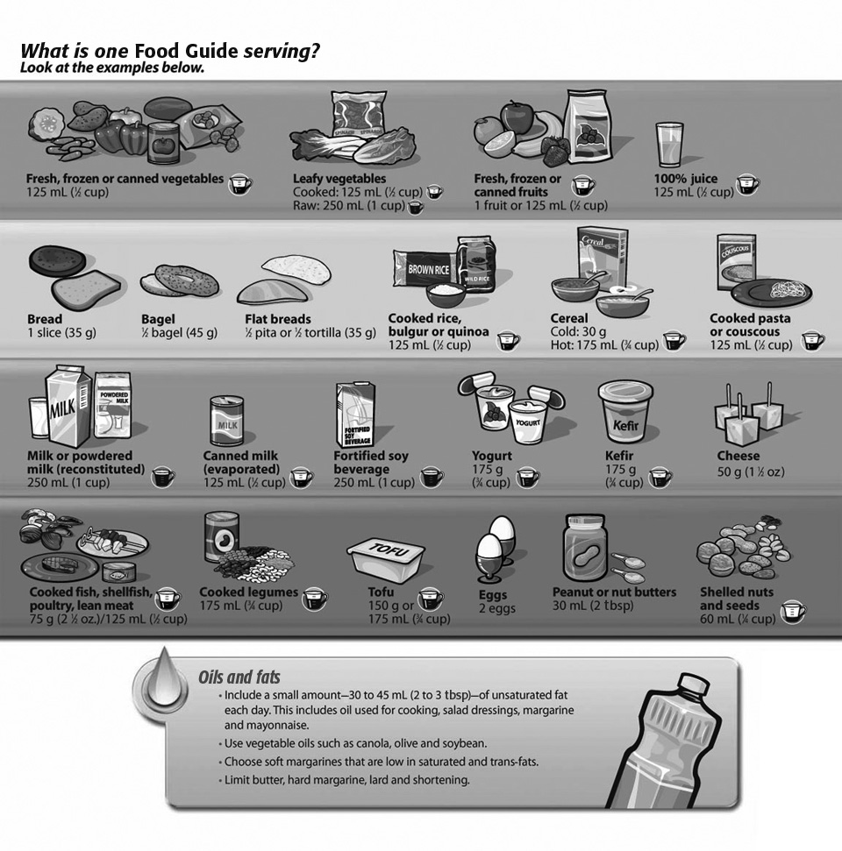
Canada’s Food Guide (continued)
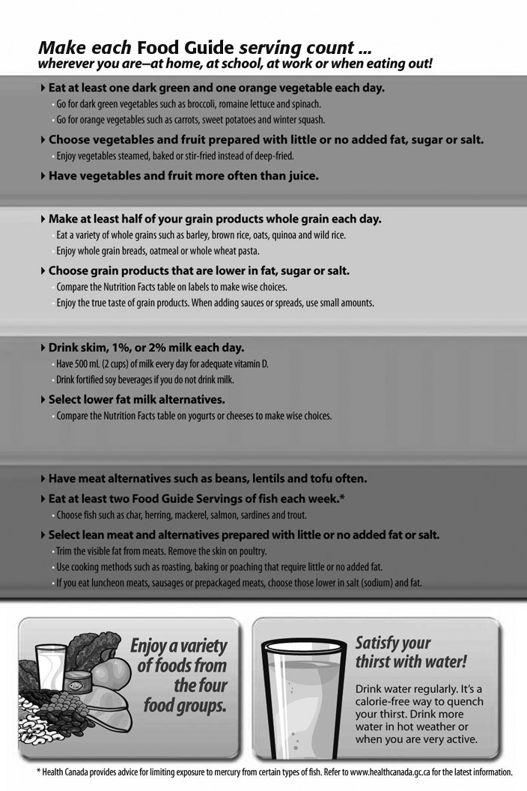
Canada’s Food Guide (continued)
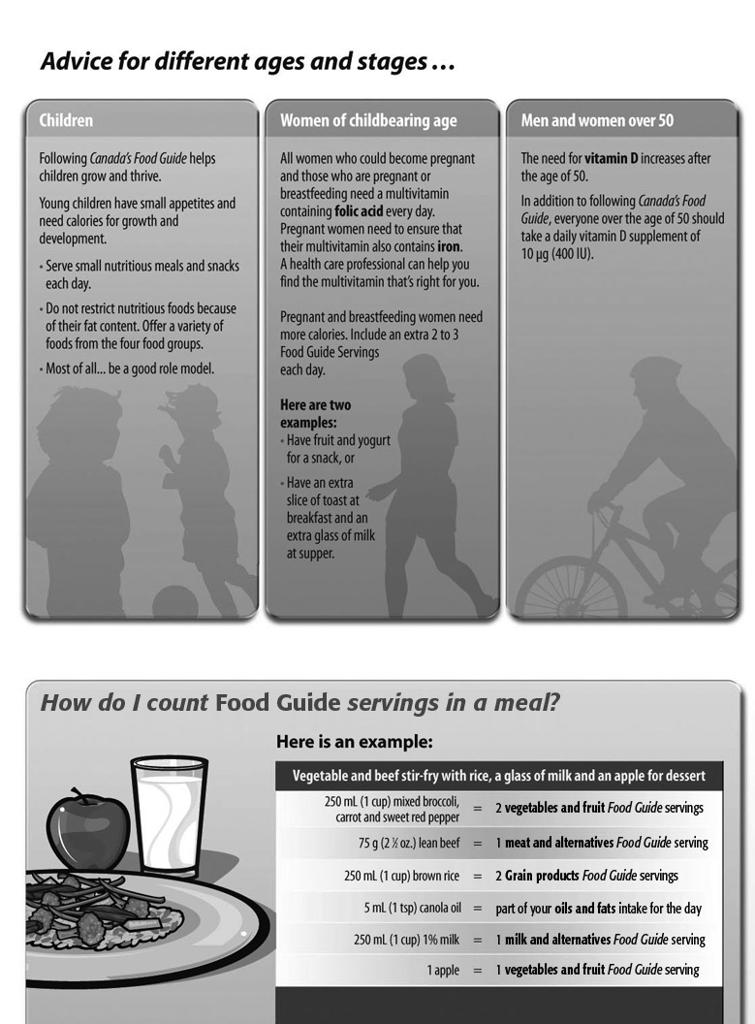
Canada’s Food Guide (continued)
