SAME OR DIFFERENT?
STUDENT BOOK: Chapter 5, pp. 129–130
Concepts: Genetic diversity
Method: Observation
Genes are responsible for most of the physical traits we see in a person. Brown eyes, dimples
in cheeks when smiling, a widow’s peak at the hairline and the ability to curl the tongue into a
U-shape are all traits dictated by dominant genes. In sum, genetic diversity within a population expresses mostly the presence or absence of dominant genes in the individuals making up
that group.
IDENTIFYING OBSERVATION CRITERIA
Read pp. 129–130 in your student book for help in answering the following questions.
1. Genes determine an individual’s physical traits. Where are the genes located in the cell?
2. What role do genes play in an individual’s physical makeup?
3. Does everyone have similar genes? Explain your answer.
4. What is genetic diversity?
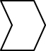
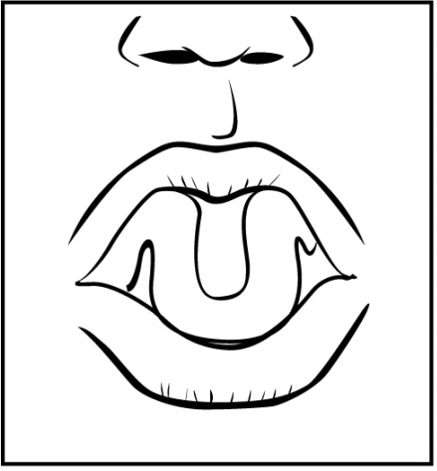
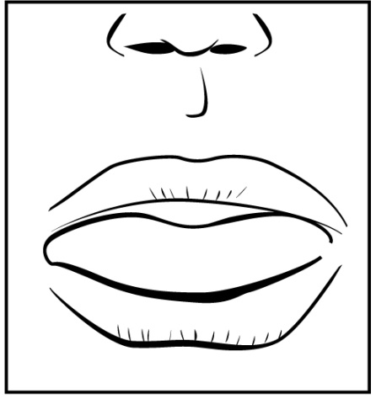
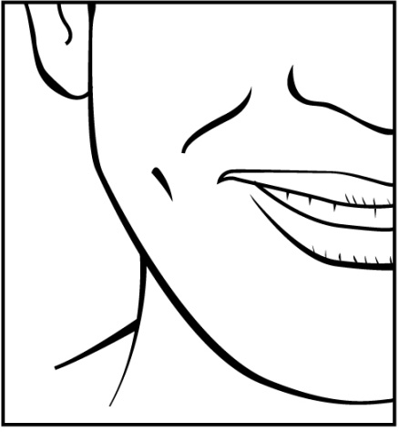
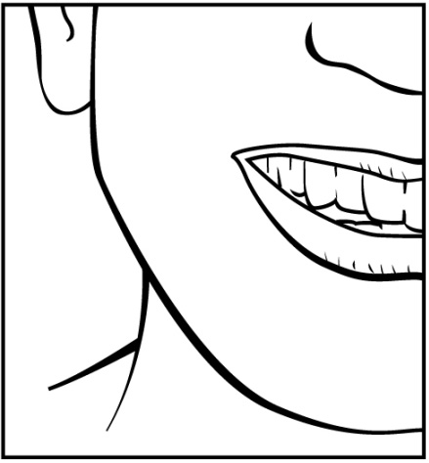
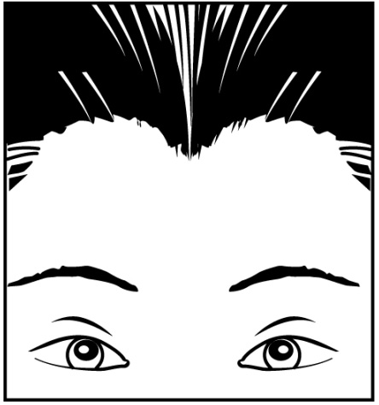
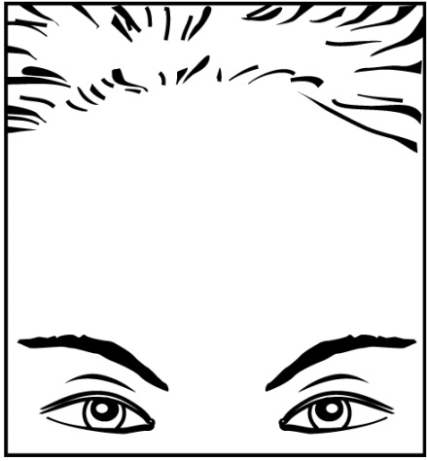
5. For a clearer picture of genetic diversity, look for these four physical traits in your classmates.
Physical traits | Possible variations
Eye colour | Brown or green | Blue or grey
Hairline on the forehead | Widow’s peak | No widow’s peak
Ability to curl the tongue  into a U-shape | Can curl tongue | Can’t curl tongue
Dimples in cheeks  when smiling | Dimples | No dimples
ESTABLISHING AN OBSERVATION PROTOCOL
6. Choose a sampling of individuals for your observations.
7. Create a protocol for observing the four physical traits among the individuals in your sampling.
APPLYING THE OBSERVATION PROTOCOL
8. Apply the observation protocol you created and record your answers in the table below.
Remember to title your table of results.
Title:

Subject | Eye colour |  | Hairline on  the forehead |  | Ability to curl  tongue into U-shape |  | Dimples in cheeks  when smiling
Subject | Brown  or green | Blue  or grey | Widow’s  peak | No widow’s  peak | Can | Can’t | Dimples | No dimples
1
2
3
4
5
6
7
8
9
(continued)
Subject | Eye colour |  | Hairline on  the forehead |  | Ability to curl  tongue into U-shape |  | Dimples in cheeks  when smiling
Subject | Brown  or green | Blue  or grey | Widow’s  peak | No widow’s  peak | Can | Can’t | Dimples | No dimples
10
11
12
13
14
15
16
17
18
19
20
21
22
23
24
25
26
27
28
29
30
31
32
33
34
35
36
37
38
REFLECTING ON YOUR APPROACH
9. Were you able to observe any genetic diversity? Explain why.
10. Were any of the four physical traits missing from your sampling?
11. Are the possible variations for a given gene always distributed equally among a population? Explain your answer based on your observations.
12. How could you have improved your observation protocol?

