PEERING ABOVE THE CROWD
STUDENT BOOK: Chapter 4, pp. 106–110
Concepts: Deviation of light waves
Method: Technological design
Jumping up or perching on a friend’s shoulders to peer above the crowd doesn’t seem the best way to see what is happening beyond an obstacle. The object that will solve this problem must be lightweight, easy to handle and made from simple materials.
IDENTIFYING AND MEETING A NEED
Read pp. 106–110 in your student book for help in answering the following questions.
In this activity, you will learn how to make a periscope so you can see over obstacles.
IDENTIFYING THE WORKING PRINCIPLES
1. Complete a design plan for your periscope by drawing:
a) the incident rays, reflected rays and normals
b) the angles of incidence and reflection
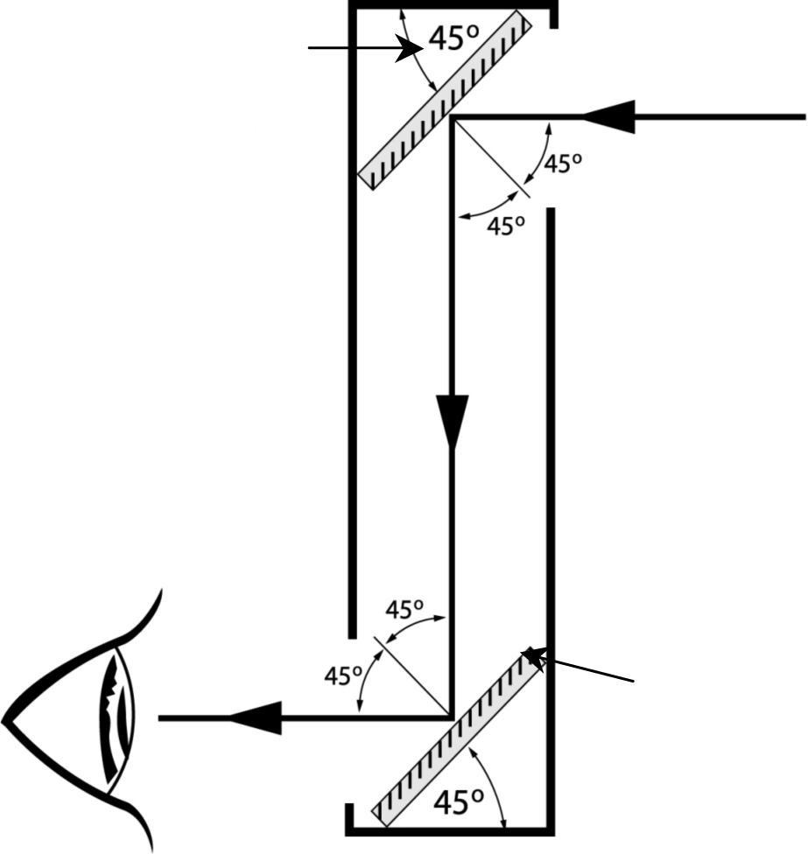
Design plan

Mirror 1
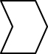

Mirror 2
2. Name the phenomenon that allows you to see an image through a periscope.
3. What are the basic principles of plane mirrors?
IDENTIFYING THE DESIGN PRINCIPLES
4. A periscope has two main types of parts. Name them.
5. You have the following equipment and materials to build your periscope:
• 2 1-L milk cartons • ruler
• 2 small plane mirrors (≈ 7 cm square) • pencil
• retractable utility knife • masking tape
• cutting mat • plasticine
After familiarizing yourself with these materials, complete a technical diagram for your periscope by:
a) naming the parts
b) filling in the legend of materials
c) naming the linking components you will use to put your periscope together
Technical diagram
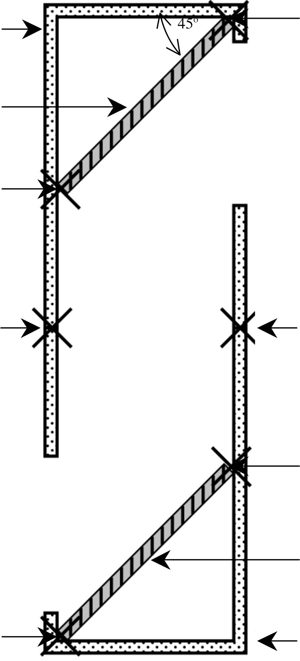
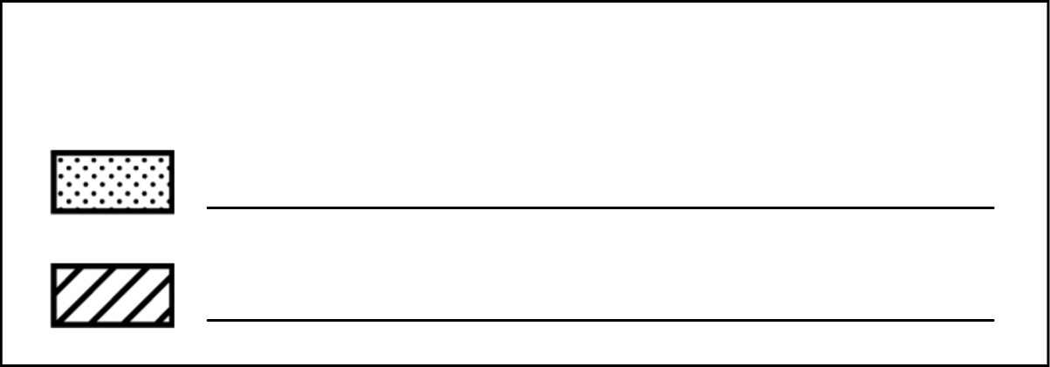
Legend of materials

BUILDING AND TESTING A PROTOTYPE
6. Build your prototype following the steps of this manufacturing process:
Manufacturing process – Periscope
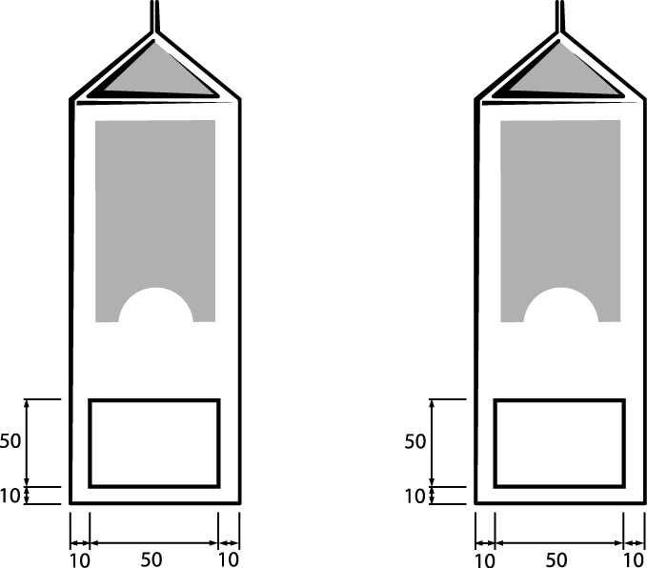
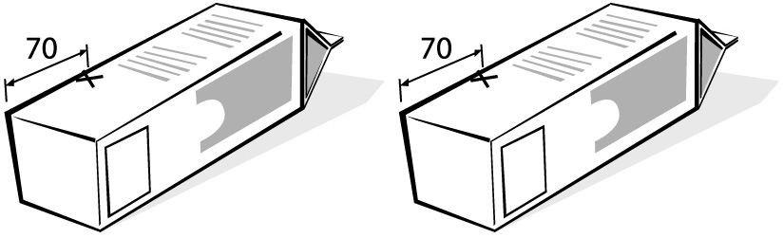
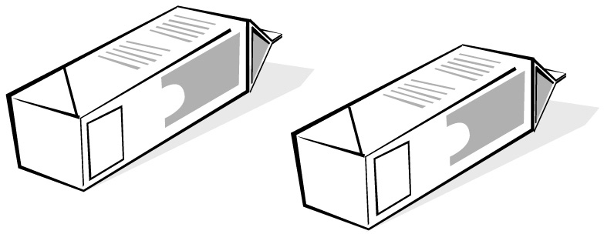
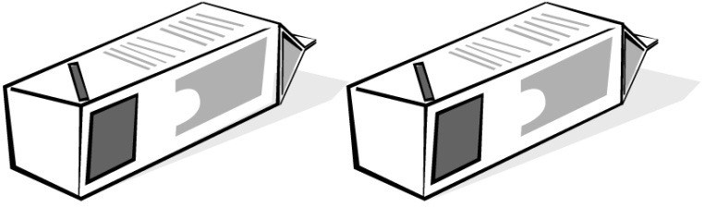
Materials: 2 milk cartons, masking tape, plasticine
No. |  | Step |  | Sketch |  | Materials
10 |  | Measuring and marking
11 |  | Mark a square about  50 mm × 50 mm at the bottom  on one side of the carton.  Leave at least 10 mm of carton  around the square. Repeat for  the other carton. |  |  |  | • ruler  • pencil
12 |  | Lay the carton down so the  side with the marked square is  to your right. On the side facing  up, measure 70 mm from the  bottom left corner and make  a reference point. Repeat for  the other carton. |  |  |  | • ruler  • pencil
13 |  | Draw a line from the bottom  right corner to the reference  point you made. Repeat for  the other carton. |  |  |  | • ruler  • pencil
14 |  | Measure the thickness of the  mirrors, then draw a second  line parallel to the first line and at a distance equal to the thickness of the mirrors. Repeat for the other carton. |  |  |  | • ruler  • pencil
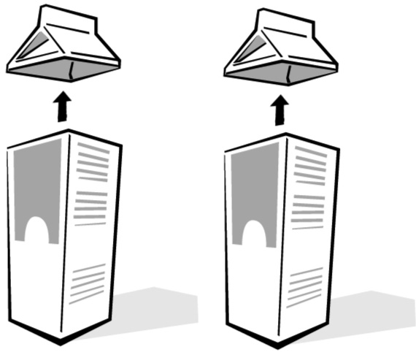
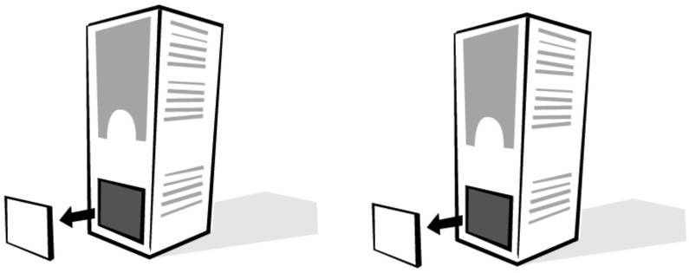
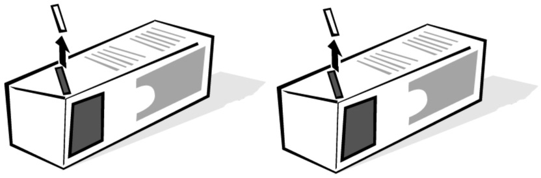
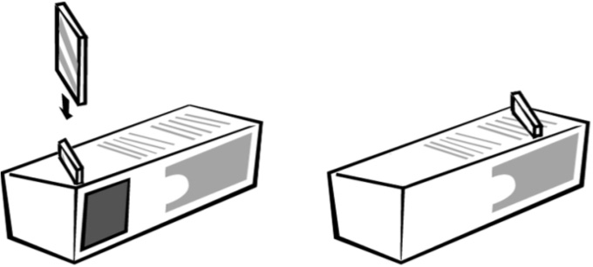
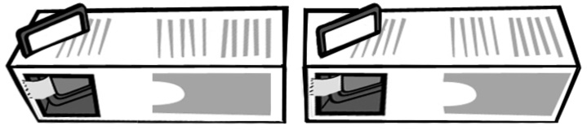
Manufacturing process (continued)
No. |  | Step |  | Sketch |  | Materials
20 |  | Machining
21 |  | Cut off the top of each carton. |  |  |  | • retractable  utility knife  • cutting mat
22 |  | Cut out the square marked on  each carton. |  |  |  | • retractable utility knife
23 |  | Cut out the slot for the mirror  on each carton. |  |  |  | • retractable utility knife
30 |  | Assembling
31 |  | Insert the mirrors into the slots,  the reflective sides facing the  square hole in the carton.
32 |  | Fasten each mirror to  its carton with the linking  component named on your  technical diagram.
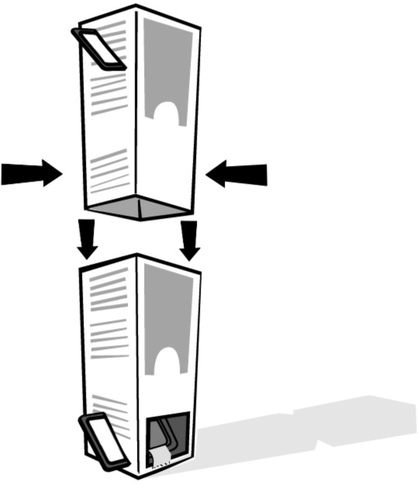
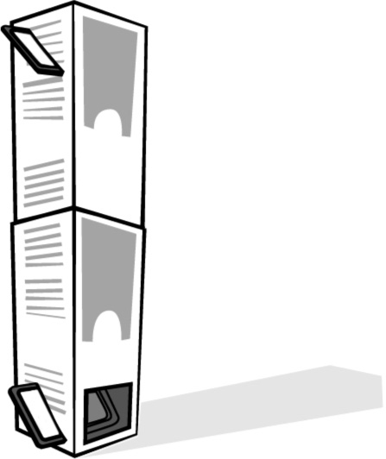
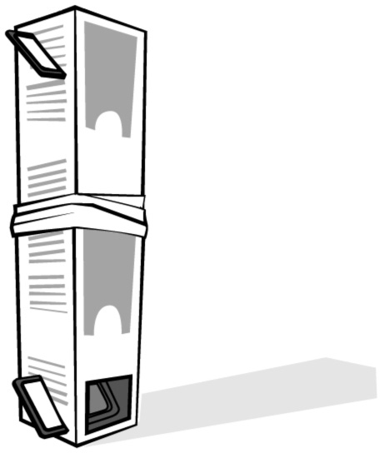
Manufacturing process (continued)
No. |  | Step |  | Sketch |  | Materials
33 |  | Stand one carton on end,  with the hole facing you. Turn  the other carton upside down,  with the mirror and the hole  at the top. The hole at the top  of the carton must be facing  away from you.
34 |  | Carefully set the top carton  onto the bottom carton so they fit together.
35 |  | Fasten the two cartons  together with the linking  component you named on  your technical diagram.
7. Test your periscope. Stand in front of an obstacle: a desk, low wall or person, for instance.
Look into the periscope through one hole, the other hole positioned above the obstacle. Is
your periscope working as expected? If not, what is the problem?
8. Is the final image horizontally inverted or not? Explain your answer.
9. What do you think would happen if your periscope box were much longer?
10. How could you modify your periscope to see higher or lower on the other side of an obstacle?
11. What could you add to make your periscope magnify the final image?

