GAS UNDER PRESSURE
STUDENT BOOK: Chapter 3, pp. 68, 75–79
Concepts: Compressible fluid
Relationship between pressure and volume
Method: Observation
The relationship between gas pressure and volume has many possible applications, such as the use of weather balloons and compressed gas cylinders. Your setup for this activity will help you visualize what happens to the volume of a gas when the pressure increases or decreases.
IDENTIFYING THE OBSERVATION CRITERIA
Read pp. 68 and 75–79 in your student book for help in answering the following questions.
1. What do you call a fluid whose volume may decrease under pressure?
2. Is air a compressible or incompressible fluid?
3. What causes pressure in a gas?
4. What happens with the pressure of a gas when its volume decreases? Explain your answer.

5. What happens with the pressure of a gas when its volume increases? Explain your answer.
6. What happens with the volume of a gas when the pressure is increased? Explain your answer.
7. What happens with a volume of a gas when the pressure is decreased? Explain your answer.
8. Complete the following sentences summarizing the relationship between gas pressure
and volume.
If the volume increases, the pressure
If the volume decreases, the pressure
If the pressure increases, the volume
If the pressure decreases, the volume
ESTABLISHING AN OBSERVATION PROTOCOL
9. Use the following materials to make your setup:
• clear plastic bottle (2 L or 1 L)
• inflatable balloon (30 cm or 22-cm)
• a straw
• transparent adhesive tape or adhesive putty
10. Make the setup by carrying out steps 1–5 of the following procedure.
Procedure
1. Insert the balloon into the bottle, leaving
one end outside.
2. Inflate the balloon slightly and fasten it closed.
3. Insert the straw into the bottle alongside
the balloon, leaving one end of the straw
outside the bottle.
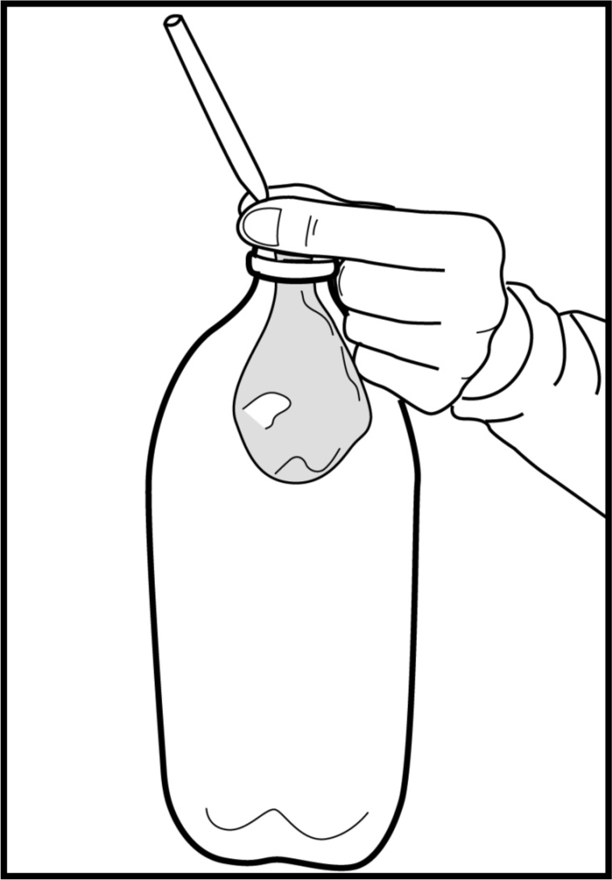
4. Fold the lip of the balloon down
around the mouth of the bottle,
carefully avoiding the straw.
5. Using the adhesive tape, hermetically
seal the balloon to the bottle, being
careful not to crush the straw.
6. Suck air from the bottle through the
straw. Watch how the balloon changes,
and record your observations.
7. Blow air into the bottle through the
straw. Watch the balloon, and record
your observations.
8. Repeat the experiment.

APPLYING THE OBSERVATION PROTOCOL
11. Perform steps 6–8 of the procedure, and record your results in the table on the next page.
Table of results
Procedure |  | Observation
First observation
Suck air from the bottle.
Blow air into the bottle.
Second observation
Suck air from the bottle.
Blow air into the bottle.
REFLECTING ON YOUR APPROACH
12. How does pressure inside the bottle change when air is removed?
13. How does the balloon volume change when air is sucked from the bottle through the straw.
14. How does the balloon volume change when air is blown into the bottle with the straw?
15. Based on your observations, what can you conclude about the relationship between the balloon volume and the air pressure around the balloon?
16. Do your observations improve your understanding of the process under study?
Explain your answer.
17. What changes could you make to improve the suggested protocol?

