A MAGIC KEY
STUDENT BOOK: Chapter 2, pp. 55–56
Concepts: Chemical changes
Decomposition
Method: Observation

The process of electrolysis has many practical applications. It is used to produce hydrogen
and oxygen from water and chlorine from salt and to extract metals from ores. This activity is
designed to determine whether copper can be extracted from a copper compound solution and
to observe how a metal object changes through electrolysis.
IDENTIFYING the OBSERVATION CRITERIA
Read pp. 55–56 in your student book for help in answering questions 1–5.
1. Does the electrolysis process involve a physical reaction or a chemical reaction?
2. What is the name of that reaction?
3. Does electrolysis absorb or release energy?
4. What type of energy is involved in electrolysis?
5. Knowing that electrolysis decomposes water (H₂O) into hydrogen (H₂) and oxygen (O), what compounds will be released during electrolysis of a copper chloride solution (CuCl₂)?

6. What tells you that electrolysis has taken place?
ESTABLISHING AN OBSERVATION PROTOCOL
7. A key was chosen as the small object for the copper deposition experiment. Why do you think the object should not be too big?
8. In your opinion, what other ordinary small objects would be suitable?
9. Below is the list of materials you should use to copper-plate your key by electrolysis:
• 150-mL glass beaker
• 100 mL copper chloride
• 2 metal paper clips
• source of variable current
• 3 connector wires with alligator clips
• dissection tweezers
• ammeter
• stopwatch
• small metal object (key)
• liquid soap
10. Below are the steps of the procedure for copper deposition by electrolysis.

Procedure
1. Use the dissection tweezers to handle the key.
2. Clean the key with soap.
3. Thoroughly rinse the key with water to remove the soap residue, then dry the key with a paper towel.
4. Measure the key’s mass and record the measurement in the table of results.
5. Measure the mass of one of the paper clips, and record the measurement in the table of results. This will be the “plain” paper clip.
6. Unbend the plain paper clip and attach to the rim of the beaker. Fold one end over into the beaker, making sure it extends below the 100 mL line.
7. Hook the key onto the second paper clip.
8. Bend the paper clip holding the key over the rim and into the beaker,
making sure the key is below the 100-mL line. Make sure that
the key and the plain paper clip do not touch.
9. Connect the plain paper clip to the positive terminal
of the current source.
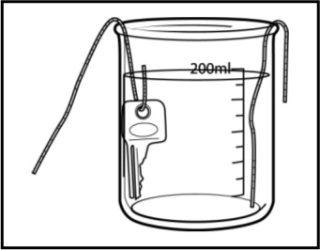
10. Connect the paper clip holding the key to the “500” positive
terminal of the ammeter.
11. Connect the negative terminal of the ammeter to the negative
terminal of the variable current source.
12. Pour 150 mL of copper chloride solution into the beaker.
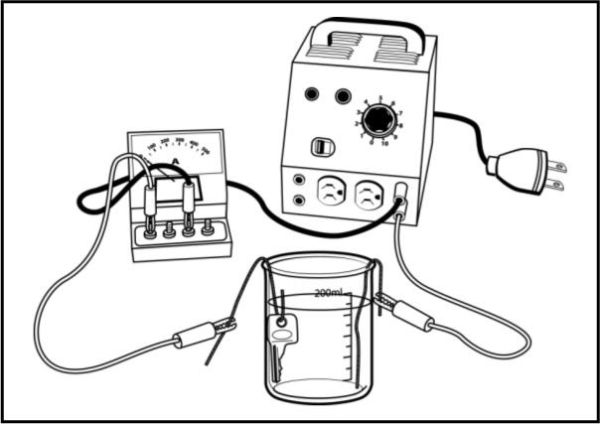
13. Adjust the current in the circuit to 500 mA.
14. Start the stopwatch.
15. Record any changes that occur while the current
is flowing (over the metal objects and in the solution).
16. After 20 minutes, turn off and disconnect the current,
then remove the key and paper clips from the solution.
17. Observe the appearance of the key.
18. Rinse and dry the key, then measure its mass.
19. Repeat steps 17 and 18 with the plain paper clip.
20. Record the results in the table.
21. Return the copper solution to its original container.
22. Clean and store the materials.
APPLYING THE OBSERVATION PROTOCOL
11. Use the table below to record the changes you observed (before, during and after electrolysis).
Table of results
Starting mass of key:
Starting mass of “plain” paper clip:

Final mass of key:
Final mass of “plain” paper clip:

Observation |  | Reaction  time |  |  |  | Changes
Colour of key |  | Start:
 |  | After |  | min:
 |  | End: |  | min.
Deposit on key |  | Start:
 |  | After |  | min:
 |  | End: |  | min.
Solution |  | Start:
 |  | After |  | min:
 |  | End: |  | min.
Other change |  | Start:
 |  | After |  | min:
 |  | End: |  | min.
12. What do you observe during the electrolytic reaction? Describe what happens on the key.
13. What do you observe about the colour of the solution?
14. Do you observe anything else in the solution?
REFLECTING ON YOUR APPROACH
15. What indicates that electrolysis took place and produced copper?
16. What do these changes mean?
17. Has this activity improved your understanding of electrolysis? Explain your answer.
18. Would the experiment have produced the same observations if the solution had contained a metal other than copper? Explain your answer.
19. How could you improve the observation protocol?

