CURVES AND LINES
STUDENT BOOK: Chapter 11, pp. 340–347
Concepts: Geometric lines
Projections
Method: Observation
Certain drawings are produced by the clever use of lines and shapes, giving the impression that they are distorted. They are known as optical illusions, or geometric illusions, and they give rise to misrepresentations of size, angle, curve, perspective and so on. In this activity, you will see a few drawings of different geometric shapes. You are to measure them to determine what is illusion and what is not.
IDENTIFYING the OBSERVATION CRITERIA
Read pp. 340–347 in your student book for help in answering questions 1–5.
1. Name three possible ways of producing a technical drawing.
2. Name the lines that can be drawn using drafting instruments and the rules of geometry.
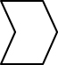
3. Provide two examples of optical illusion drawings that you have seen before. Think, for example, of those you may have seen on posters or clothing.
4. Complete the following table with the names of the drafting instruments needed to verify certain elements of the drawings.
Sketch |  | Name of  instrument used |  | Function
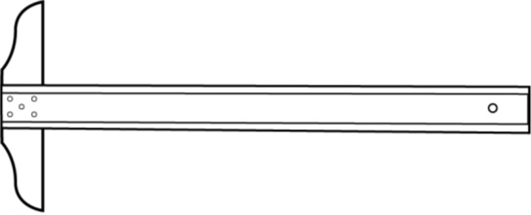 |  |  |  | Checks whether straight lines are
 |  |  |  | horizontal and parallel to each other.
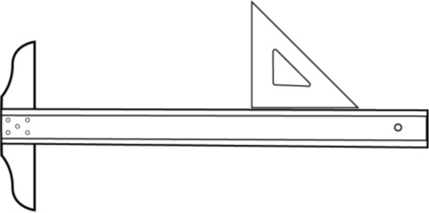
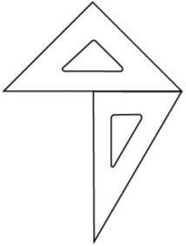 |  |  |  | Checks whether
 |  |  |  |  | lines are
 |  |  |  |  | to each other.
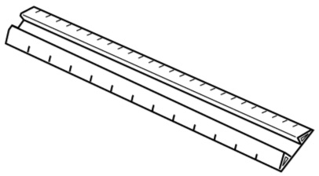 |  |  |  | Checks the length of lines.
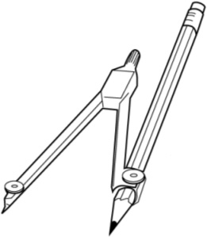
ESTABLISHING an OBSERVATION PROTOCOL
5. Make the following observations of the drawings in series A (p. 154). Record your results in the table on the next page as you go.
Drawing 1  • Spot the illusion by indicating which of  the two horizontal lines looks longer.  • Check the length of these two lines and  indicate whether one of them is really  longer than the other. |  | Drawing 2  • Spot the illusion by indicating which of  the two lines looks longer.  • Check the length of these two lines and  indicate whether one of them is really  longer than the other.
Drawing 3  • Spot the illusion by indicating which of  the two black vertical lines marked A and  B looks longer.  • Check the length of these two lines and  indicate whether one of them is really  longer than the other. |  | Drawing 4  • Spot the illusion by indicating which of  the three horizontal lines looks longest.  • Check the length of these three lines  and indicate whether any of them is  really longer.
6. Make the following observations of the drawings of series B (p. 154). Record your results in the table on the next page as you go.
Drawing 1  • Spot the illusion by indicating whether  the horizontal lines on the drawing look  parallel or not.  • Check and indicate whether the  horizontal lines are really parallel. |  | Drawing 2  • Spot the illusion by indicating whether the  oblique lines of the drawing look parallel  to each other.  • Check and indicate whether the oblique  lines are really parallel.
Drawing 3  • Spot the illusion by indicating whether  the horizontal lines look parallel to each  other and whether the vertical lines look  parallel to each other.  • Check the parallelism of the horizontal  lines to each other and of the vertical  lines to each other. Indicate whether  they are really parallel. |  | Drawing 4  • Spot the illusion by indicating whether  the lines forming the two ellipses point in  the same direction.  • Check the direction of the lines and  indicate whether they point in the  same direction.
7. Make the following observations of the drawings in series C (p. 155). Record your results in the table below as you go.
Drawing 1  • Spot the illusion by indicating whether the  circles in the centre of the two groups  look the same size.  • Check the size of the circles in the centre  of the two groups and indicate whether  one of them is really bigger than  the other. |  | Drawing 2  • Spot the illusion by indicating whether  the two circles look the same size.  • Check the size of the two circles and  indicate whether one of them is really  bigger than the other.
Drawing 3  • Spot the illusion by indicating whether the  two white rectangles look the same size.  • Check the size of the two white  rectangles and indicate whether one  of them is really bigger than the other. |  | Drawing 4  • Spot the illusion by indicating whether  the two squares are the same size.  • Check the size of the two squares and  indicate whether one of them is really  bigger than the other.
APPLYING THE OBSERVATION PROTOCOL
Table of results
Drawing  No. |  | Illusion |  |  |  | Reality
Series A
1 |  | The horizontal line at the |  |  |  | The two horizontal lines are
 |  | looks longer than the one at the
2
Table of results (continued)
Drawing  No. |  | Illusion |  | Reality
Series A (continued)
3
4
Series B
1
2
3
4
Series C
1
2
Table of results (continued)
Drawing  No. |  | Illusion |  | Reality
Series C (continued)
3
4
REFLECTING ON YOUR APPROACH
8. Even though you knew the drawings were optical illusions, did you see illusions in all the drawings observed?
9. What do the drawings in each series have in common?
a) In series A?
b) In series B?
c) In series C?
10. How did you figure out the optical illusions in this activity?
11. In comparing your observations with those of your classmates:
a) Did you all notice the same types of illusions in the same drawings?
b) Did you all obtain the same results in measuring your drawings?
12. How could you improve your observation protocol?
Series A
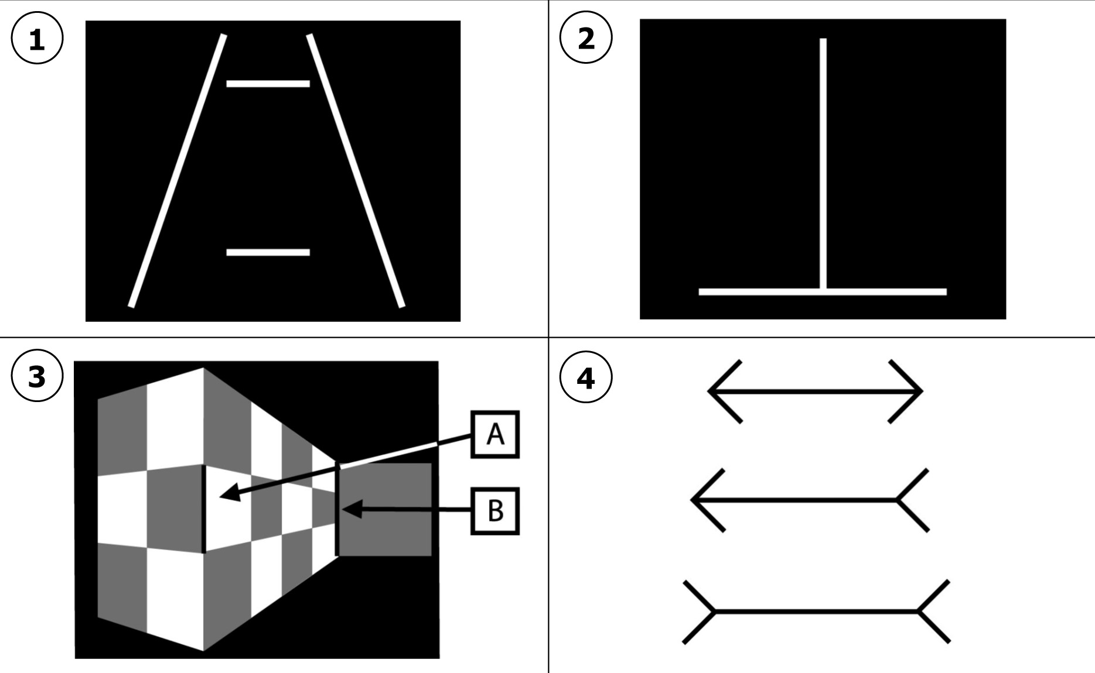
Series B
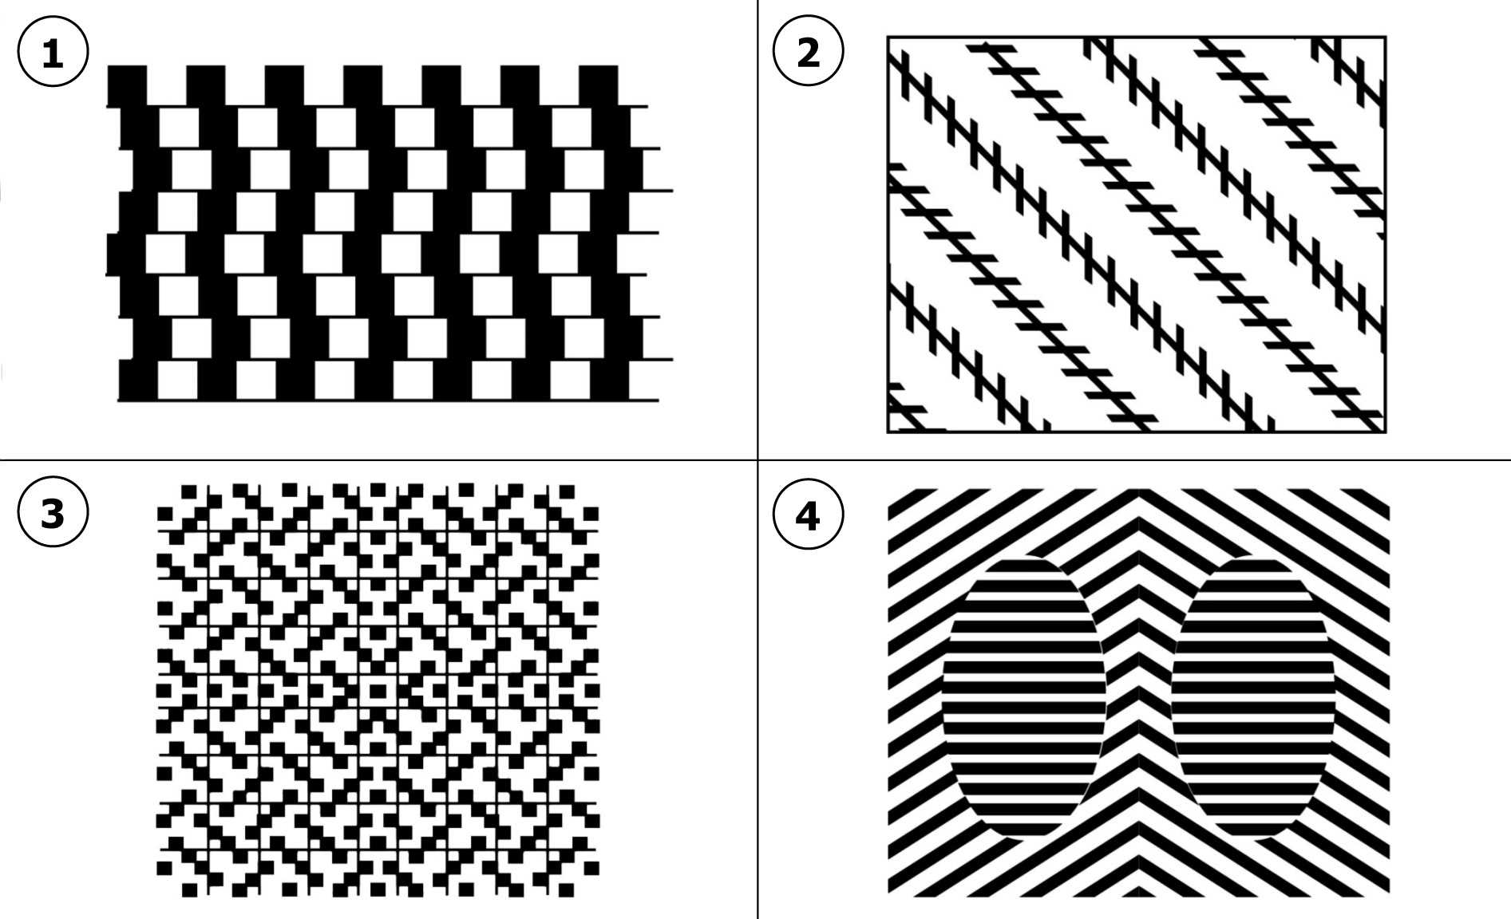
Series C
