ROUND, ROUND
AND ROUND AGAIN
STUDENT BOOK: Chapter 11, pp. 340–342
Concepts: Geometric lines
Method: Technological analysis
Tools and rulers are essential for drawing geometric lines. The bow compass is among the most
commonly used geometric tools for drawing circles. How is this instrument designed? You will be
able to answer this question by carrying out a technological analysis of this compass.
Read pp. 355–359, 378–380 and 383–388 in your student book for help in answering the following questions.
WHAT IS THe OBJECT USED FOR?
1. What is a compass used for?
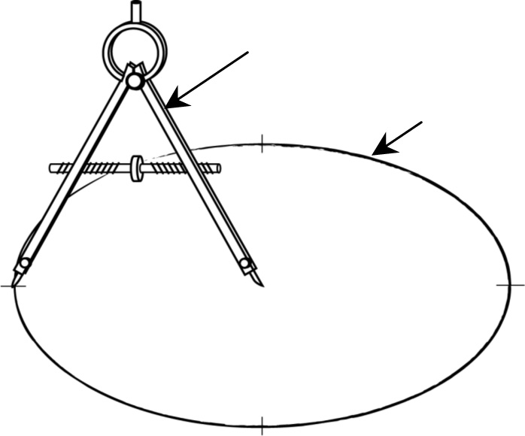
HOW DOES THE OBJECT WORK?
compass
circle
2. Which part of a circle is measured by the
distance between the two limbs of the compass?

3. If you don’t have a compass, how can you draw a circle using a piece of string, a needle and
a pencil?
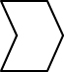
4. Observe the threads on both sides of the head of the screw for the compass adjustment mechanism. What differentiates the threads?
5. Observe the adjustment mechanism of the compass.
a) To what is the adjusting screw connected on the inner side of the compass limbs?
b) Where is force applied to turn the screw for adjusting the limb spread?
c) What motion do the nuts make when the screw is rotated?
d) What motion do the compass limbs make when they spread apart or move closer together?
e) What type of motion transformation system makes up the mechanism?
f) Circle the diagram showing the motion
transformation system used for the compass.
Pay special attention to the symbols
representing the screw threads.
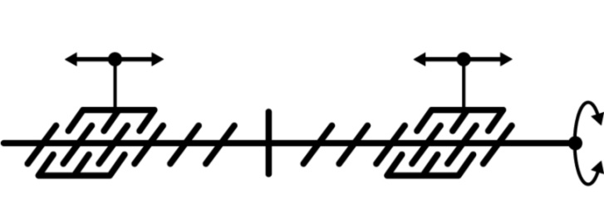
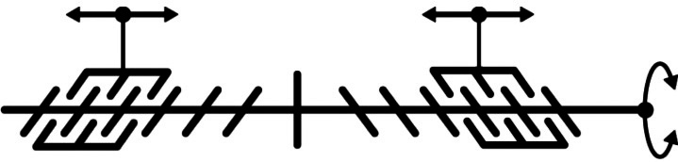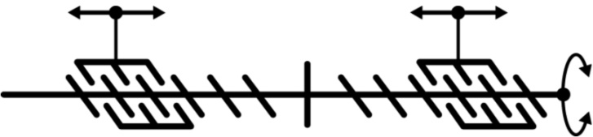
6. Based on your answers to questions 4 and 5, complete the design plan for spacing the compass limbs. To do this, indicate the following on the plan:
• the point of application of force using the symbol 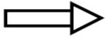
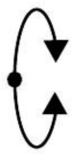
• the motions of the compass adjusting screw using
the proper symbols from among those shown here: 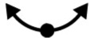
• the names of the different parts of the compass using the following terms:
limb with sharp point • limb with pencil graphite • adjustment mechanism
head • O-ring • sharp point • limb joint
Design plan
Pencil graphite
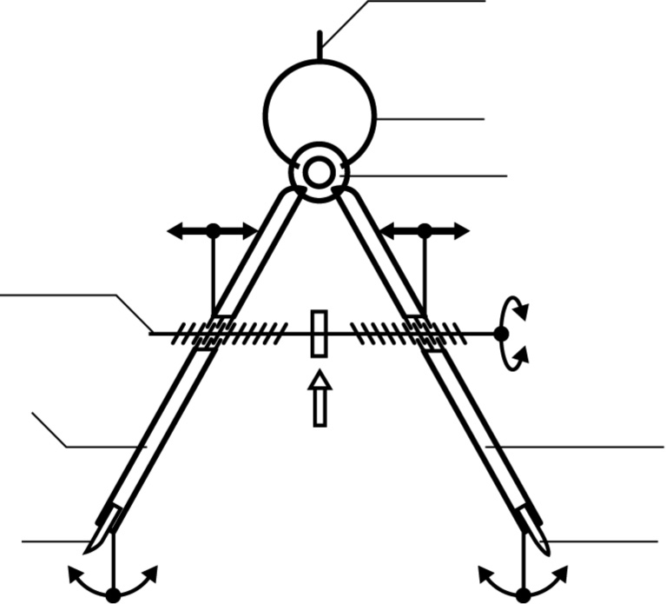
7. What motion does the head make to draw a circle?
HOW IS the object CONSTRUCTED?
8. Circle the type of material used to make the O-ring, screw, nuts and head of the compass.
wood • modified wood • metal or alloy • plastic • other material
9. Circle the type of material used to make the limbs of the compass.
wood • modified wood • metal or alloy • plastic • other material
10. What type of guide is the limb joint of the bow compass: translational or rotational?
11. Based on your answers to questions 8 to 10, complete the technical diagram of the bow compass below as follows:
• Record the missing names of the compass parts (see the list in question 6).
• Draw the proper symbol for the guiding motion provided by the limb joint. For
rotational motion, draw the symbol . For translational motion, draw the symbol 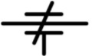.
• Complete the legend of materials.
Technical diagram
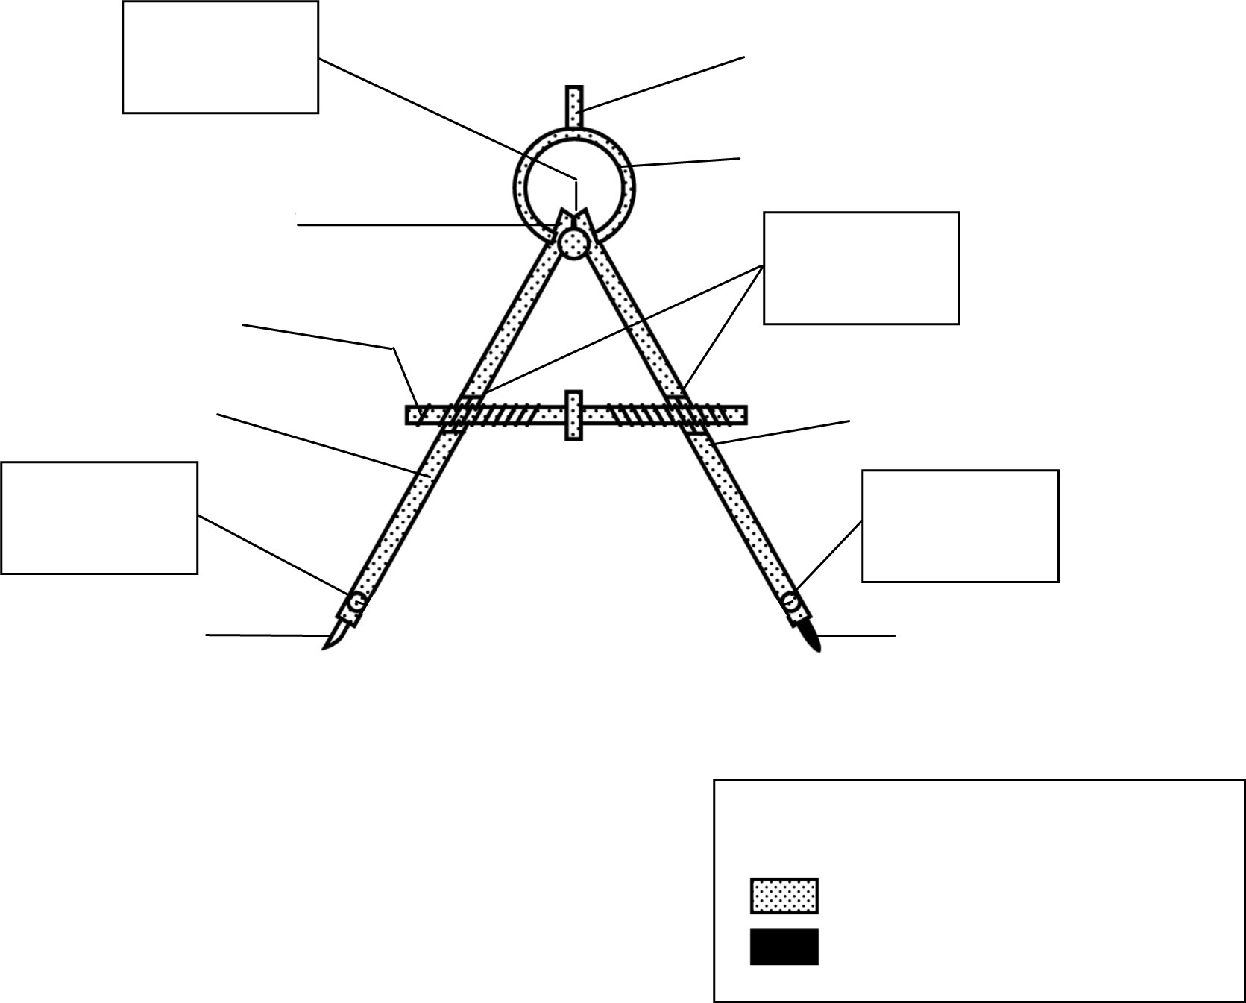
Pencil graphite
Legend of materials
Graphite
12. Name the characteristics of the links in the bow compass by checking the appropriate boxes. Refer to pp. 385–386 in your textbook to refresh your knowledge of link characteristics.
a) characteristics of the link between the head and the O-ring
£ Direct £ Indirect
£ Rigid £ Flexible
£ Removable £ Non-removable
£ Complete £ Partial
b) characteristics of the link between the sharp point and the compass
£ Direct £ Indirect
£ Rigid £ Flexible
£ Removable £ Non-removable
£ Complete £ Partial
c) characteristics of the link between the graphite and the compass
£ Direct £ Indirect
£ Rigid £ Flexible
£ Removable £ Non-removable
£ Complete £ Partial
d) characteristics of the link between the O-ring and the limbs of the compass
£ Direct £ Indirect
£ Rigid £ Flexible
£ Removable £ Non-removable
£ Complete £ Partial
13. Could you make changes to improve the compass? If so, what are they?

