WITNESSES TO HISTORY
STUDENT BOOK: Chapter 10, pp. 312,
319–325
Concepts: Fossils
Major stages in the
history of life on earth
Method: Observation
Without realizing it, we occasionally come across fossils during our nature outings and travels.
Those fossils are witnesses to our history. But what do we know about them? By closely
observing them, we can reconstruct the history of life on Earth.
IDENTIFYING the OBSERVATION CRITERIA
Read pp. 312 and 319–325 in your student book for help in answering questions 1–5.
1. From which era do the earliest fossils date?
2. Which era left behind the fewest fossils? Why, in your opinion?
3. How many types of fossils are there? Name them.
4. Name three types of organisms that remains of which fossilized over time.
•
•
•

5. What information provides helpful clues for better fossil identification?
ESTABLISHING AN OBSERVATION PROTOCOL
6. Complete the following table as instructed below:
a) Carefully observe the photos on pp. 139–140.
b) For each fossil, find the information missing from the table in question 7.
APPLYING THE OBSERVATION PROTOCOL
7. Use your observations to complete the following table.
Description of fossils
Fossil |  | Period |  | Group of living organisms |  | Fossil type |  | Clue
 |  | Cambrian. |  | Various invertebrates |  | Petrified fossil. |  | • Lobster's ancestor.
 |  |  |  | (trilobite). |  |  |  | • Among oldest living
 |  |  |  |  |  |  |  | organisms.
 |  | Carboniferous. |  |  |  |  |  | • Feather-like.
 |  |  |  |  |  |  |  | • Very abundant
 |  |  |  |  |  |  |  | at the time.
 |  | Triassic. |  |  |  |  |  | • Full of silica.
 |  |  |  |  |  |  |  | • Well preserved
 |  |  |  |  |  |  |  | structure.
Description of fossils (continued)
Fossil |  | Period |  | Group of living organisms |  | Fossil type |  | Clue
 |  | Tertiary. |  | Animals (fish). |  | Petrified fossil. |  | • Vertebrate.
 |  |  |  |  |  |  |  | • Spoke-like.
 |  | Quaternary. |  | Animals (mammals). |  |  |  | • Jaw.
REFLECTING ON YOUR APPROACH
8. Which of the fossils you just observed were the easiest to identify?
9. How could you improve the observation protocol?
FOSSILS
Fossil 1 Fossil 2
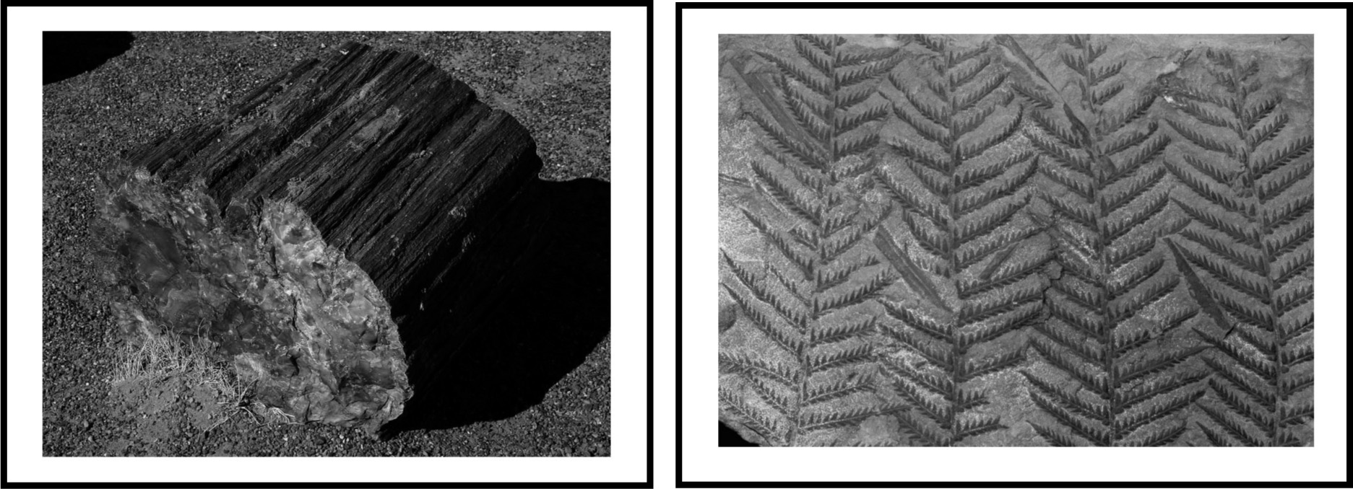
FOSSILS (continued)
Fossil 3
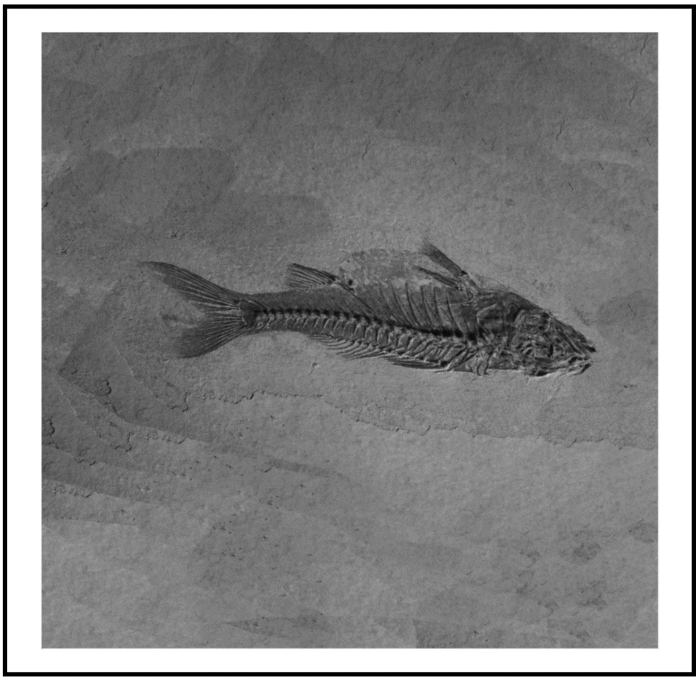 | Fossil 4
 | 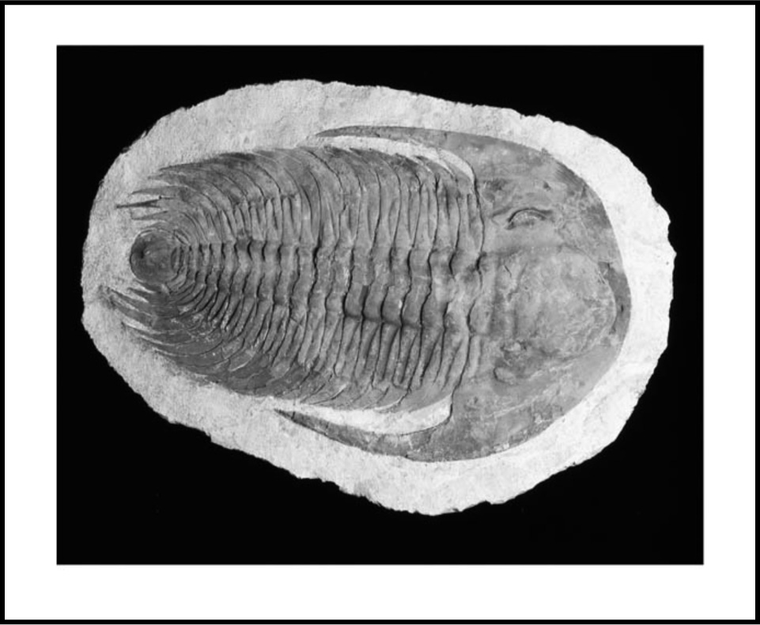
Fossil 5
