The nervous and musculoskeletal systems
STUDENT BOOK | Ch. 7, pp. 202–206

Nervous system, neuron, nerve impulse,
peripheral nervous system, nerves
1. Use the following words to complete the text below. Terms may be used more than once.
 | sensory  brain | central  peripheral | nerves  nervous | stimuli

The |  |  |  |  | system is composed of the |  |  |  |  |  |  |  |  |  | nervous system and
the |  |  |  | nervous system. It coordinates all activities that help the organism to
function. The nervous system receives |  |  |  |  |  |  |  |  |  |  |  |  | from |  |  |  | receptors,
then transmits the information to the brain. In turn, the |  |  |  |  |  |  |  |  |  |  |  |  |  |  |  | processes, stores
and transmits the information via |  |  |  |  |  |  |  |  |  | to various parts of the body where
action occurs. The |  |  |  |  |  |  | nervous system connects parts of the body to the
central nervous system by means of |  |  |  |  |  |  |  |  |  |  |  | .
2. The neuron, a specialized cell, is made up of four parts: the axon, axon terminals, the cell body and dendrites. Match each part to one of the following statements.
a) | They receive messages and transform them into nerve impulses.
b) | They transmit nerve impulses.
c) | Nerve impulses travel through these long neuron extensions.
d) | Central structure that holds the nucleus.
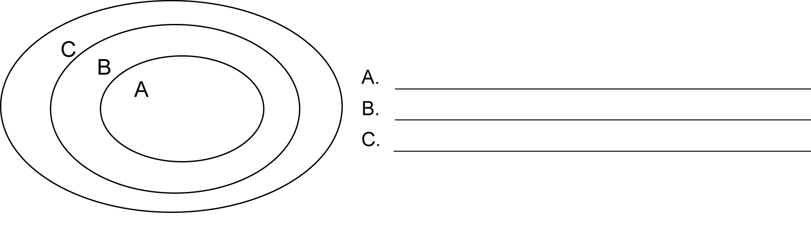
3. The diagram below illustrates the relationship among different structures of the nervous system. Match each ellipse to the corresponding term.

 | Nerves | Axons | Peripheral nervous system

Nervous system, neuron, nerve impulse,
peripheral nervous system, nerves (continued)
4. Match each nervous system structure to the corresponding description.
Nervous system structure | Description
a) Sensory receptors  b) Nerve impulse  c) Synapse  d) Neurotransmitters  e) Sensory nerves  f) Motor nerves | 1. Electrical message travelling from one neuron to another  2. Junction between two neurons  3. Structures that transmit nerve impulses  to muscles.  4. Chemical substances secreted by axon terminals  5. Specialized nerve cells that recognize stimuli.  6. Structures that transmit nerve impulses  to sensory receptors in the central nervous system.
5. A person hears a very loud sound and takes a step back to move away from it. Place in order the structures through which the nervous impulse will travel.
 | Sensory nerve  Motor nerve | Central nervous system  Sensory receptors (ears) | Stimulus (sound)  Muscles

 |  | →
→ |  | →
→ |  | →
6. Place a check mark beside each statement that does not apply specifically to neurons.
a) | Require a great deal of oxygen and glucose. | 
b) | There are about 100 billion in the human organism. | 
c) | Help the nervous system function. | 
d) | Can live for only a few days. | 
e) | Transform a stimulus into a nerve impulse. | 

The nervous and musculoskeletal
systems (continued)
STUDENT BOOK | Ch. 7, pp. 206–212

Central nervous system
1. What is the connection between the brain, the brain stem, the cerebrum and the cerebellum? Circle the correct answer.
a) The cerebrum contains the cerebellum and the brain stem contains the brain.
b) The brain contains the cerebellum and the brain stem contains the cerebrum.
c) The brain is made up of the brain stem, the cerebrum and the cerebellum.
d) The brain stem contains the cerebrum, the cerebellum and the brain.
2. What am I?
a) | We are the membranes that protect the cerebrum and the spinal cord.
b) | I control voluntary movement.
c) | We are the solid structure that protects  the spinal cord.
d) | I control the organism’s equilibrium.
e) | I control involuntary movement.
3. Use the following terms to identify the location of the nervous system structures listed below. Terms may be used more than once.
 | Spinal cord | Cerebrum | Skull | Brain | Spine

 | Nervous system structure
a) | Cranial nerves
b) | Grey matter
c) | Spinal nerves
d) | Meninges
e) | Spinal cord
f) | Brain

Central nervous system (continued)
4. Match the following types of movements to the corresponding situations listed below.
 | A. Voluntary movement | B. Involuntary movement | C. Reflex

a) | Withdrawing your hand from a hot barbecue grill
b) | Motions of the digestive system to digest an ice cream cone
c) | Reading an adventure novel
d) | Protecting your head when near a falling object
e) | Turning your head to see a friend
f) | Breathing during sleep
5. The descriptions below refer to nerves of the central nervous system.
A. There are 31 pairs.
B. Path taken by nerve impulses to the brain stem
(during involuntary movement)
C. Path taken by nerve impulses from the cerebrum to the muscles
(during voluntary movement)
D. Circulation of nerve impulses during reflexes
E. There are 12 pairs.
F. Communication between the brain and the organism
Match the above descriptions to the corresponding type of nerves. Certain descriptions may correspond to more than one type of nerve.
Spinal nerves:
Cranial nerves:
Sensory nerves:
Motor nerves:

The nervous and musculoskeletal
systems (continued)
STUDENT BOOK | Ch. 7, pp. 213–220

Sensory receptors, sensory organs
1. True or false?
a) | Sensory receptors are distributed throughout the organism.
b) | Sensory receptors pick up only external stimuli.
c) | Sensory receptors are specialized nerve cells.
d) | Sensory receptors connected to sensory organs can pick up  stimuli only from the external environment.
2. Sensory organs possess a specialized structure that contains sensory receptors. Match each sensory organ to its structure.
Sensory organ | Structure containing sensory receptors
a) Eye  b) Ear  c) Skin  d) Nose  e) Tongue | 1. Olfactory epithelium  2. Taste buds  3. Retina  4. Cochlea  5. Dermis
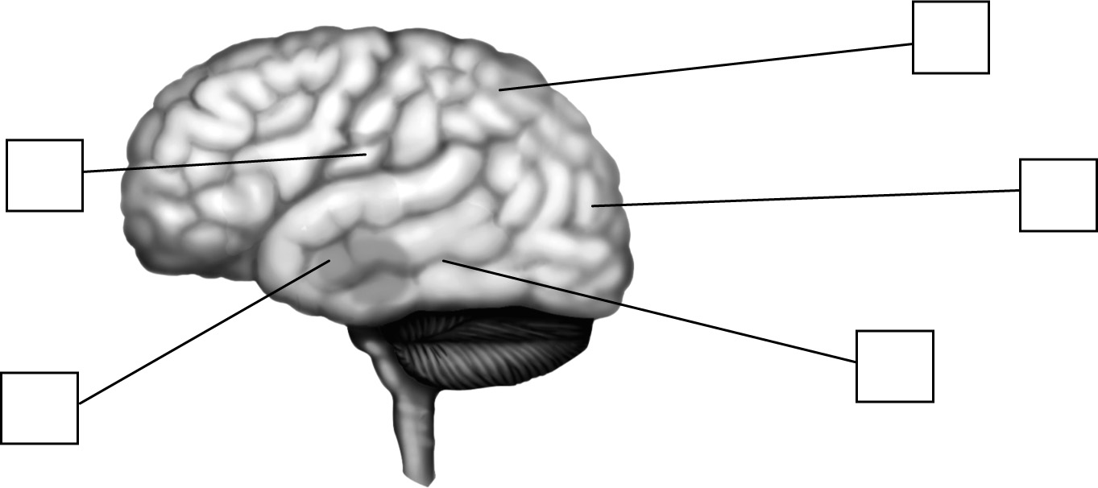
3. Match the senses below to their corresponding region of the brain in the illustration.

 | Sense: | A. Hearing | B. Vision | C. Taste | D. Smell | E. Touch

Sensory receptors, sensory organs (continued)
4. What transforms stimuli picked up by sensory organs into nerve impulses?
a) the brain
b) sensory receptors
c) the spinal cord
d) sensory nerves
5. For each of the two sensory organs below, place their respective terms in order starting from the stimulus to the brain’s perception.
a) In the ear:
 | Auditory nerve | Cerebrum | Perception of sound | Cochlea | Sound waves

 | → |  | →
 | → |  | →
b) In the nose:
 | Olfactory epithelium | Olfactory nerve | Odour | Perception of odour | Cerebrum

 | → |  | →
 | → |  | →
6. Complete the sentences below.
 | are nerve cells present on the surface of the |  |  |  |  |  |  |  | .
They make it possible to see |  |  |  |  | . |  |  | are nerve cells that
make it possible to see |  |  |  | in light intensity.

The musculoskeletal and
nervous systems (continued)
STUDENT BOOK | Ch. 7, pp. 221–228

Musculoskeletal system,
function of bones, joints and muscles,
types of muscles, joint movements
1. Use the following words to complete the text below. Terms may be used more than once.
 | mobility  size  bones | bladder  heart  skeleton | muscles  joints  shape

The musculoskeletal system is made up of |  |  |  |  |  |  |  |  |  |  |  |  |  |  |  | , |  |  |  |  | and
 |  |  | . The |  |  |  |  |  |  | is made up of |  |  |  |  |  |  |  |  |  | .
The tissue of |  |  |  |  |  |  | is the hardest material found in the body. Bones are
classed into four different categories according to their |  |  |  |  |  |  |  |  |  |  |  |  |  |  |  |  |  |  | and their
 |  |  | . |  |  |  |  |  | are junction points between two or more bones. The
composition and degree of |  |  |  |  |  |  |  |  |  |  |  |  | differ from one joint to another.
 |  |  | are tissues that surround and are attached to the bones. Some muscles
also make up the wall of organs such as the |  |  |  |  |  |  |  |  |  |  |  |  |  |  |  |  |  | , the uterus and the stomach.
An organ, the |  |  |  |  |  |  |  | , consists of a unique muscle in the organism.
2. Name the three functions of bones.
3. True or false?
a) | All bones are composed of spongy bones and compact bones.
b) | Bones of the skull and shoulder blades are flat.
c) | The spine is composed of regular-shaped bones.
d) | The rounded end of a long bone is called epiphysis.
e) | Flat bones are made up of two layers of spongy bone.
f) | The tibia is an example of a long bone.
g) | Short bones are found in the fingers and the toes.

Musculoskeletal system, function
of bones, joints and muscles,
types of muscles, joint movements (continued)
4. Match the types of muscles to the appropriate description.
 | Muscle: | A. Smooth muscle | B. Skeletal muscle | C. Heart muscle

 | Description
a) | Involuntary and highly resistant to fatigue
b) | Striated, involuntary, strong and unique
c) | Voluntary, connected to bone by a tendon
d) | Works slowly.
e) | Tires quickly.
f) | Thigh muscle
5. Match each action in the left column to the corresponding type of joint movement.
Action | Joint movement
a) Making circles with the arms  b) Lifting a leg straight out  c) Bending an arm  d) Unbending the knees  e) Bringing both legs together | 1. Extension  2. Abduction  3. Adduction  4. Rotation  5. Inflection
6. What muscle is the only one of its type found in the organism?

