The organization of matter
STUDENT BOOK | Ch. 1, pp. 9, 21–26

Pure substances
1. Complete the sentences below using the terms listed. Two terms apply more than once.
 | Particle  Elements  Periodic  Atom | Compounds  One hundred  Mixtures  Element | Oxygen  Carbon  Chemical  Pure | Compound  Elements  Pure substances  Properties  Compound

a) | Unlike |  |  |  |  |  | , which are composed of many substances,
 |  |  |  | are formed of a single substance and therefore one type of
 |  |  |  | . |  |  |  | substances can be
 |  |  | or |  |  |  |  |  | .

b) | An |  |  | is composed of a one type of |  |  |  |  |  |  |  | ,
 | while a |  |  |  |  | contains at least two different
 | that are chemically bonded. |  |  |  |  |  |  | separation techniques are used to
 | separate the different elements of a |  |  |  |  |  |  |  |  | , but an element cannot be
 | separated into other substances.

c) | The |  |  |  | table contains more than
 | chemical elements from which all substances are formed. Elements are grouped together
 | according to their |  |  |  |  |  | . Living beings are composed mostly of four
 | elements: |  |  |  |  | , hydrogen, |  |  |  | and nitrogen.
2. Indicate if the pure substances listed below are elements or compounds.
 |  | Element | Compound
a) | Sugar |  | 
b) | Carbon powder (graphite) |  | 
c) | Silver |  | 
d) | Water |  | 
e) | Gold |  | 
f) | Nitrogen gas |  | 
g) | C₃H₈ (propane gas) |  | 
h) | Ozone (O₃) |  | 

Organization of matter (continued)
STUDENT BOOK | Ch. 1, pp. 9-13,19-20

Homogeneous and heterogeneous
mixtures, separation of mixtures
1. The diagram below illustrates the relationship among terms linked to the organization of matter in the following box. Identify the term that corresponds to each figure in the diagram.
 | Mixtures | Homogeneous mixtures |  | Matter
 | Heterogeneous mixtures |  | Solutions | Colloids
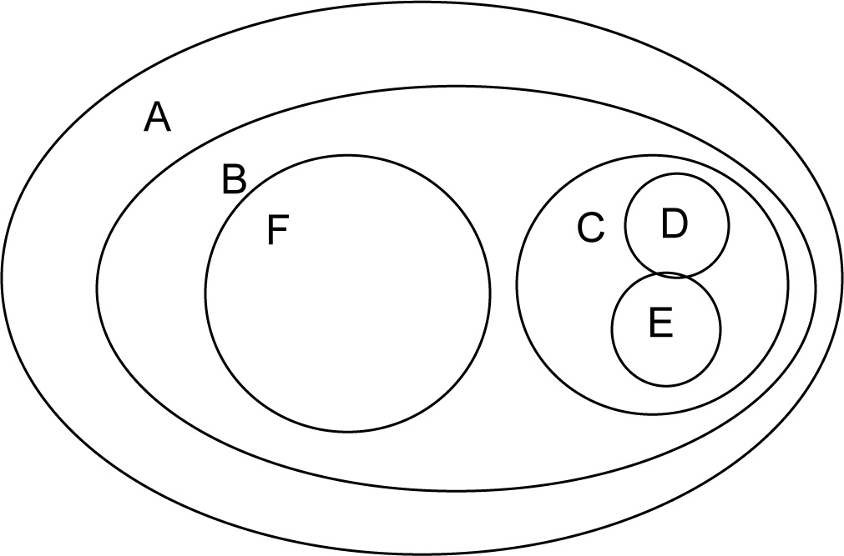

A.
B.
C.
D.
E.
F.
2. True or false?
a) | In a heterogeneous mixture, substances are distributed evenly.
b) | A colloid is a type of homogeneous mixture.
c) | A homogeneous mixture is made up of a single substance and  a heterogeneous mixture is made up of several substances.
d) | Substances in a homogeneous mixture can be distinguished  with the naked eye.
e) | A solution is a heterogeneous mixture.

Homogeneous and heterogeneous mixtures,
separation of mixtures (continued)
3. The following substances are homogeneous mixtures. In the space provided, indicate if each mixture is a solution (S) or a colloid (C).
a) | Mayonnaise
b) | Filtered apple juice
c) | Milk
d) | Chlorinated water (from a swimming pool)
e) | Steel
f) | Petroleum
g) | Blood
4. Match each mixture to a physical separation method used to purify it or to separate its components.
Mixture | Physical separation method
a) Plant pigments  b) Raw apple juice (with pulp)  c) Vinegar and olive oil  d) Blood (constituents)  e) Water and lavender oil  f) Seawater (water and salt) | 1. Centrifugation  2. Vaporization  3. Distillation  4. Chromatography  5. Decantation  6. Filtration
5. Indicate with a check mark each separation technique below that requires a source of heat.
a) | Centrifugation | 
b) | Vaporization | 
c) | Distillation | 
d) | Chromatography | 
e) | Decantation | 
f) | Filtration | 

