Types of motion
1. Match each type of motion with its definition.
Type of motion | Definition
a) Translational motion  b) Rotational motion  c) Helical motion | 1. Motion made by a part of an object as it moves  along an axis while turning about that axis  2. Motion made by a part of an object moving in a  straight line  3. Motion made by a part of an object turning on  an axis
2. Identify the type of motion described in each example.
a) | Motion of a screw entering wood
b) | Motion of a dresser drawer being opened
c) | Motion of a doorknob
d) | Motion of a corkscrew entering a cork
e) | Motion of a train on tracks
f) | Motion of blades of a fan
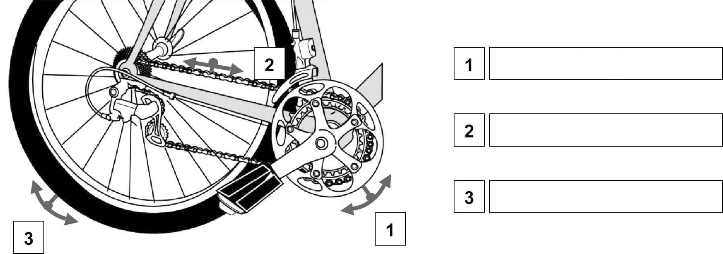
3. Identify each type of motion indicated by arrows in the drawing.

