Tectonic plate
1. Use the words in the box to complete the text below on tectonic plates.
 | float  oceans | mantle  crust  plates | lithosphere  glide  continents | continental drift  tectonic plates

The |  | is the solid envelope of Earth. It is made up of the

 | and part of the |  | . It is broken up into more than a

dozen large pieces called |  | . These plates form the bed of the

 | and the |  | . They |  | on the partially

molten part of the mantle. The extreme heat of Earth’s interior creates movement in the part

of the mantle on which the |  | rest. This explains why the tectonic plates

very slowly in relation to one another. This is known as
2. Match each consequence of tectonic plate movement with its description.
Consequence of tectonic  plate movement | Description
a) Divergence  b) Friction  c) Collision | 1. Plates slide toward each other and collide. One plate sometimes slides underneath the other.  2. Plates move further and further apart, and magma rises to the surface to fill the empty space and solidifies.  3. Two plates slide against each other, creating a huge release of heat.
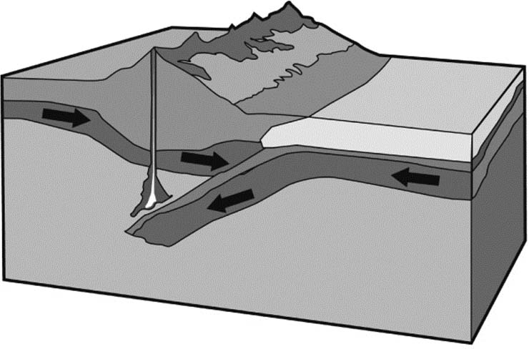
3. Which consequence of tectonic plate movement is illustrated here?
It is the main cause of the appearance of
faults, volcanoes and mountains. It can
also cause earthquakes.

