Technical drawing
Design plan
1. Indicate if each statement describes a technical drawing or a design plan.
a) | This is a simplified representation of how an  object operates.
b) | This identifies the parts and materials to be used  for manufacturing an object.
c) | This shows how the parts are interconnected and  their appropriate guides.
d) | This gives the forces and motions involved in  operating of the object.
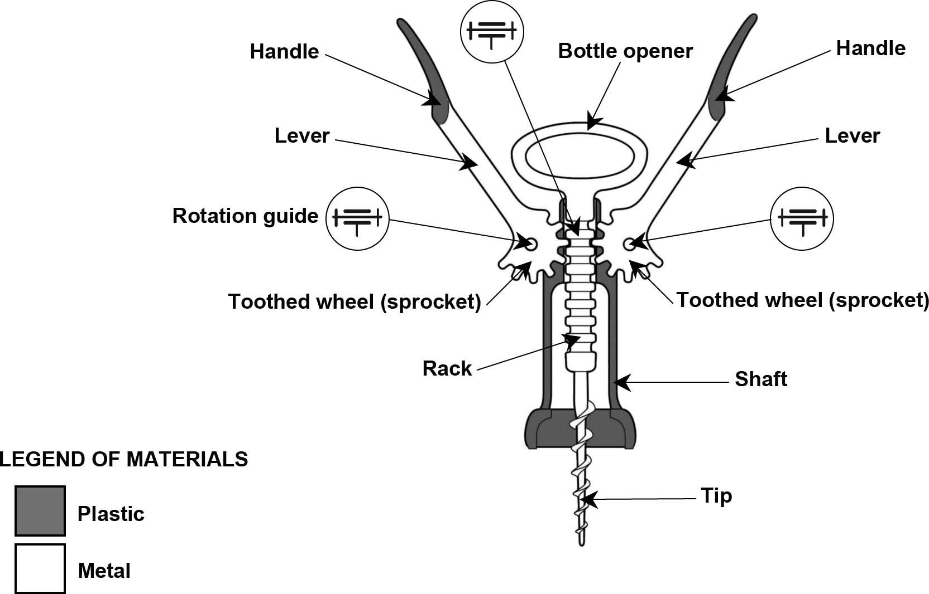
2. Use the illustration to answer the questions below.

a) | Is this a technical drawing or a design plan?
b) | What is the tip of the corkscrew made of?

