Seasons
1. What causes the seasons to change? Check the correct answer(s).
a) Earth’s orbit of the Sun 
b) The Moon’s orbit of Earth 
c) The inclination of Earth 
d) The inclination of the Sun 
e) Earth’s rotation on its own axis 
f) Earth’s spherical shape 
2. Complete the diagram below of the changing seasons using the words in the box.
 | Spring equinox | Fall equinox | Summer solstice | Winter solstice
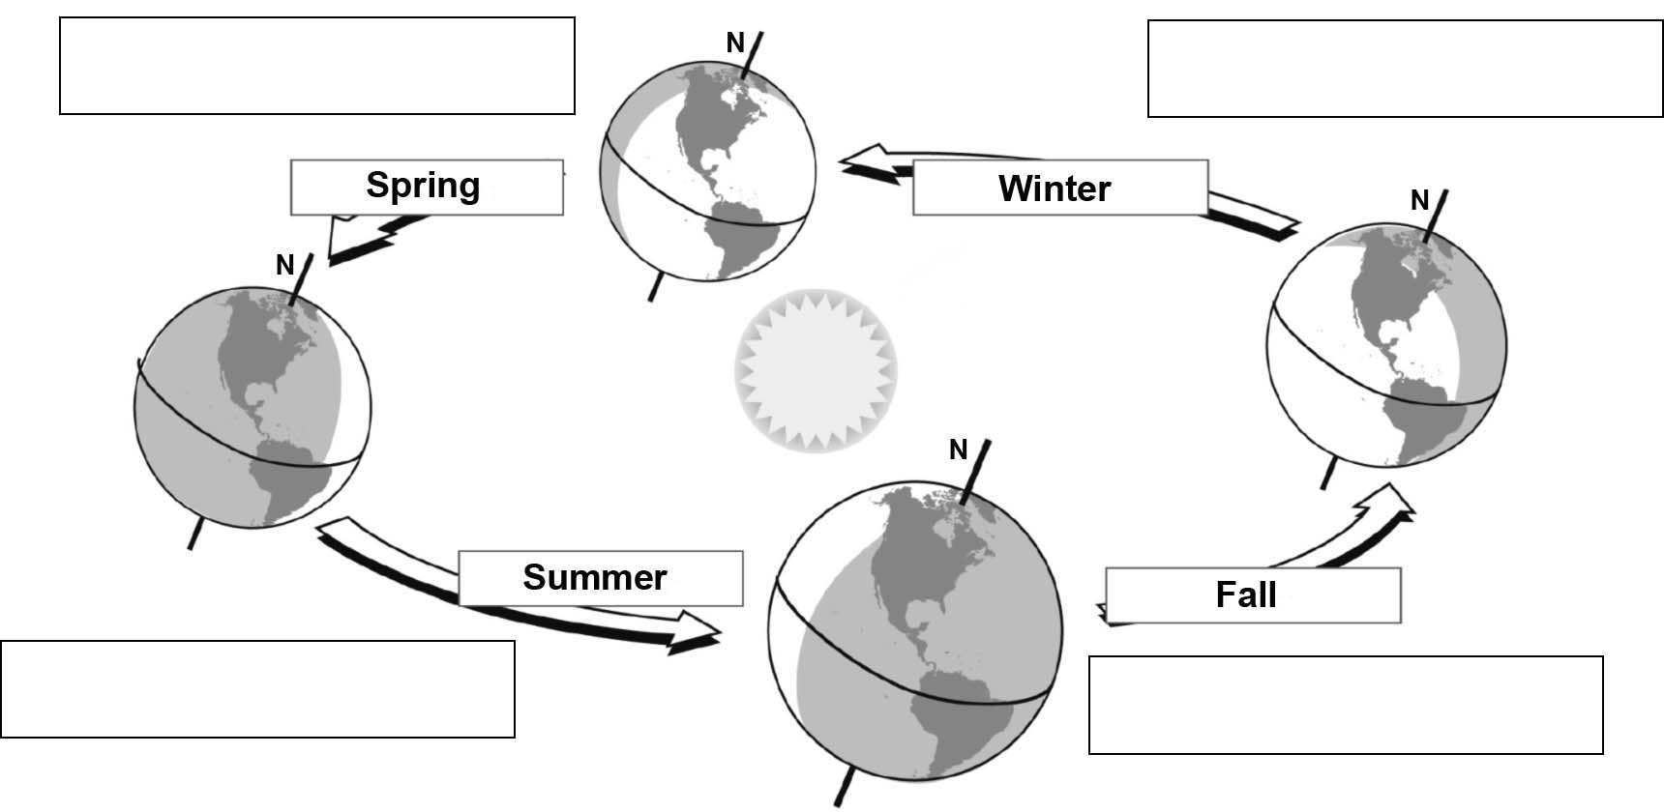
ALTERNATION OF SEASONS IN NORTHERN HEMISPHERE

3. True or false?
a) | An equinox or a solstice marks the start of each season.
b) | In the Northern Hemisphere, the Sun’s rays are oblique  and less direct in winter.
c) | It takes Earth 365.0 days to revolve around the Sun.
d) | Day is longer than night during an equinox.
e) | In the Northern Hemisphere, it is warmer in summer  because Earth is closer to the Sun.
f) | In the Northern Hemisphere, the days get longer after  the summer solstice.

