Reproductive organs
1. Match each term with its description.
Female reproductive organ | Description
a) Ovary  b) Fallopian tube  c) Uterus  d) Vagina  e) Bartholin’s gland  f) Clitoris  g) Hymen | 1. Thick, extendable organ that contains large numbers  of muscles.  2. Gland that produces ova and female sex hormones.  3. Gland that secretes a clear fluid that moistens the  vulva and vagina.  4. Supple tube that connects the uterus and the vulva.  5. Organ that is highly sensitive to touch.  6. Duct through which the ovum descends into the uterus.  7. Membrane that partially closes the entrance to  the vagina.
2. Use the terms from question 1 to complete the following diagrams of the female
reproductive organs.
EXTERNAL FEMALE INTERNAL FEMALE
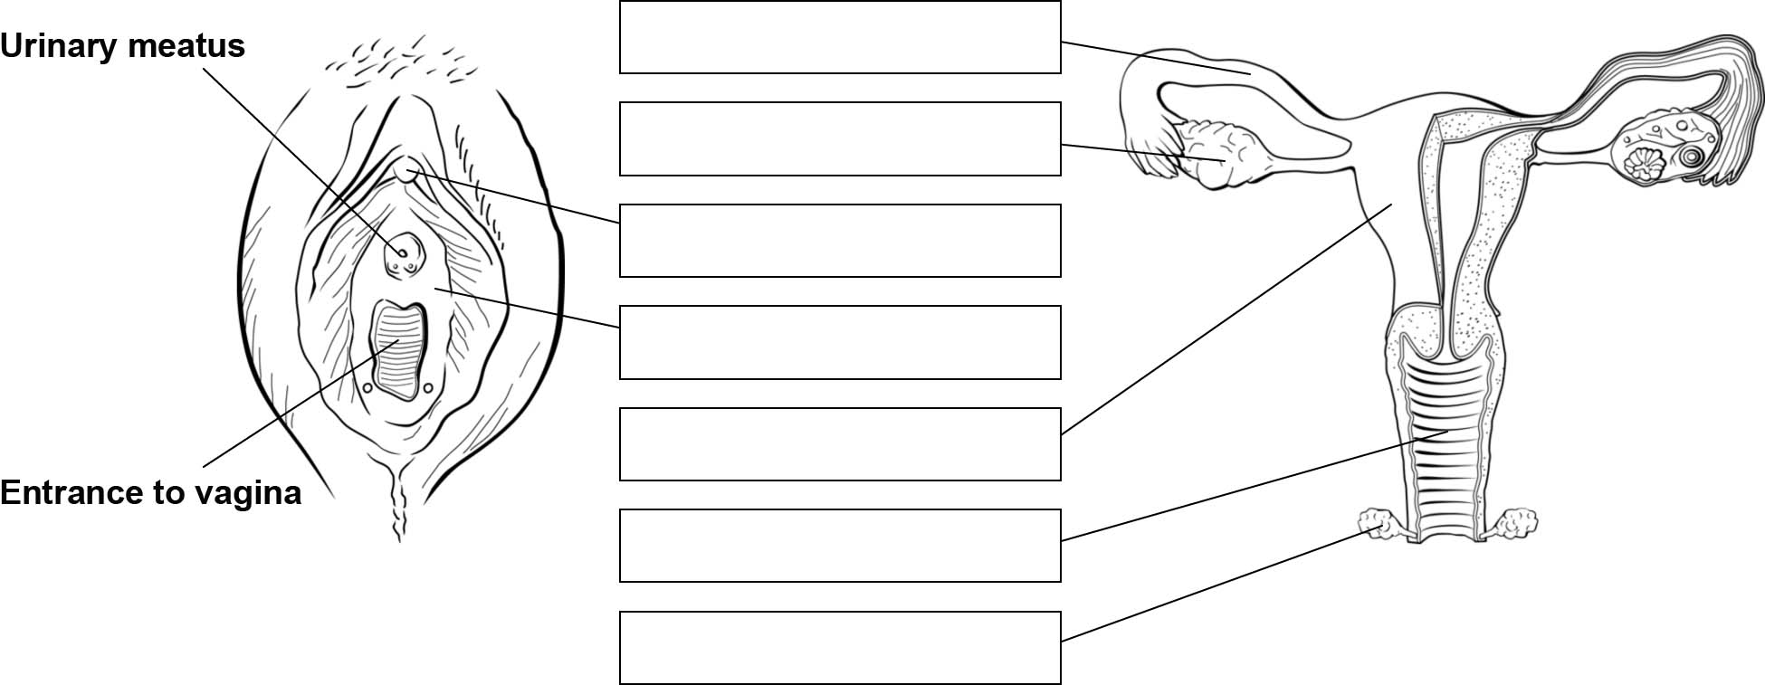
REPRODUCTIVE ORGANS REPRODUCTIVE ORGANS
3. Name the female reproductive organ in which these activities take place:
a) | Fertilization.
b) | Development of a future baby.

Reproductive organs (continued)
4. Match each term with its description.
Male reproductive organ | Description
a) Penis  b) Scrotum  c) Testicle  d) Epididymis  e) Urethra  f) Cowper’s gland  g) Prostate  h) Seminal vesicle  i) Vas deferens | 1. Tube through which sperm leaves the body.  2. Gland that produces a fluid that lubricates the tip of  the penis.  3. Gland that secretes a fluid that activates and  nourishes spermatozoa.  4. Gland that produces a fluid consisting mostly of sperm.  5. Tube that connects the epididymis to the prostate.  6. Area located in the testicles for the temporary storage  of spermatozoa  7. Organ that contains male sex hormones and  spermatozoa.  8. Cutaneous sac that contains the testicles.  9. Characteristic male genital organ
5. Use the terms from question 4 to complete the following diagram of the male reproductive
organs.
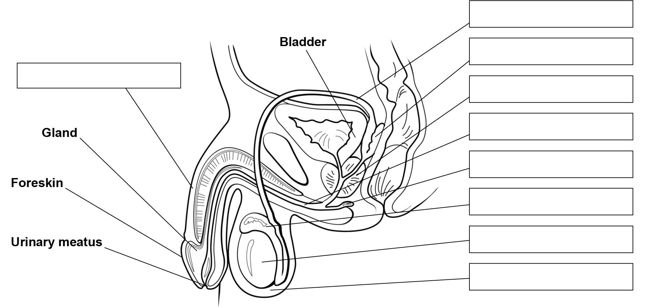
MALE REPRODUCTIVE ORGANS

