Reproductive methods in plants
1. Some plants reproduce asexually and others sexually. Many plants produce flowers by
sexual reproduction. Complete the following table with the numbers marked on the flower
anatomy diagram below.
Number | Structure
 | Stamen (male organ)
 | Pollen (seed)
 | Anther (part covered with pollen)
 | Pistil (female organ)
 | Stigma (entrance to pistil)
 | Ovary (contains ovules)
 | Ovule (turns into a seed once it is fertilized)
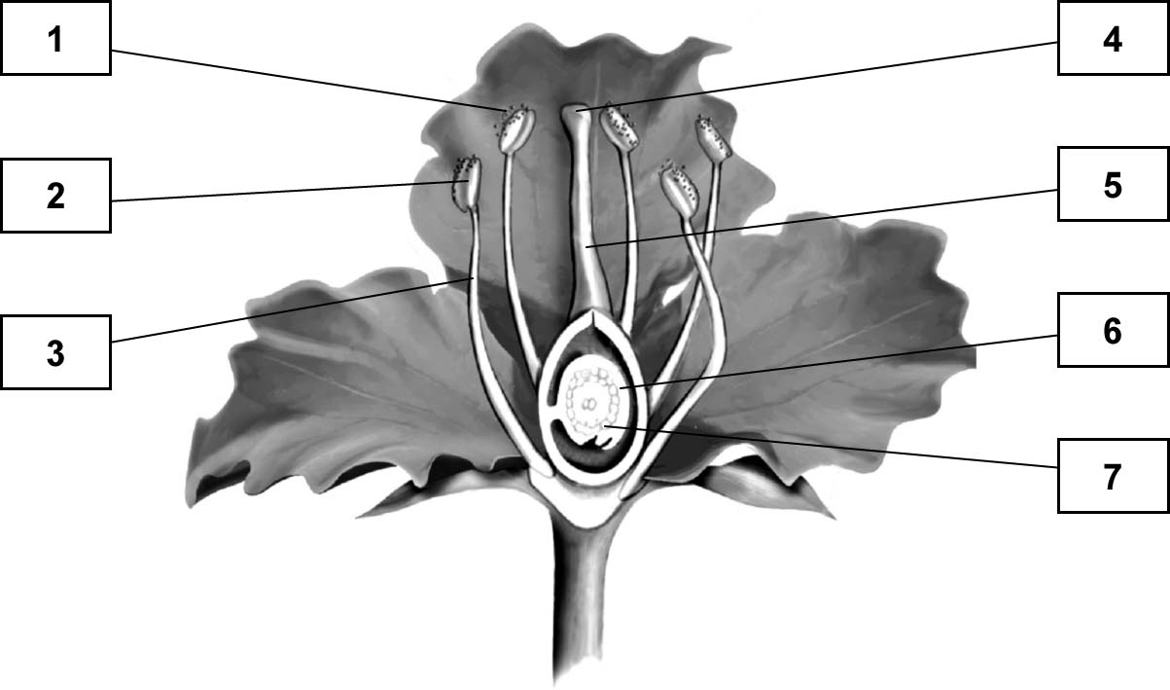
ANATOMY OF A FLOWER
2. The following stages of reproduction of a flowering plant are listed in chronological order
(a to d). Match each stage with its description.
Reproductive stage of  flowering plant | Description
a) Pollination  b) Fertilization  c) Fructification  d) Germination | 1. Stage marked by the formation of seed-bearing fruit  2. Stage marked by the transport of pollen from the anther  of the stamen to the stigma of the pistil  3. Stage marked by the development of the embryo inside  the seed  4. Stage marked by the joining of male cells (pollen) and  a female cell

