Pregnancy
1. Match each term with its definition.
Term | Definition
a) Fertilization  b) Implantation  c) Pregnancy  d) Fetus  e) Embryo  f) Zygote | 1. Time period during which a woman carries a future baby  in her uterus.  2. Union of an ovum and a spermatozoan  3. Fertilized ovum  4. Name for a future baby from its ninth week in the uterus  to its delivery  5. Attachment of the zygote in the uterus  6. Name for a future baby from implantation to the eighth  week in the uterus
2. Use the words in the box to complete the table of labels for the two diagrams below.
 | Placenta  Embryo  Amniotic fluid | Zygote  Vagina  Umbilical cord | Ovum  Fetus | Amniotic sac  Uterus
FROM FERTILIZED OVUM DEVELOPMENT OF BABY
TO IMPLANTATION
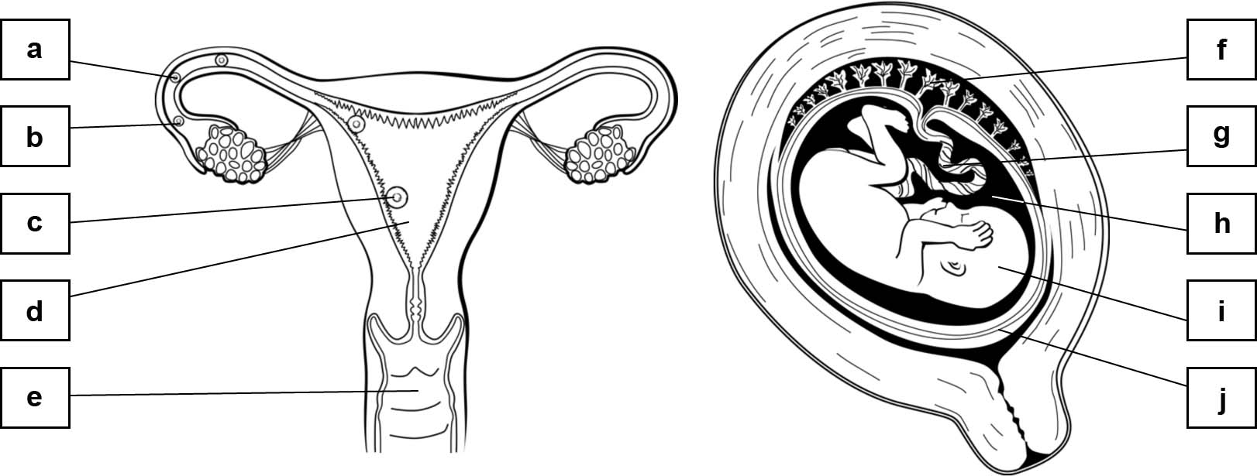
a) |  | f)
b) |  | g)
c) |  | h)
d) |  | i)
e) |  | j)

