Plant and animal cells
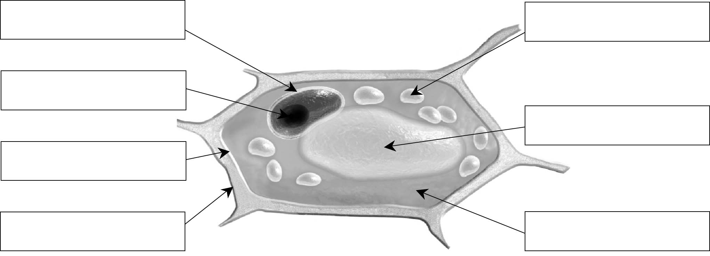
1. Use the words in the box to complete the diagram of a plant cell below.
 | Chloroplast  Nuclear membrane | Cytoplasm  Vacuole | Cell membrane  Cellulose wall | Nucleus
PLANT CELL
2. Use the words in the box to complete the diagram of an animal cell below.
 | Nuclear membrane  Nucleus | Cell membrane  Vacuole | Cytoplasm
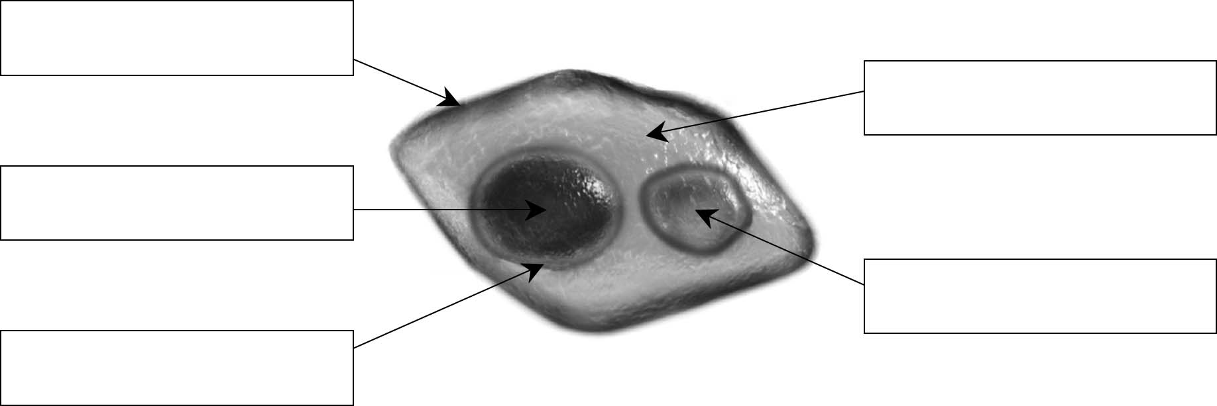
ANIMAL CELL
3. On the diagram in question 1, circle the names of the structures found in a plant cell,
but not in an animal cell.

