Phases of the Moon
1. Which of the following statements is false?
a) At a new moon, the Moon is not visible because its illuminated
side is turned toward the Sun. 
b) The phases of the Moon refer to the parts of the Moon illuminated
by the Sun as seen from Earth. 
c) The phases of the Moon refer to the parts of the Moon that reflect
on Earth. 
d) There are only eight lunar phases. 
e) The phases of the Moon are explained by the fact that the Moon
orbits Earth and the Sun illuminates the Moon at different angles,
depending on its position. 
2. Name each phase of the Moon shown below. Choose from among the terms in the box.
 | New moon  Waning crescent moon  Waxing gibbous moon | Full moon  First quarter moon  Waning gibbous moon | Waxing crescent moon  Last quarter moon
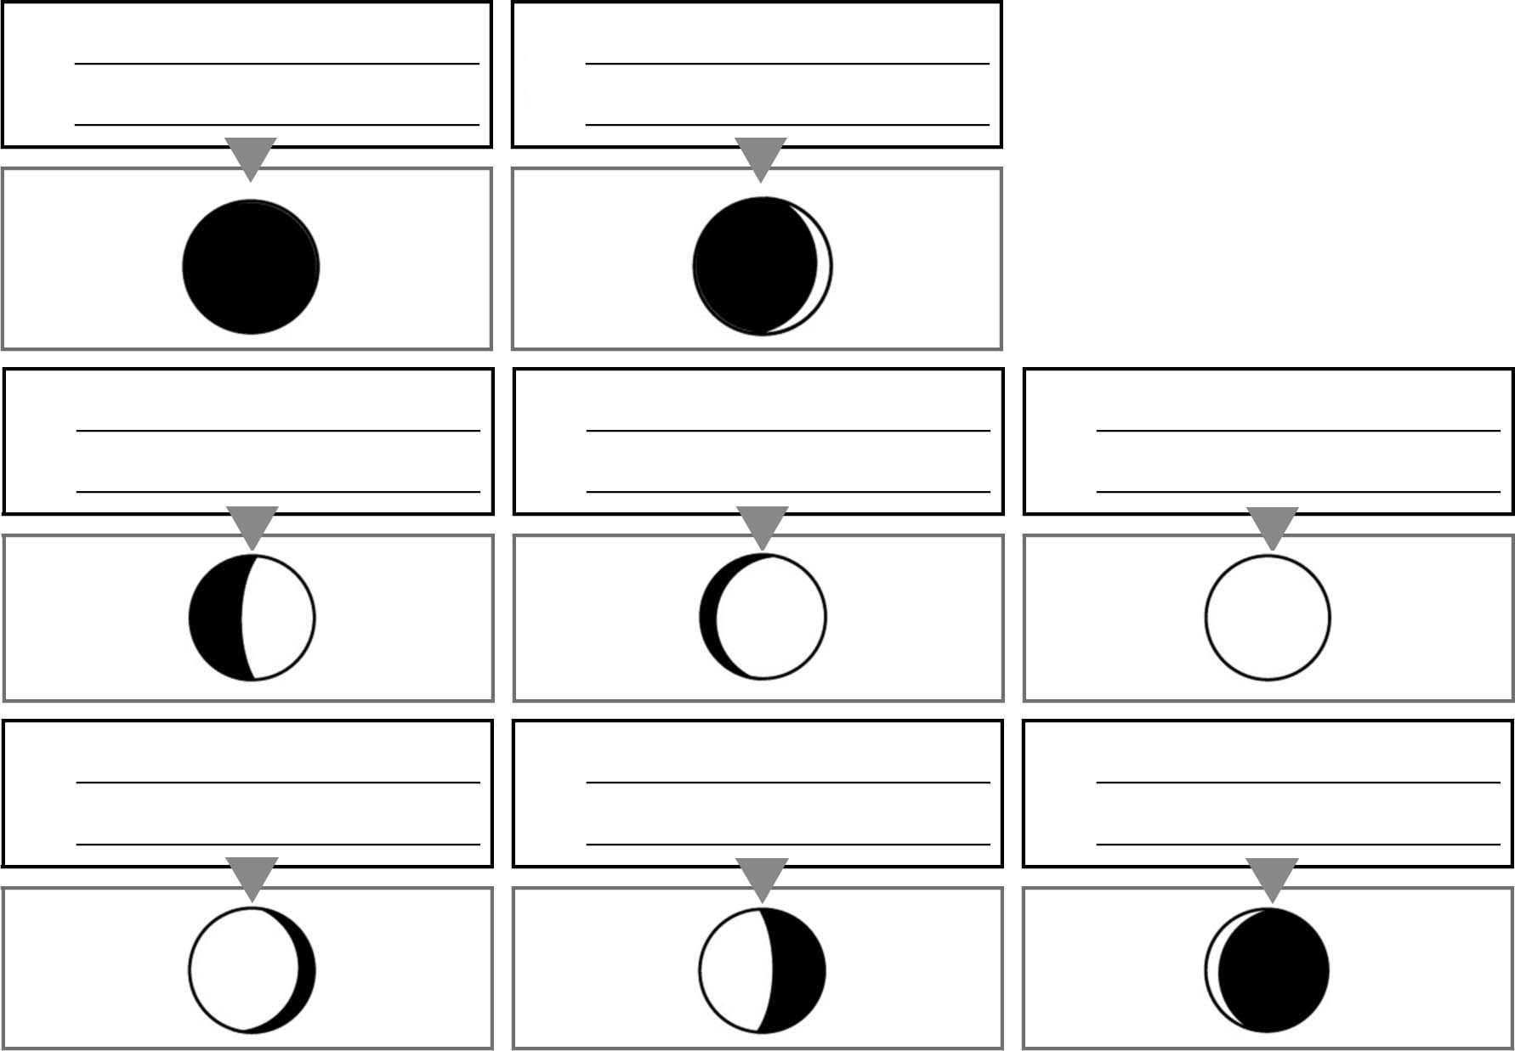
PHASES OF THE MOON
2
3
4
5
6
7
8
1

