Periodic table
1. Match each term with its definition.
Term | Definition
a) Element  b) Periodic table  c) Atomic number  d) Chemical symbol  e) Atomic mass | 1. Relative mass of one atom of an element with respect  to an atom of another element  2. International abbreviation of the name of an element  3. Substance that cannot be separated into other  substances by physical or chemical means.  4. Catalogue providing details on element properties  5. Number that indicates where an element can be found  in the periodic table.
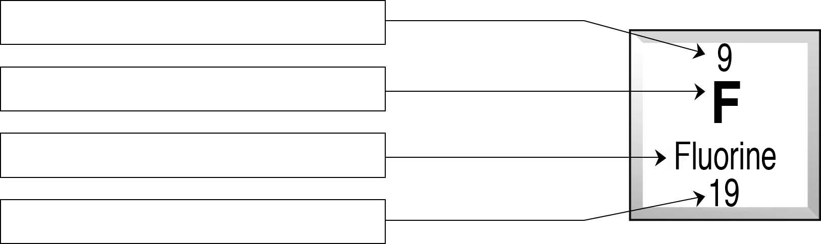
2. Here is a sample periodic table entry. Use the words in the box to identify each item
of information it contains.
 | Name of element | Atomic mass | Chemical symbol | Atomic number
3. There are many different kinds of periodic tables, some more complex than others. For
example, different colours can be used to identify an element as a solid, liquid or gas, or
as a metal or nonmetal. Answer the following questions using the periodic table on the inside
back cover of the textbook.
a) Classify the following elements by their state at a temperature of 25°C:
Hg, Au, Br, O, Mg, He, H, Ca
Gaseous elements | Liquid elements | Solid elements
b) Identify each element described.
• | My atomic number is 8.
• | My atomic mass is 12.
• | My symbol is K.
• | My atomic mass is double the atomic mass of hydrogen.
• | I am the only liquid metal at a temperature of 25°C.

