Mechanisms that transform motion
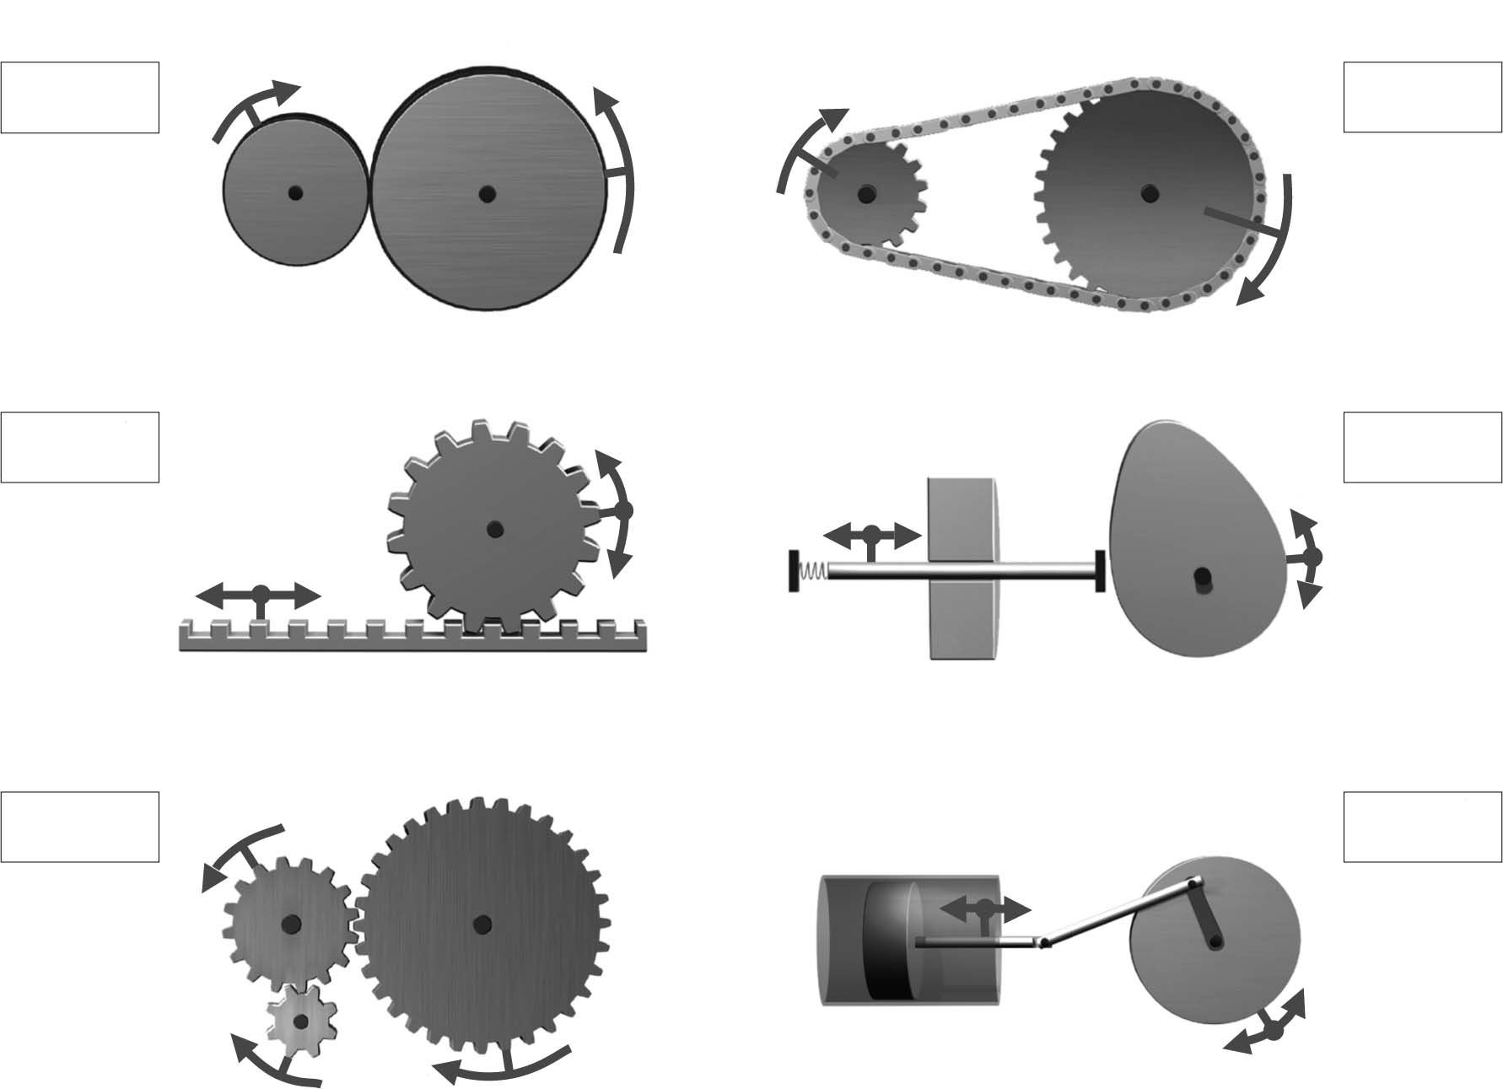
1. Which of the following mechanisms bring about a change in motion?
Check the correct examples.
2. Look at the illustrations in question 1 and find the ones that show the systems listed below.
Put the appropriate letters (A to F) on the lines provided. In addition, use the word rotational
or translational to complete the sentences describing the systems.
A 
B 
C 
D 
E 
F 
a) | Illustration of a cam and follower system: |  |  | .
 |  | motion of the cam is transformed into
motion of the follower.

b) | Illustration of a rack and pinion system: |  |  | .
 |  | motion of the rack is transformed into
motion of the pinion.

c) | Illustration of a slider-crank system: |  |  | .
 |  | motion of the crank is transformed into
motion of the slider.

Mechanisms that transmit motion
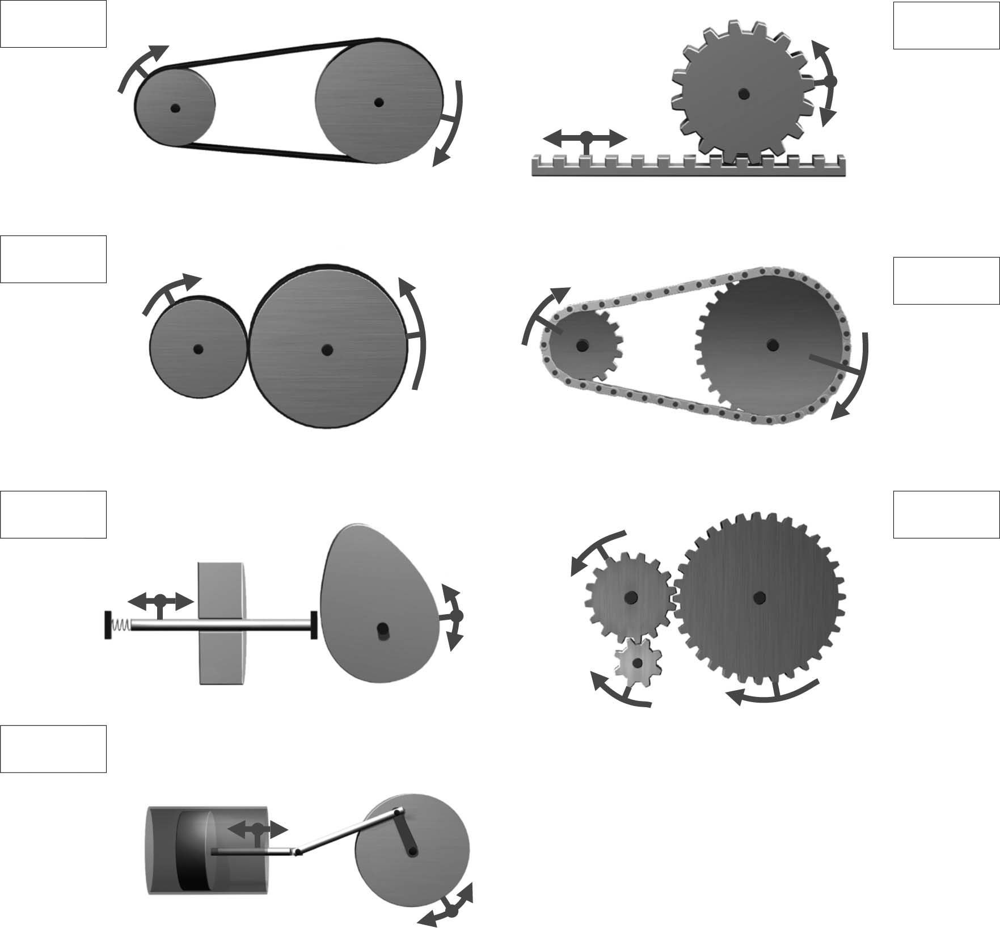
1. Which of the following mechanisms transmit motion?
Check the correct examples.
2. Look at the illustrations in question 1 and find the ones that show the systems listed below.
Put the appropriate letters (A to G) on the lines provided.
A 
B 
C 
D 
E 
F 
G 
a) | Friction gear system
b) | Simple gear system
c) | Chain and sprocket system
d) | Pulley and belt system

