Internal structure of Earth
1. Complete the diagram of Earth’s internal structure using the words in the box.
 | Nucleus | Mantle | Crust

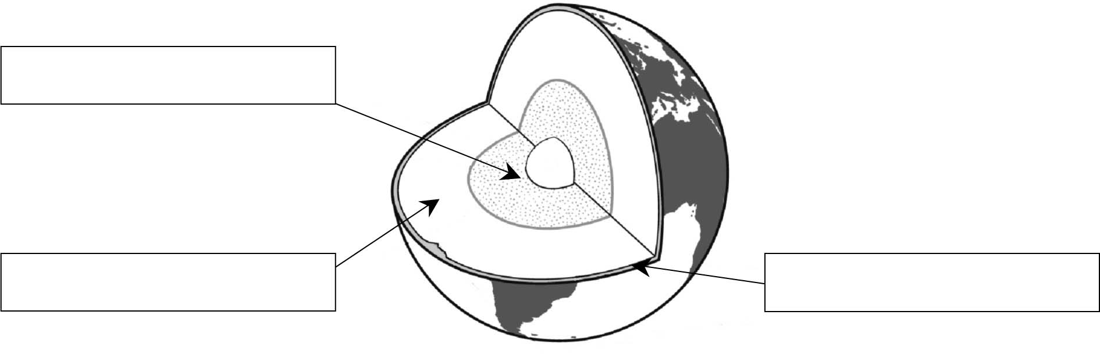
INTERNAL STRUCTURE OF EARTH

2. The following statements describe characteristics of the three main parts of Earth. Indicate if
each statement describes a characteristic of the core, mantle or crust.
a) | This is the hottest part.
b) | This is the densest part.
c) | This part makes up the largest part of Earth’s volume.
d) | This part is solid rock.
e) | This part is thicker beneath the continents.
f) | This part contains magma.
g) | This part makes up only two percent of Earth’s volume.
h) | This part has a solid centre and a liquid outer layer.
3. Which statement below does not apply to magma?
a) Magma is molten rock. 
b) Magma forms in the mantle. 
c) Magma gushes from volcanoes in the form of lava. 
d) Magma sometimes forms at low temperatures. 

