Eclipses
1. What is an eclipse?
2. Which statements describe a solar eclipse?
a) Earth comes between the Sun and the Moon. 
b) The Moon comes between Earth and the Sun. 
c) The Sun, the Moon and Earth are aligned. 
d) Earth blocks the light of the Sun, so the Moon is no
longer illuminated directly. 
e) The Moon blocks the light of the Sun. 
3. Which statements describe a lunar eclipse?
a) Earth comes between the Sun and the Moon. 
b) The Moon comes between Earth and the Sun. 
c) The Sun, the Moon and Earth are aligned. 
d) Earth blocks the light of the Sun, and the Moon is no
longer illuminated directly. 
e) The Moon blocks the light of the Sun. 
4. The following illustration shows a solar eclipse. Indicate on the drawing the areas of total
eclipse and partial eclipse.
SOLAR ECLIPSE
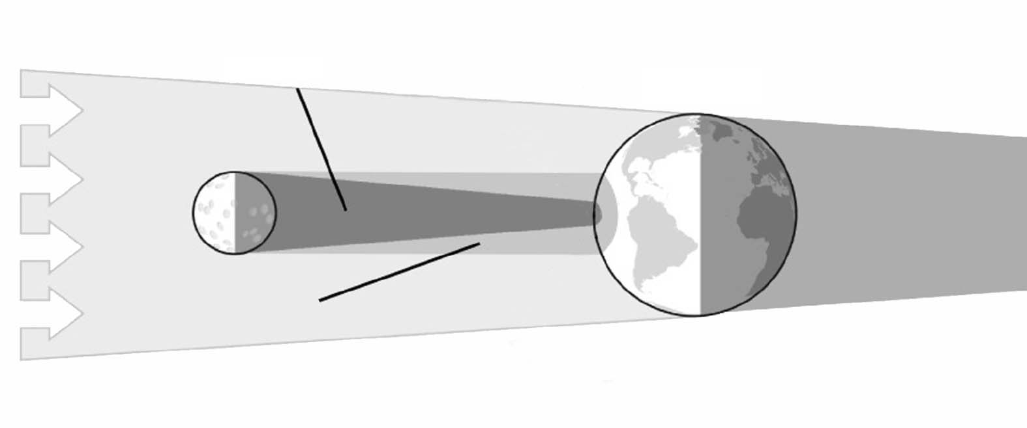
Light from
the Sun
Moon
Penumbra
Umbra
Earth

