Diffusion
1. Which of the following statements matches the definition of diffusion?
a) Diffusion is the movement of a solute from the most
concentrated area toward the least concentrated area. 
b) Diffusion is the movement of a solute from the least
concentrated area toward the most concentrated area. 
c) Diffusion is the movement of a solvent from the most concentrated
area toward the least concentrated area. 
d) Diffusion is the movement of a solvent from the least
concentrated area toward the most concentrated area. 
2. Illustrate particle diffusion through a cell membrane by using the legend to complete the
diagrams. (There are two possibilities depending on whether the cell or the outside milieu
is the most highly concentrated.)
PARTICLE DIFFUSION THROUGH A CELL MEMBRANE
3. When blood reaches the lungs:
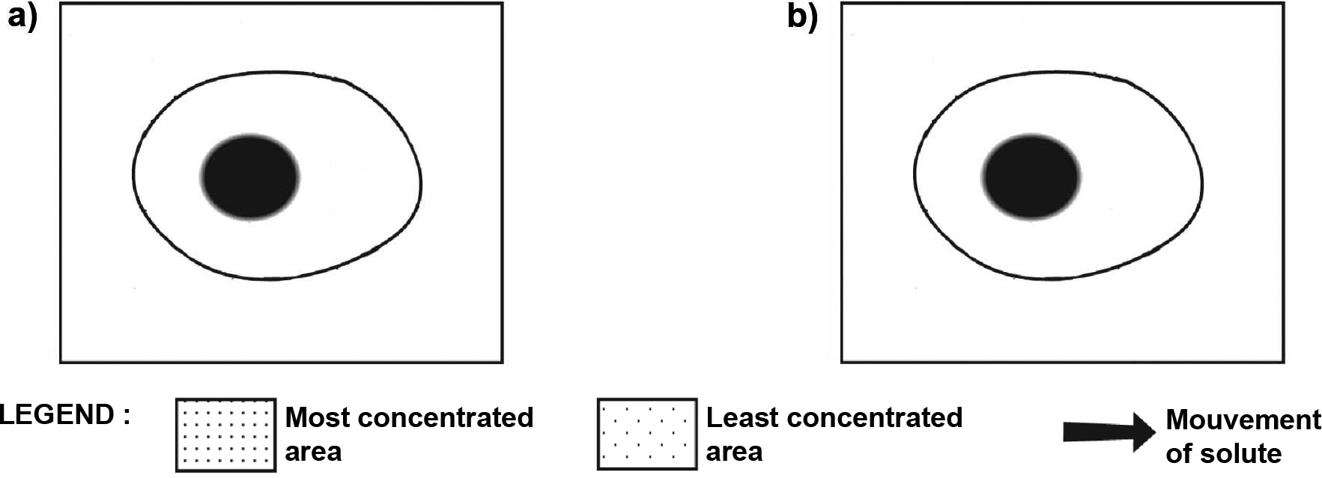

a) The concentration of oxygen is lower than that in the lungs. In which direction will
oxygen diffuse: from the blood to the lungs or from the lungs to the blood?
b) The concentration of carbon dioxide is higher than that in the lungs. In what direction will
carbon dioxide diffuse: from the blood to the lungs or from the lungs to the blood?

