Cycles of day and night
1. Match each phenomenon with its explanation.
Phenomenon | Explanation
a) Day alternates with night.  b) One day is about 24 hours long.  c) The Sun rises in the east and sets  in the west.  d) The days are longer at the start  of summer.  e) It is hotter during the day than at night. | 1. Earth rotates at almost constant speed.  2. Earth rotates on its own axis.  3. During the day, the Sun's rays reach  Earth directly.  4. Earth rotates from west to east.  5. Earth rotates on a slightly tilted axis.
2. Use the following illustration to answer the questions below.
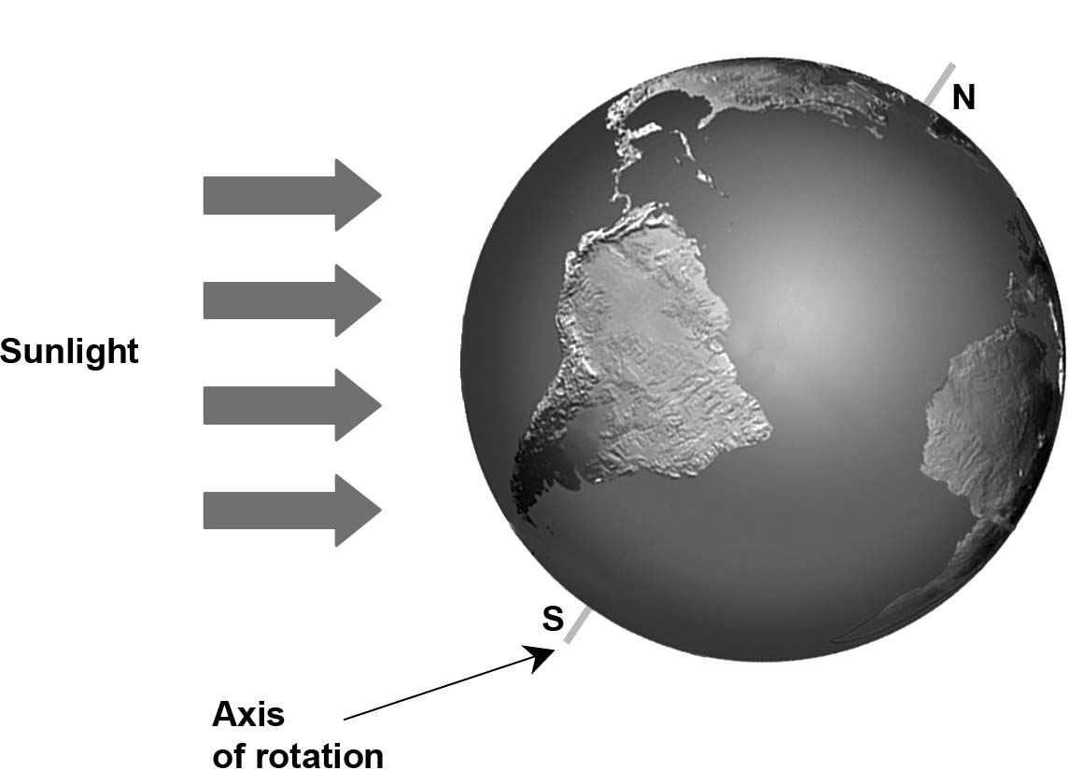

a) Draw a dotted line to mark off the zone on Earth where it is night.
b) Mark the zone where it is nighttime (night) and the zone where it is daytime (day).
c) In which hemisphere are the days longer than the nights?
d) In which hemisphere is it winter?

