Air (composition)
1. What is air? Check the correct answer.
a) Gaseous mixture that is mostly oxygen. 
b) Gas of unchanging composition surrounding Earth 
c) Mix of gases forming Earth’s atmosphere 
d) Pure substance in gaseous phase 
2. Complete the air composition diagram using the words in the box below.
 | Oxygen | Nitrogen | Other gases (carbon dioxide, etc.)
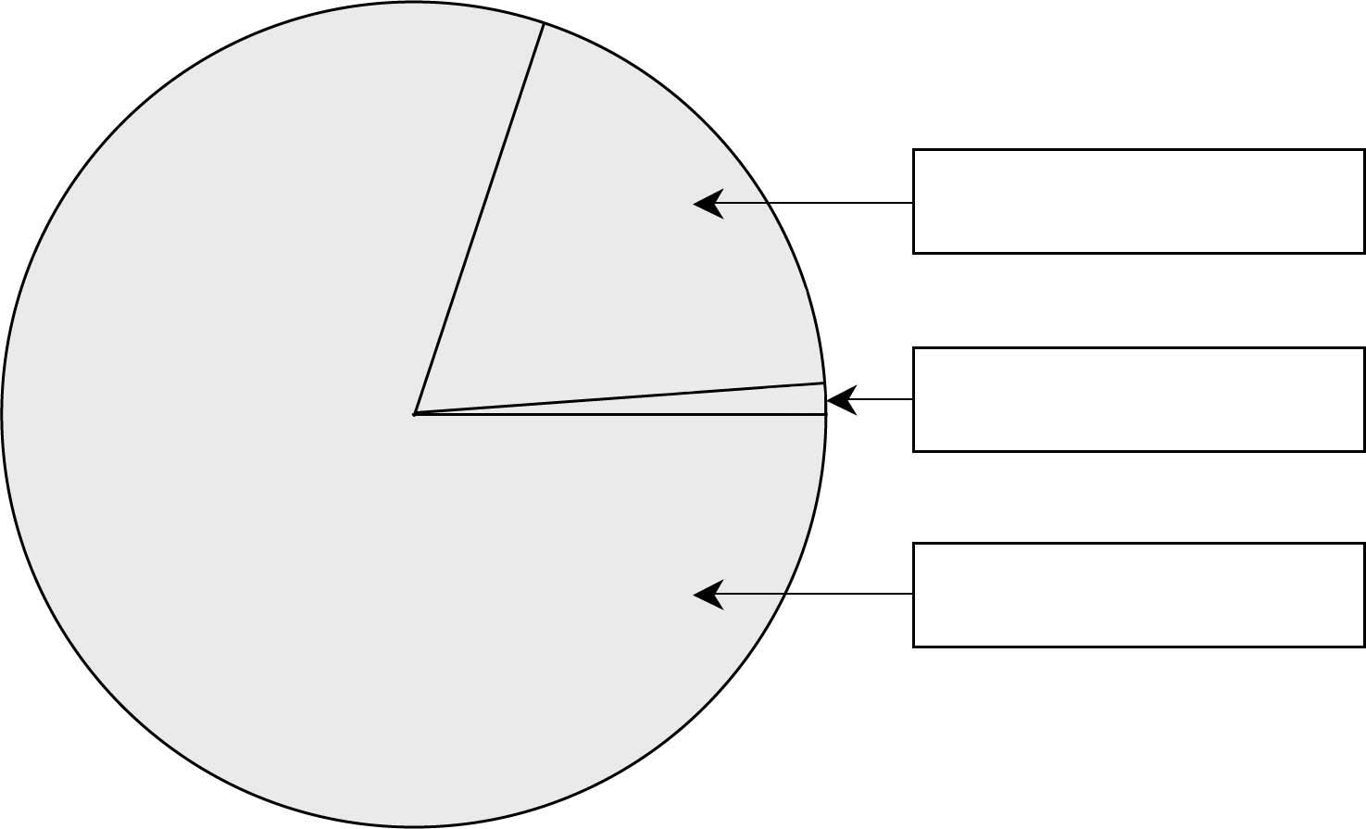
COMPOSITION OF AIR

21%
1%
78%
3. Where does oxygen in the air come from?

4. Some of the carbon dioxide in the air comes from the use of oxygen by living organisms. What is this process called?

